APPLICATION OF NITROUS OXIDE IN AUTOMOBILES

INRODUCTION

In modern automobiles, nitrous oxide (often just "nitrous" or "nitro" in this context) is sometimes injected into the intake manifold (or just prior to the intake manifold) to increase power: even though the gas itself is not flammable, it delivers more oxygen than atmospheric air by breaking down at elevated temperatures, thus allowing the engine to burn more fuel and air. Additionally, since nitrous oxide is stored as a liquid, the evaporation of liquid nitrous oxide in the intake manifold causes a large drop in intake charge temperature. This results in a smaller, denser charge, and can reduce detonation, as well as increase power available to the engine.

ABOUT NITROUS OXIDE

Nitrous oxide, also known as dinitrogen oxide or dinitrogen monoxide, is a chemical compound with chemical formula N₂O. Under room conditions it is a colourless non-flammable gas, with a pleasant slightly sweet odor. It is commonly known as laughing gas due to the exhilarating effects of inhaling it, and because it can cause spontaneous laughter in some users. It is used in surgery and dentistry for its anaesthetic and analgesic effects. Nitrous oxide is present in the atmosphere where it acts as a powerful greenhouse gas.

Properties
Name | Dinitrogen oxide
Chemical formula | N₂O
Appearance | Colourless gas

History
The gas was discovered by Joseph Priestley in 1772. Humphry Davy in the 1790s tested the gas on himself and some of his friends, including the poets Samuel Taylor Coleridge and Robert Southey. They soon realised that nitrous oxide considerably dulled the sensation of pain, even if the inhaler were still semi-conscious, and so it came into use as an anaesthetic, particularly by dentists, who do not typically have access to the services of an anesthesiologist and who may benefit from a patient who can respond to verbal commands.
Chemistry
The structure of the nitrous oxide molecule is a linear chain of a nitrogen atom bound to a second nitrogen, which in turn is bound to an oxygen atom. It can be considered a resonance hybrid of
and
Nitrous oxide N₂O should not be confused with the other nitrogen oxides such as nitric oxide NO and nitrogen dioxide NO₂.Nitrous oxide can be used to produce nitrites by mixing it with boiling alkali metals, and to oxidize organic compounds at high temperatures.
Legality

Posession of nitrous oxide is illegal in most localities in the United States for the purposes of inhaling (or otherwise ingesting) if not under the care of a physician or dentist.Nitrous oxide injection systems for automobiles is generally legal, although using the nitrous system will likely result in speeds that are in violation of other traffic laws. Some localities also require certified system components.

Uses
- It can be used as an oxidiser in rogket engine.
- It is used in automobiles to increase the power.

ABOUT NITROUS OXIDE SYSTEM USED IN AUTOMOBILES

A full range of Nitrous delivery systems are available for all applications of vehicles and engine types and can be matched to each cylinder in the engine. The common delivery systems are-

WET SYSTEM: The fuel and Nitrous are mixed and introduced together to the primary part of the intake. This system produces slightly more power than dry but cannot be applied to an engine with a dry intake typically most fuel injected engines.
DRY SYSTEM: The N₂O is injected into dry air (without fuel) upstream in the manifold and it is then mixed with fuel at the injectors. The extra fuel required to maintain the burn balance from Lean to Rich is delivered by the injectors of the car. The primary part of the intake is kept dry of fuel. In this system only nitrous oxide is injected into the intake air. A ‘Dry’ nitrous system relies on the vehicle's computer system sensing that the engine is, say, running too lean and adding additional fuel. Most stock computer systems were not designed for this purpose, and may have difficulty in working.
WET SYSTEMS

At Nitrous Works we prefer the ‘Wet’ principal, which simply means that both fuel and nitrous oxide are injected together at the spray bar or nozzle. A ‘Dry’ system injects nitrous oxide alone without and additional fuel for the engine. A properly engineered ‘Wet’ system is a safer way to inject nitrous oxide into an engine.

PRINCIPLE

The objective of nitrous oxide is to make more horsepower, which is achieved in two ways. Firstly, nitrous oxide comprises one-part oxygen and two-part nitrogen. This is a much higher percentage of oxygen than that found in the atmosphere and, because of this; the additional oxygen being forced into the combustion chamber provides more potential power. Nonetheless, the additional power cannot be realized safely without enrichening the amount of fuel in the combustion chamber. The second way nitrous oxide will increase an engine's horsepower is by cooling the air charge from the atmosphere.

One of the most important aspects of keeping an engine healthy when using nitrous oxide is to ensure it operates at the proper air/fuel ratio. Running too lean can cause detonation, resulting in damaged engine parts. Running too rich can also harm performance and destroy engine parts, too. Once calibrated, they'll inject the proper amount of fuel with the nitrous system to maintain the correct air/fuel ratio. It should be ensured that the amount of nitrous that the system is engineered to dispense does not exceed that which the intake system can flow. This prevents fuel “puddling” or distribution problems.

A further advantage of a ‘Wet’ system is that it lends itself to fine-tuning. By adjusting the fuel pressure and fuel orifice, either up or down from the baseline, the system's performance can be further improved. In addition, on a direct-port nitrous system each cylinder can be fine tuned to optimize performance and overcome rich or lean cylinders that the engine may have naturally aspirated.

The internal-combustion engine is basically a large air pump and its ability to pump air is one of the factors, which determine how much power it can produce. Air contains oxygen and by drawing more oxygen into the combustion chamber, more power will be produced. In order to achieve efficient combustion, the air needs to be mixed with fuel in the correct ratio. The stoichiometric (chemically correct) ratio is for basic gasoline is 14.7 parts air to 1 part of fuel.

Greater quantities of oxygen can be drawn into the combustion chamber by simply introducing nitrous oxide. By weight, Nitrous contains 36% oxygen while air has only 23%. A charge of nitrous oxide is capable of burning much more fuel than the equivalent amount of air.

Because nitrous is more oxygen-rich than air, the recommended air fuel ratio becomes 9.5 parts of nitrous to 1 part of fuel (9.5:1). That means when oxygen-rich nitrous is introduced additional fuel must also be supplied in order to maintain the optimum ratio Without the additional fuel the mixture would become dangerously lean - circumstances that will almost always lead to severe and expensive damage.

NITROUS IN THE COMBUSTION PROCESS

For racing purposes, nitrous oxide is usually contained in an aluminium cylinder; available in a variety of sizes ranging from 2.5 lbs to 20 lbs. While retained in the cylinder the nitrous is in a liquid form and held under high pressure. When it is released from the cylinder into the intake tract its physical state changes from a liquid to a gas. This transformation occurs as the nitrous is released from an area of extreme pressure (the aluminium cylinders are pressurized to approximately 1000 P.S.I.) into the vacuum of the intake manifold. This change in state is usually referred to as the nitrous ‘boiling’.

It takes energy to enable the nitrous to expand and boil. This energy is produced by the heat, which is absorbed from the surrounding air/gas in the intake tract. The end result is an intake charge that is cool, dense and oxygen rich - the ideal recipe for producing more power.

When the additional fuel required for nitrous is introduced in such a way that it is exposed to the full force of the expanding nitrous, it is atomized completely. This promotes improved burning in the combustion chamber and, as a direct result, power-output is increased.

Nitrous Oxide (also known by the chemical formula N₂O) comprises two atoms of nitrogen and one of oxygen and the heat of the combustion break the chemical bond that holds them together. Without heat, the three atoms would remain bonded and, consequently, the oxygen atom rendered powerless - unable to play its role in the combustion process. This is why inhaling nitrous can lead to asphyxiation, even though it has higher oxygen content than air. Your body cannot produce the heat necessary (about 525° Fahrenheit) to break the bond between the nitrogen and the oxygen; leaving the oxygen content useless for respiration.

Gasses are often considered in terms of moles. The definition of a mole is the amount of substance that contains Avogadro’s number of atoms or molecules. Though this number remains the same (6.02 x 10 to the power of 23), the weight of a mole will vary depending on the atomic weight of the molecule in question. A mole of any substance occupies 22.4 litters at standard pressure and temperature. The fact remains that all gasses have the same molar volume in similar conditions. So, if a cylinder can draw two moles of air on an intake stroke, it can also consume the same volume of nitrous. By volume, air contains 21% oxygen compared to nitrous, which is 50% oxygen. For every two moles of Nitrous Oxide (N₂O) introduced to the cylinder, there are two moles of Nitrogen (N₂) and one mole of Oxygen (O₂), as can be seen in the equation below:

2 N₂O ==> 2 N₂ + 1 O₂

There lies the hidden advantage of Nitrous Oxide. Since every mole has the same volume, its clear that two moles of nitrous drawn into the cylinder become three moles through the combustion process .This further raises combustion pressures and increases the power-producing potential of the engine.

NITROUS NECESSITIES
Producing more power requires introducing higher standards of engine preparation than would be necessary with lesser-powered units. This is especially true when considering engines injected with nitrous oxide. Their capability to produce massive and sudden power, and increased combustion pressures all necessitate the addition or improvement of certain engine systems.

One of the most important considerations when using nitrous oxide is the selection of a top-notch fuel system. As mentioned previously, introducing oxygen-rich nitrous without additional fuel would be detrimental to the health of the engine. Starved of the necessary fuel, the lean mixture will cause combustion temperatures to soar.

Extreme temperatures cause catastrophic damage to pistons and other parts in the combustion chamber and lead to massive engine failures

To prevent this, one must ensure the fuel system can handle both the normal engine requirements as well as the additional demands created by the nitrous system. If there’s the slightest hint that the fuel supply is insufficient, act immediately. There are two options available to remedy the situation. One solution is to beef-up the existing fuel system. The preferred method though, is to have two independent fuel systems; one that serves the engine and another dedicated solely to the supply of fuel for the nitrous system. This later method is much preferred, due to the fact that it protects the engine from spikes in pressure - an undesirable characteristic that can occur when using nitrous oxide.

Increased combustion pressures often require a more powerful ignition system than that required on a non-nitrous engine. This is especially true on kits for late-model, fuel-injected production cars. The increased pressure appears to the ignition system as an increased plug gap. Since many ignition systems are only powerful enough to operate under the conditions they were designed for, increased combustion pressures may extend the original ignition system beyond its limits.

A lack of spark can cause drastic reductions in power and allows the unburned, highly atomized air/fuel mixture to enter the exhaust tract that can lead to unnecessary and serious damage. Catalytic converters and expensive high-flow mufflers do not cope well with explosive backfires.

Obviously, it is wise to be realistic when considering the amount of power an engine, transmission and driveline can handle. A strong engine coupled to a weak transmission or differential will obviously disappoint sooner or later. Even if the engine is equipped with the best ignition and fuel systems, its internal components have to be capable of coping with the increased loadings associated with producing more power. Adding a 300- horsepower nitrous-oxide kit to a production small-block Chevrolet will not be a lasting situation. Better to be a little conservative and gain greater reliability and longer component life.

WORKING OF NITROUS

A nitrous system has many benefits. There are two main types of nitrous kits: direct-port nozzle and plate kits and both feature very high quality and sound engineering.

- Direct port nozzle system:

The most advanced device in nitrous nozzle technology is power wing nozzle. With its unique wing-tip shape, it not only produces a low-pressure area on the trailing edge of the nozzle that improves atomization, it also provokes less obstruction and turbulence in the air intake tract. The internal passages have unrestricted flow yet, remarkably, remain freeze-free at all horsepower levels.

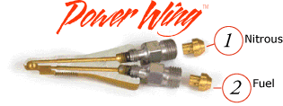

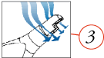
Conventional Nozzle Power Wing™ Nozzle

- Straight delivery of nitrous.
- Straight delivery of fuel.
- The aero shape of the power wing nozzle reduces the turbulence in the intake tract, leading to better atomization of fuel and nitrous to develop more power.

Nitrous injection can be done using Fogger type injector.

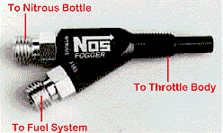
Fogger nozzle

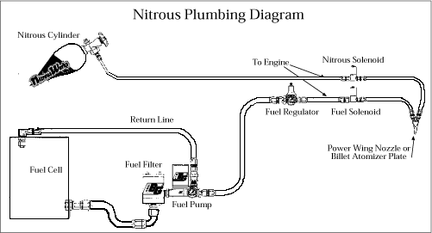

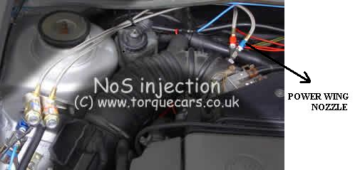

NOTE: Power wing nozzle is connected to the intake manifold.

2. The plate systems:

The carburettor-style kits feature the Billet Atomizer TM plate which differs from other plates in two ways. One, the inlet fitting is engineered to prevent the nitrous from expanding. Expansion leads to freezing and a consequent reduction in flow. Two, the fitting is designed to eliminate turbulence of the nitrous which can also reduce the rate of flow. Obviously, any loss of flow results in a subsequent loss of power. The spray bars in the Billet Atomizer(tm) plate also feature symmetrical clusters of multiple holes - designed for improved atomization.

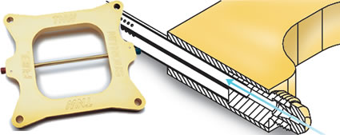

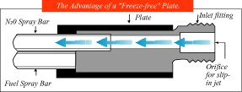

Billet Atomizer TM plate

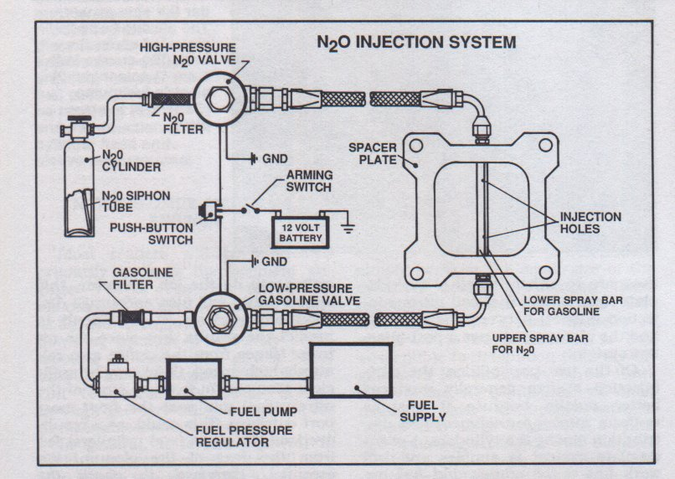
N₂O injection using Billet Atomizer TM plate

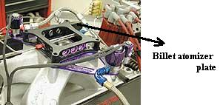

Billet atomizer is fitted at the intake port.

ADVANTAGES OF NITROGEN OXIDE SYSTEM

When comparing the costs of tuning an internal combustion engine, Nitrous oxide offers more power-per-dollar than all known alternatives. It has appreciably more than a turbocharger or blower and superior to a new set of cylinder heads or a different camshaft.

Another great advantage of installing nitrous oxide is its ability to provide instant power when it’s needed. Negotiating a high-horsepower engine through city traffic is usually not regarded as the most pleasant motoring experience.

Tuning with nitrous also provides the potential to increase power levels. By purchasing an adjustable kit, more power can be added, assuming the vehicle’s engine, transmission and driveline are up to the task. Its simply a matter of changing jets.

Installing a nitrous system is reasonably straight forward, when compared to other horsepower improving modifications. And, unlike cylinder heads and cams etc., the system can always be transferred from vehicle to vehicle.

Nitrous oxide system can be easily replaced.

LIMITATIONS OF NITROUS OXIDE SYSTEM

1. If a nitrous bottle is overheated or heated too quickly, a catastrophic explosion can occur.

2. Liquid nitrous will cause severe and permanent frostbite damage to skin.

3. Inhalation of nitrous oxide can cause suffocation and immediate death.

4. The nitrous system is designed to operate at 1100 psi and exceeding that pressure can cause the engine to become too lean and cause extensive engine damage.

5. If a stock fuel system cannot supply enough fuel to the engine, the mixture will become too lean and severe engine damage will occur.

6. Activating the nitrous oxide system may cause an explosion on engine start-up.

Conclusion

This technology has been implemented in sport vehicles. Since it has the ability to provide instant power whenever needed. Within few years the use of nitrous oxide in vehicles will be implemented in commercial vehicles also.

REFERENCE

http\www.barrygrant.com
http\www.torqecars.co.uk
http\www.Nitrous oxide - Wikipedia, the free encyclopedia.htm
http\www.Car Craft Magazine Nitrous.htm
http\www_geocities_com-MotorCity-5335-graphics-fogger_gif.htm

