ABSTRACT

An automatic transmission is a device, which changes gear ratios automatically, according to the increase or decrease in speed and load of the engine. This ensures that the engine is running at its efficient speed to deliver maximum efficiency. There are two main types of automatic transmissions, the planetary gear type and the continuously variable type. This report gives a description about the working and the components present.

INTRODUCTION

A transmission is a device that is used to provide a set of discrete angular velocity outputs from a constant velocity source. It is connected to the output of the engine and delivers the power from the engine to the drive wheels. The transmission uses gears to make more effective use of the engines torque and to keep the engine operating at an appropriate speed
An automobile engine runs at its best efficiency at a certain Revolutions Per Minute (RPM) range and it is the transmission's job to make sure that the power is delivered to the wheels while keeping the engine within that range. It does this through various gear combinations. In first gear, the engine turns much faster in relation to the drive wheels, while in high gear the engine is loafing even though the car may be travelling at higher speeds. In addition to the various forward gears, a transmission also has a neutral position which disconnects the engine from the drive wheels, and reverse, which causes the drive wheels to turn in the opposite direction allowing to reverse the direction of the car
An automatic transmission is much easier to drive than a manual transmission, because they do not have a clutch pedal or gearshift lever. An automatic transmission does the work all by itself. The first automatic transmission appeared in 1939. Automatic transmissions automatically change to higher and lower gear ratios with changes in the speed of the car and the load on the engine. These transmissions are also aware of how far down the accelerator have been pushed, and shift accordingly.
CLASSIFICATION
The Automatic transmissions are mainly classified into two types according to the type of systems used in it. They are classified as
- Automatic transmissions using planetary gears
- Continuously variable transmission(CVT)

AUTOMATIC TRANSMISSIONS using PLANETARY GEARS

The modern automatic transmission is one of the most complicated mechanical components in today's automobile. Automatic transmissions contain mechanical systems, hydraulic systems, electrical systems and computer controls, all working together in perfect harmony. This automatic transmission obtains different gear ratios using planetary gears. The main components in these systems are
- Planetary Gear Sets
- Torque Converter
- Hydraulic System
- Governor
- Computer Controls

PLANETARY GEAR SET

Automatic transmissions contain many gears in various combinations. In a manual transmission, gears slide along shafts as the shift lever is moved from one position to another, engaging various sized gears as required in order to provide the correct gear ratio. In an automatic transmission the gears are never physically moved and are always engaged to the same gears. This is accomplished through the use of planetary gear sets.
The basic planetary gear set consists of a sun gear, a ring gear and two or more planet gears, all remaining in constant mesh as shown in Fig.1 The planet gears are connected to each other through a common carrier. The carrier allows the planet gears to spin on shafts called pinions, which are attached to the carrier. Each of these three components can be the input, the output or can be held stationary. Choosing this determines the gear ratio for the gear set

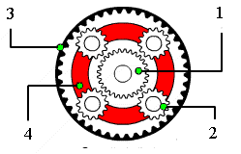
1 sun gear 2 planet gear 3 ring gear
Figure 1 Planetary gear system
Any planetary gear set has three main components:
- The sun gear
- The planet gears and the planet gears carrier
- The ring gear.
One way that this system can be used is by connecting the ring gear to the input shaft coming from the engine, connecting the planet carrier to the output shaft, and locking the sun gear so that it can't move. In this scenario, when the ring gear is turned, the planets will move along the sun gear (which is held stationary). This causes the planet carrier to turn the output shaft in the same direction as the input shaft but at a slower speed causing gear reduction (similar to a car in first gear).
If we unlock the sun gear and lock any two elements together, this will cause all three elements to turn at the same speed so that the output shaft will turn at the same rate of speed as the input shaft. This is like a car that is in third or high gear. Another way that we can use a Planetary gear set is by locking the planet carrier from moving, then applying power to the ring gear which will cause the sun gear to turn in the opposite direction giving reverse gear.
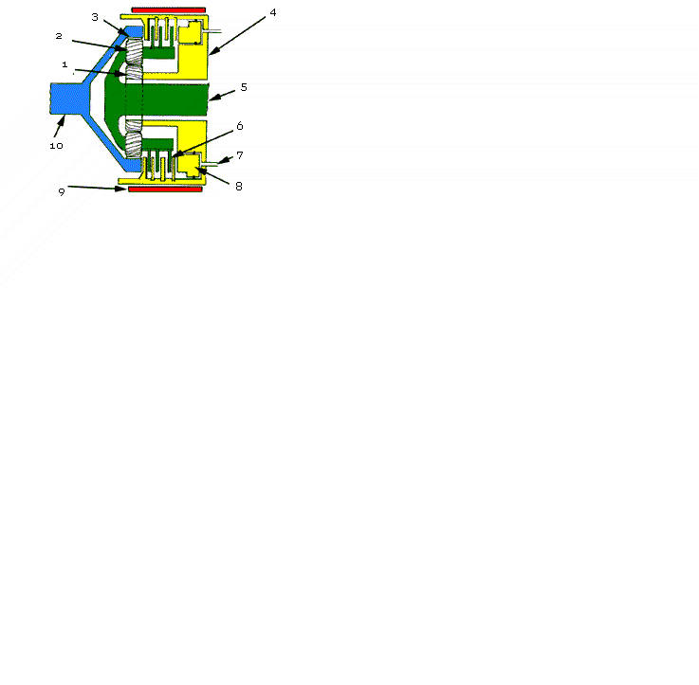
The illustration on Fig.2 shows how the simple system described above would look in an actual transmission. The input shaft is connected to the ring gear. The Output shaft is connected to the planet carrier, which is also connected to a Multi-disk clutch pack. The sun gear is connected to a drum that is also connected to the other half of the clutch pack. Surrounding the outside of the drum is a band that can be tightened around the drum when required to prevent the drum with the attached sun gear from turning. The clutch pack is used, to lock the planet carrier with the sun gear forcing both to turn at the same speed. If both the clutch pack and the band were released, the system would be in neutral. Turning the input shaft would turn the planet gears against the sun gear, but since nothing is holding the sun gear, it will spin free and have no effect on the output shaft. To place the unit in first gear, the band is applied to hold the sun gear from moving. To shift from first to high gear, the band is released and the clutch is applied causing the output shaft to turn at the same speed as the input shaft.

1. Sun gear 2. Planet gear 3. Ring gear 4. Drum connected to sun gear
5. Output shaft and planet carrier 6.Clutch pack 7. Oil line 8. Clutch piston 9. Band 10. Input shaft
Figure 2 planetary gear system (Side view)

HOW PLANETARY GEARS WORK
Each member of the planetary gear set can revolve or be held at rest. Power transfer can only take place when one of the members is held at rest or if two of the members are locked. Depending on which member is the driver, which is held, and which is driven, either a torque increase or a speed increase is produced .The different gear ratios are given below.
- First Gear
In first gear, the smaller sun gear is driven clockwise by the turbine in the torque converter. The planet carrier tries to spin counterclockwise, but it is held still by the one way clutch (which only allows rotation in the clockwise direction) and the ring gear turns the output (counterclockwise). This results in maximum gear reduction. Here the input speed is high but the output speed is low.
- Second Gear
In the second gear the input is the small sun gear; the ring gear is held stationary by the band, and the output is the planet carrier. The planetary carrier is the output in this case. This gives a reduction, but it is smaller than the first gear.
- Third Gear
Most automatic transmissions have a 1:1 ratio in third gear. This is obtained by locking any two members together. The planetary gears and the ring gears are held together. This causes everything to spin as a unit, producing a 1:1 ratio.
- Overdrive
By definition, an overdrive has a faster output speed than input speed. It's a speed increase. This is obtained by holding the ring gear and rotating the planetary gear. Here the sun gear is the output and planetary gear is the input. This results in maximum speed increase.
- Reverse
Reverse is very similar to first gear, except that instead of the small sun gear being driven by the torque converter turbine, the sun gear is held, and the carrier rotates the freewheels in the opposite direction. A reverse band holds the planet carrier to the housing
The number of teeth in each gear is selected according to the gear ratios required. Usually the ring gear is of 72 teeth and sun gear is of 30 teeth. Many more combinations are possible using two or more planetary sets connected in various ways to provide the different forward speeds and reverse that are found in modern automatic transmissions. On modern vehicles, the computer monitors controls these shifts so that they are almost imperceptible.

TORQUE CONVERTOR
On automatic transmissions, the torque converter takes the place of the clutch found on standard shift vehicles. It is there to allow the engine to continue running when the vehicle comes to a stop. The principle behind a torque converter is like taking a fan that is plugged into the wall and blowing air into another fan, which is unplugged. If the blade is grabbed on the unplugged fan, it does not turn but when it is let free it will begin to speed up until it comes close to the speed of the powered fan. The difference with a torque converter is that instead of using air, it uses oil or transmission fluid, to make it more precise.
A torque converter is a large doughnut shaped device (10" to 15" in diameter) as shown in Fig.3 that is mounted between the engine and the transmission. It consists of three internal elements that work together to transmit power to the transmission.
The three main elements of the torque converter are the Pump, the Turbine, and the Stator. The pump is mounted directly to the converter housing, which in turn is bolted directly to the engine's crankshaft and turns at engine speed. The turbine is inside the housing and is connected directly to the input shaft of the transmission, which provides power to move the vehicle. The stator is mounted to a one-way clutch, so that it can spin freely only in one direction. Each of the three elements has fins mounted in them to precisely direct the flow of oil through the converter

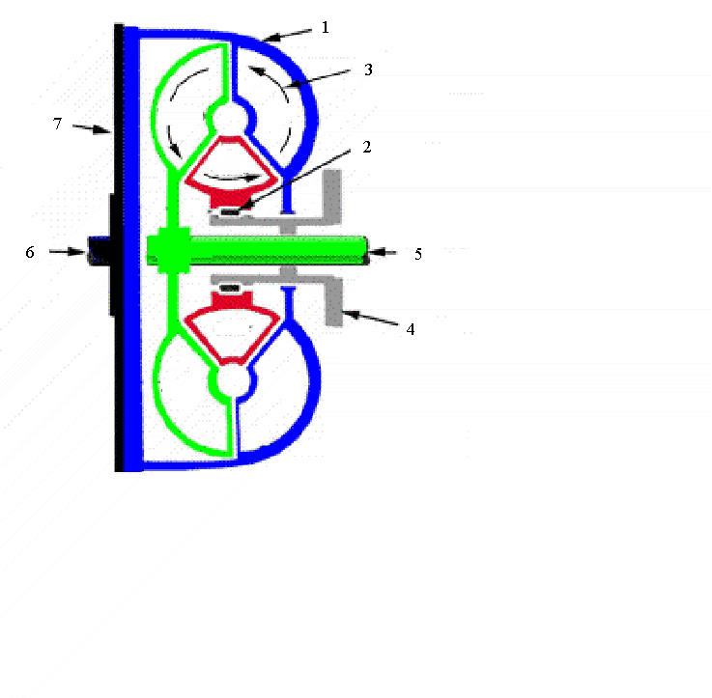
1. Turbine 2.Stator 3.Pump 4.Stator output shaft 5.Turbine output shaft
6. Housing 7.Flywheel
Figure 3 Torque converter

When the engine is running, transmission fluid is pulled into the pump section and is pushed outward by centrifugal force until it reaches the turbine section which starts it turning. The fluid continues in a circular motion back towards the center of the turbine where it enters the stator. If the turbine is moving considerably slower than the pump, the fluid will make contact with the front of the stator fins which push the stator into the one way clutch and prevent it from turning. With the stator stopped, the fluid is directed by the stator fins to re-enter the pump at an angle providing a torque increase. As the speed of the turbine catches up with the pump, the fluid starts hitting the stator blades on the backside causing the stator to turn in the same direction as the pump and turbine. As the speed increases, all three elements begin to turn at approximately the same speed.

THE HYDRAULIC SYSTEM
The Hydraulic system is a complex maze of passages and tubes that sends transmission fluid under pressure to all parts of the transmission and torque converter. The newer systems are much more complex and are combined with computerized electrical components. Transmission fluid serves a number of purposes including shift control, general lubrication and transmission cooling. Unlike the engine, which uses oil primarily for lubrication, every aspect of a transmission's functions is dependent on a constant supply of fluid under pressure. In order to keep the transmission at normal operating temperature, a portion of the fluid is sent through one of two steel tubes to a special chamber that is submerged in the radiator. Fluid passing through this chamber is cooled and then returned to the transmission through the other steel tube. A typical transmission has an average of ten quarts of fluid between the transmission, torque converter, and cooler tank. In fact, most of the components of a transmission are constantly submerged in fluid including the clutch packs and bands. The friction surfaces on these parts are designed to operate properly only when they are submerged in oil.
- Oil Pump
The transmission oil pump (not to be confused with the pump element inside the torque converter) is responsible for producing all the oil pressure that is required in the transmission. The oil pump is mounted to the front of the transmission case and is directly connected to a flange on the torque converter housing. Since the torque converter housing is directly connected to the engine crankshaft, the pump will produce pressure whenever the engine is running as long as there is a sufficient amount of transmission fluid available. The oil enters the pump through a filter that is located at the bottom of the transmission oil pan and travels up a pickup tube directly to the oil pump. The oil is then sent, under pressure to the pressure regulator, the valve body and the rest of the components, as required.
- Valve Body
The valve body is the brain of the automatic transmission. It contains a maze of channels and passages that direct hydraulic fluid to the numerous valves which then activate the appropriate clutch pack or band servo to smoothly shift to the appropriate gear for each driving situation. Each of the many valves in the valve body has a specific purpose and is named for that function.
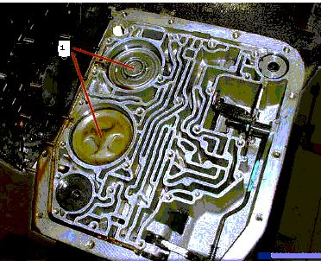
The most important valve and one that have direct control over are the manual valve. The manual valve is directly connected to the gear shift handle and covers and uncovers various passages depending on what position the gear shift is placed in. When place the gearshift in Drive, for instance, the manual valve directs fluid to the clutch pack(s) that activates 1st gear. It also sets up to monitor vehicle speed and throttle position so that it can determine the optimal time and the force for the 1 - 2 shift. On computer controlled transmissions, will also have electrical solenoids that are mounted in the valve body to direct fluid to the appropriate clutch packs or bands under computer control to more precisely control shift points.
1 Pistons

Figure 4 Valve body

Shift valves
Shift valves supply hydraulic pressure to the clutches and bands to engage each gear. The valve body of the transmission contains several shift valves. The shift valve determines when to shift from one gear to the next. For instance, the 1 to 2 shift valves determines when to shift from first to second gear. The shift valve is pressurized with fluid from the governor on one side, and the throttle valve on the other. They are supplied with fluid by the pump, and they route that fluid to one of two circuits to control, which gear the car, runs in.
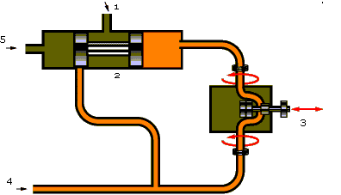
The shift valve will delay a shift if the car is accelerating quickly. If the car accelerates gently, the shift will occur at a lower speed. When the car accelerates gently, as car speed increases, the pressure from the governor builds. This forces the shift valve over until the first gear circuit is closed, and the second gear circuit opens. Since the car is accelerating at light throttle, the throttle valve does not apply much pressure against the shift valve. When the car accelerates quickly, the throttle valve applies more pressure against the shift valve. This means that the pressure from the governor has to be higher (and therefore the vehicle speed has to be faster) before the shift valve moves over far enough to engage second gear.

1. Fluid to clutches and bands 2.Shift valve 3.Governor 4.Fluid from pump 5.Throttle pressure
Figure 5 The shift circuit
- Bands
A band is a steel strap with friction material bonded to the inside surface. One end of the band is anchored against the transmission case while the other end is connected to a servo. At the appropriate time hydraulic oil is sent to the servo under pressure to tighten the band around the drum to stop it from turning.
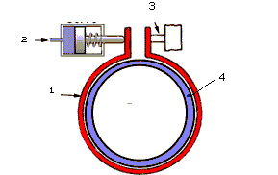
1 band 2 oil 3 anchor 4 drum
Figure 6 Band

GOVERNER
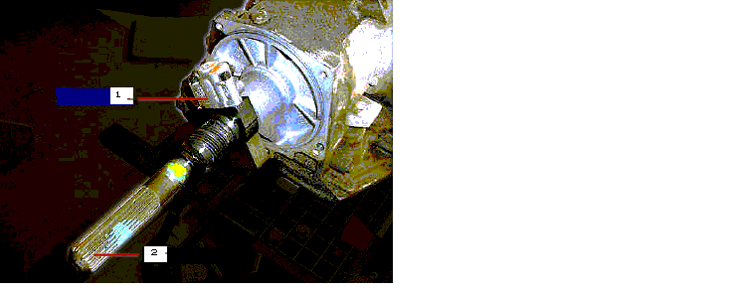
The governor provides the inputs that tell the transmission when to shift. The governor is connected to the output shaft and regulates hydraulic pressure based on vehicle speed. It accomplishes this using centrifugal force to spin a pair of hinged weights against pullback springs. As the weights pull further out against the springs, more oil pressure is allowed past the governor to act on the shift valves that are in the valve body which then

1 Governor 2 Output shaft

Figure 7 Governor
Signal the appropriate shifts. Of course, vehicle speed is not the only thing that controls when a transmission should shift, the load that the engine is under is also important. The more load place on the engine, the longer the transmission will hold a gear before shifting to the next one.
There are two types of devices that serve the purpose of monitoring the engine load: the Throttle Cable and the Vacuum Modulator. A transmission will use one or the other of these devices. Each works in a different way to monitor engine load.
The Throttle Cable simply monitors the position of the gas pedal through a cable that runs from the gas pedal to the throttle valve in the valve body. The Vacuum Modulator monitors engine vacuum by a rubber vacuum hose, which is connected to the engine. Engine vacuum reacts very accurately to engine load with high vacuum produced when the engine is under light load and diminishing down to zero vacuum when the engine is under a heavy load. The modulator is attached to the outside of the transmission case and has a shaft, which passes through the case and attaches to the throttle valve in the valve body. When an engine is under a light load or no load, high vacuum acts on the modulator, which moves the throttle, valve in one direction to allow the transmission to shift early and soft. As the engine load increases, vacuum is diminished which moves the valve in the other direction causing the transmission to shift later and more firmly

COMPUTER CONTROLLS
The computer uses sensors on the engine and transmission to detect such things as throttle position, vehicle speed, engine speed, engine load, stop light switch position, etc. to control exact shift points as well as how soft or firm the shift should be. Some computerized transmissions even learn driving style by using special programs and constantly adapt to it so that every shift is timed precisely when would need it.
Because of computer controls, sports models are coming out with the ability to take manual control of the transmission, allowing the driver to select gears manually. This is accomplished on some cars by passing the shift lever through a special gate, then tapping it in one direction or the other in order to up-shift or downshift at will. The computer monitors this activity to make sure that the driver does not select a gear that could over speed the engine and damage it. Using this information and an advanced control strategy based on fuzzy logic, a method of programming control systems using human-type reasoning, electronically controlled transmissions can do things like:
- Downshift automatically when going downhill, to control speed and reduce wear on the brakes.
- Up shift when braking on a slippery surface to reduce the braking torque applied by the engine.
- Inhibit the Upshift when going into a turn on a winding road.
Another advantage to these computerized transmissions is that they have a self diagnostic mode which can detect a problem early on and warn with an indicator light on the dash. A technician can then plug test equipment in and retrieve a list of trouble codes that will help pinpoint where the problem is.

Continuously Variable Transmission (CVT)

The CVT or the Continuous Variable Transmission is an ideal design, it varies the transmission ratio continuously so that it is an automatic transmission with infinite no of gear ratios. As the result, at any time the most suitable ratio can be chosen so that performance and energy efficiency are both optimized.
The CVT can be classified into two main types

The CVT using belts
- The CVT using Double-Idler Assembly

CVT using belts
This type of CVT consists of a driving belt running between two pulleys, one connect to the engine output and one to the drive shaft (fig 8).
Each pulley comprises of two pieces of disc, with slope surface. When the discs are positioned far away from each other, the belt runs in an orbit with relatively small diameter that is equal to a small gear of a conventional gearbox. When the discs are pushed towards together, the belt is pushed outside and runs in an orbit of large diameter, which equals to a big gear. As a result, pushing or easing the discs can vary the transmission ratio. When one pulley is varied, the other pulley must adapt itself inversely since the length of the belt is fixed. This also multiplies the change of transmission ratio

Steel belts
As the belt is the highly stressed member, it must be very strong and grip very well on the pulleys But CVT using belts cannot be used for heavy applications, because of the belt used. The belt usually fails at higher loads and torque. Modern CVTs use a steel V-section belt. How much torque the CVT withstand depends on the design of belt. It is almost as flexible as the V-section belt but much stronger. Therefore it can handle high torque.
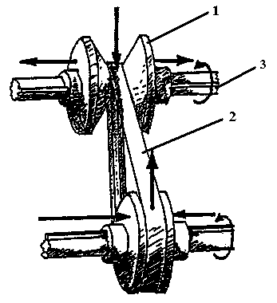
This belt consists of hundreds of transverse metal plates and longitude metal tapes. The transverse ones are used to grip the pulley, the longitude ones hold the transverse plates and deal with strain.
1. Cone 2.Belt 3.Shaft
Figure 8 Continuous Variable Transmission

CVT USING DOUBLE-IDLER ASSEMBLY

CVTs using belts had a problem in delivering the required torque since excessive amounts have caused the belts to fail. To address this problem CVT using double idler is effective which was not based on a belt system. This design is more versatile and safer to use. The double idler consists of two polyurethane rubber wheels positioned at 90 degrees to one another and connected by a pair of mitre gears. This assembly results in a 1:1 angular velocity ratio between the input and output wheels. Depending upon the orientation of this assembly, the aforementioned velocity ratios between the cones may be achieved.
The double idler is set upon a carriage that is held in place between the torque conversion cones by a means of a pivot at the center of the described circle. The idler assembly can also be adjusted along the plane of the carriage such that the wheels are always in contact with the cones. This is achieved by tightening a spring against the housing of the double idler. To obtain the desired output ratio, the idler is oriented by a speed control mounted on the main housing. This design consists of three components: the torque conversion cones, the double-idler assembly, and the main housing.
- Torque Conversion Cones
The concept of the CVT design is based upon two aluminum cones which, when placed together, form a semicircular profile and produce the required angular velocity ratios, due to their varied surface diameter. They are mounted on steel rods and supported by both radial and thrust bearings.
- double idler
The double idler consists of two polyurethane rubber wheels positioned at 90 degrees to one another and connected by a pair of mitre gears. This assembly results in a 1:1 angular velocity ratio between the input and output wheels
- Main housing
The main housing encases the double idler assembly and torque conversion cones in a small and easily mountable envelope.

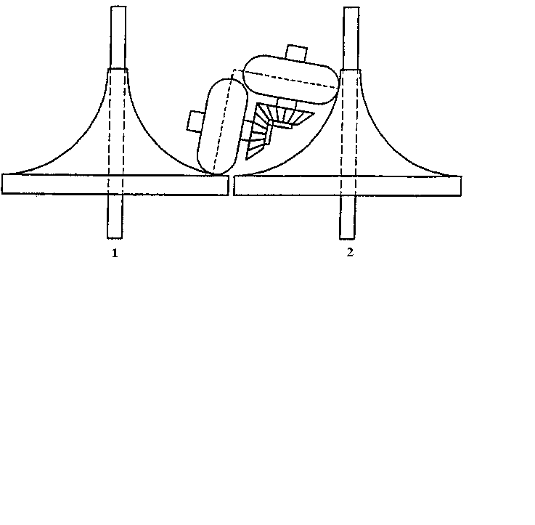
1. Output shaft 2.Input shaft
Figure.10 Double idler assembly

ADVANTAGES

- Smooth and quiet shifting
- Ease of use due to the absence of gear lever and clutch
A computerized automatic transmission has different shifting programs for different requirements For instance, if you select Sport mode, the gearbox up shift at higher engine speed to make better use of power band hence enhances acceleration. On the contrary, choosing Economy mode will ease the pressure to the engine, thus enhance smoothness, quietness and save fuel.

Disadvantages

- Because it employs a lot of planetary gears and clutches inside, it is considerably heavier and several folds more expensive then manual gearbox.
- The use of torque converter instead of clutch makes them less responsive than manual gearbox, moreover, they used to offer one less ratio, thus offer poorer acceleration and consume slightly more fuel.

CONCLUSION

Automatic transmissions contain mechanical systems, hydraulic systems, electrical systems and computer controls, all working together in perfect harmony

REFERENCES

- A short course on Automatic Transmission By Charles Ofria
- www. All World Knowledge.Com
- www. Insight Central. Net
- www. How Stuff Work.Com

