AIR CAR

Abstract

The Air car is a car currently being developed and, eventually, manufactured by Moteur Developpement International (MDI), founded by the French inventor Guy Nègre. It will be sold by this company too, as well as by ZevCat, a US company, based in California.
The air car is powered by an air engine, specifically tailored for the car. The used air engine is being manufactured by CQFD Air solution, a company closely linked to MDI.
The engine is powered by compressed air, stored in a glass or carbon-fibre tank at 4500 psi. The engine has injection similar to normal engines, but uses special crankshafts and pistons, which remain at top dead center for about 70% of the engine's cycle; this allows more power to be developed in the engine.
Though some consider the car to be pollution-free, it must be taken into account that the tanks are recharged using electric (or gasoline) compressors, resulting in some pollution, if the electricity used to operate the compressors comes from polluting power plants (such as gas-, or coal-power plants). Solar power could possibly be used to power the compressors at fuel station.

References
- Kevin Bonsor (2005-10-25). How Air-Powered Cars Will Work. HowStuffWorks. Retrieved on 2006-05-25.
- Robyn Curnow (2004-01-11). Gone with the wind. The Sunday Times (UK). Retrieved on 2006-05-25.

AIR CAR

1.Introduction

An Air Car is a car that can run on compressed air alone without the use of conventional fuels used in present day automobiles. The car is powered by an air engine. The air engine is an emission-free piston engine using compressed air. The engines are similar to steam engines as they use the expansion of externally supplied pressurised gas to perform work against a piston.
For practical application to transportation, several technical problems must be first addressed:
- As the pressurised air expands, it is cooled, which limits the efficiency. This cooling reduces the amount of energy that can be recovered by expansion, so practical engines apply ambient heat to increase the expansion available.
- Conversely, the compression of the air by pumps (to pressurise the tanks) will heat the air. If this heat is not recovered it represents a further loss of energy and so reduces efficiency.
- Storage of air at high pressure requires strong containers, which if not made of exotic materials will be heavy, reducing vehicle efficiency, while exotic materials (such as carbon fibre composites) tend to be expensive.
- Energy recovery in a vehicle during braking by compressing air also generates heat, which must be conserved for efficiency.
- It should be noted that the air engine is not truly emission-free, since the power to compress the air initially usually involves emissions at the point of generation.
This most recent development using pressurized air as fuel in an engine was invented by Guy Nègre, a French engineer. In 1991 the inventor Guy Nègre started up Moteur Developpement International (MDI), Luxembourg and invented a dual-energy engine running on both compressed air as on regular fuel. From this moment on he managed to create a compressed air only-engine, and improved his design to make it more powerful. In the 15 years he's been working on this engine, considerable progress has been made: the engine is now claimed to be competitive with modern ICEs. It is probably still not as powerful as an ICE (although depending on which model of air engine vs model ICE). Proponents claim that this is of little importance since the car can simply be made lighter, or the tanks be put on a higher pressure (psi-level), pushing the engine to above a comparable ICE- engine.
Other people that have been working on the idea are Armando Regusci and Angelo Di Pietro. They too have companies, Rugusci started up Regusci Air and Di Pietro started up Engine Air. They are selling their engines.

2.Engine Design
It uses the expansion of compressed air to drive the pistons in a modified piston engine. Efficiency of operation is gained through the use of environmental heat at normal temperature to warm the otherwise cold expanded air from the storage tank. This non-adiabatic expansion has the potential to greatly increase the efficiency of the machine. The only exhaust gas is cold air (−15 °C), which may also be used for air conditioning in a car. The source for air is a pressurized glass or carbon-fiber tank holding air at around 3,000 lbf/in² (20 MPa). Air is delivered to the engine via a rather conventional injection system. Unique crank design within the engine increases the time during which the air charge is warmed from ambient sources and a two stage process allows improved heat transfer rates.
The Armando Regusci's version of the air engine has several advantages over the original Guy Nègre's one. In the initial Guy Nègre's air engine, one piston compresses air from the atmosphere, holding it on a small container that feeds the high pressure air tanks with a small amount of air. Then that portion of the air is sent to the second piston where it works. During compression for heating it up, there is a loss of energy due to the fact that it cannot receive energy from the atmosphere as the atmosphere is less warm than it. Also, it has to expand as it has the crank. The Guy Nègre's air engine works with constant torque, and the only way to change the torque to the wheels is to use a pulley transmission of constant variation, losing efficiency. In the Regusci's version, the transmission system is direct to the wheel, and has variable torque from zero to the maximum with all the efficiency. When vehicle is stopped, Guy Nègre's engine has to be on and working, losing energy, while the Regusci's version has not.
In July 2004, Guy Nègre abandoned his original design, and showed later a new design where he stated to have it invented back in year 2001, but his new design is identical to the Armando Regusci's air engine which was patented back in 1989 (Uruguay) with the patent number 22976, and back in 1990 (Argentina). In those same patents, it is mentioned the use of electrical motors to compress air in the tanks.

3.Uses of air engine
The Nègre engine is used to power an urban car with room for five passengers and a projected range of about 100 to 200 miles (160 to 320 km), depending on traffic conditions. The main advantages are: no roadside emissions, low cost technology, engine uses food oil for lubrication (just about 1 liter, changes only every 30,000 miles (50,000 km)) and integrated air conditioning. Range could be quickly tripled, since there are already carbon fiber tanks which have passed safety standards holding gas at 10,000 lbf/in² (70 MPa).

The tanks may be refilled in about three minutes at a service station, or in a few hours at home plugging the car into the electric grid via an on-board compressor. However, the air engine and refueling system, considered as a system, are not pollution free except in special cases, as the electric power generation would have its own environmental costs. One of the special cases is where an operator of such a vehicle installs photovoltaic or wind drive electric power generation.
4.MDI CAT’s (Compressed air technology cars)
MDI prepares to introduce compressed air vehicles to the market. MDI has developed a high performance compressed air technology. When it is compared to traditional gasoline powered engines, MDI´s engine is far superior in terms of energy used and thermodynamics.
An overview of the air car
The technology that MDI vehicles use is not new, in fact it had been around for years. Compressed air technology allows for engines that are both non polluting and economical. After ten years of research and development, MDI is prepared to introduce its clean vehicles onto the market. Unlike electric or hydrogen powered vehicles, MDI vehicles are not expensive and do not have a limited driving range. MDI cars are affordable and have a performance rate that stands up to current standards. To sum it up, they are non-expensive cars that do not pollute and are easy to get around cities in.
Two technologies have been developed to meet different needs:
Single energy compressed air engines
Dual energy compressed air plus fuel engines
The single energy engines will be available in both Minicats and Citycats. These engines have been conceived for city use, where the maximum speed is 50 km/h and where MDI believes polluting will soon be prohibited.

The dual energy engine, on the other hand, has been conceived as much for the city as the open road and will be available in all MDI vehicles. The engines will work exclusively with compressed air while it is running under 50 km/h in urban areas. But when the car is used outside urban areas at speeds over 50 km/h, the engines will switch to fuel mode. The engine will be able to use gasoline, gas oil, bio diesel, gas, liquidized gas, ecological fuel, alcohol, etc.

Both engines will be available with 2, 4 and 6 cylinders, When the air tanks are empty the driver will be able to switch to fuel mode by using the car’s on board computer. The vehicles do not have normal speed gauges. Instead, they will have a small computer screen that shows the speed and engine revolutions. The system allows for infinite possibilities such as GSM telephone systems, GPS satellite tracking systems, programs for delivery people, emergency systems, internet connections, voice recognitions, map presentation, traffic information... in three words: the future is now.

Unlike the majority of traditional cars on the market, MDI´s vehicle's have fibre glass bodies which makes them light, silent urban car. The car's body is tubular, light weight, and is held together using aerospace technology.

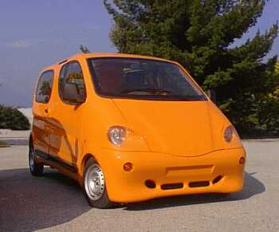
Fig 1. An MDI CAT car

Regarding security, the seatbelt system is different from what we know. One part of the belt is anchored to the floor of the car, like traditional cars. The other part of the belt, in stead of being attached to the side of the car, is also anchored to the floor of the vehicle. This helps to secure the bodies of the driver and passengers in the case of a collision.

MDI is also considering a system to replace traditional keys. This system would utilize an access card. With this card it would be possible to open the car from a short distance away without having to actually insert anything in the car.

In the single energy mode MDI cars consume less than one euro every 100Km. (around 0.75 Euros) that is to say, 10 time less than gasoline powered cars.

When there is no combustion, there is no pollution. The vehicle's driving range is close to twice that of the most advanced electric cars (from 200 to 300 km or 8 hours of circulation) This is exactly what the urban market needs where, as previously mentioned, 80% of the drivers move less than 60Km. a day.

The recharging of the car will be done at gas stations, once the market is developed. To fill the tanks it will take about to 2 to 3 minutes at a price of 1.5 euros. After refilling the car will be ready to drive 200 kilometres.

The car also has a small compressor that can be connected to an electrical network (220V or 380V) and will recharge the tanks completely in 3 or 4 minutes.

Because the engine does not burn any fuel the car's oil(a litre of vegetable) only needs to be changed every 50,000Km. The temperature of the clean air expulsed form the exhaust pipe is between 0 and 15 degrees below zero and can be subsequently channelled and used for air conditioning in the interior of the car.

5.The Basic Principle of the CAT’s 34 Engine

The CAT’s 34 Engine is a 4-cylinder engine which will be used in cars in serial production.

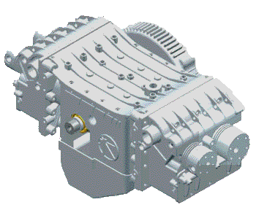
Fig 2.CAT’s 34 Engine

This engine was developed between the end of 2001 and the beginning of 2002. It uses an innovative system to control the movement of the 2nd generation pistons and one single crankshaft. The pistons work in two stages: one motor stage and one intermediate stage of compression/expansion.

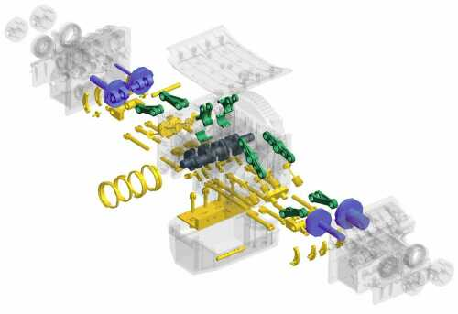
Fig 3. Detailed view of the MDI engine
The engine has 4 two-stage pistons, i.e. 8 compression and/or expansion chambers. They have two functions: to compress ambient air and refill the storage tanks; and to make successive expansions (reheating air with ambient thermal energy) thereby approaching isothermic expansion.
Its steering-wheel is equipped with a 5kW electric moto-alternator. This motor is simultaneously:
the motor to compress air, the starting motor, the alternator for recharging the battery
an electric moderator/brake, a temporary power supply (e.g. for parking) .

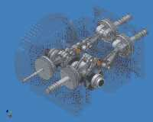
Fig 4. 3D view of the engine interior

No clutch is necessary. The engine is idle when the car is stationary and the vehicle is started by the magnetic plate which re-engages the compressed air. Parking manoeuvres are powered by the electric motor.

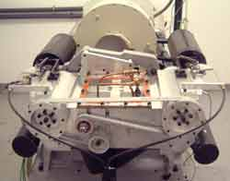
Fig 5. The engine which will be fitted in the MDI cars in serial production.
Articulated con-rod

The MDI con-rod system allows the piston to be held at Top Dead Centre for 70% of the cycle. This way, enough time is given to create the pressure in the cylinder. The torque is also better so the force exerted on the crankshaft is less substantial than in a classic system.

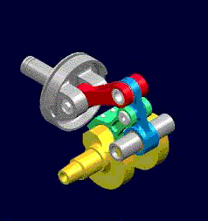
Fig 6. Articulated con-rod

Gear box
Gear changes are automatic, powered by an electronic system developed by MDI. A computer which controls the speed of the car is effectively continuously changing gears . The latest of many previous versions, this gearbox achieves the objective of seamless changes and mimimal energy consumption.

Moto-alternator
The moto-alternator connects the engine to the gearbox. It has many functions:
- It supports the CAT´s motor to allow the tanks to be refilled.
- As an alternator it produces brake power.
- It starts the vehicle and provides extra power when necessary.

Distribution and valves
To ensure smooth running and to opitimize energy efficiency, the engines use a simple electromagnetic distribution system which controls the flow of air into the engine. This system runs on very little energy and alters neither the valve phase nor its rise.
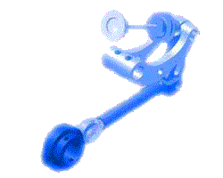
Fig 7. Distribution valve
6.The Air car's technical details
a) Compressed air tanks
The compressed air tank is a glass or carbon-fibre tank. These tanks hold 90 cubic metres of air compressed to 300 bars. This system is not dangerous in case of an accident as there is no risk of operation. Because these are the same tanks used to carry the liquid gas used by buses for public transport. The tanks enjoy the same technology developed to contain natural gas. They are designed and officially approved to carry an explosive product: methane gas.
In the case of a major accident, where the tanks are ruptured, they would not explode since they are not metal. Instead they would crack, as they are made of carbon fibre. An elongated crack would appear in the tank, without exploding, and the air would simply escape, producing a loud but harmless noise. Of course, since this technology is licensed to transport an inflammable and explosive gas (Natural gas), it is perfectly capable inoffensive and non-flammable air.
The tanks in CATs vehicles are composed of an interior thermoplastic container which ensures it is airtight. This is held in a coiled and crossed carbon fibre shell. This technique is the result of many studies into factors such as: mechanical specifications, density of material, choice of fibres etc. The conditions of use are maximum effective pressure (300 bar) and the temperature of use: from –40°C to 60°C.
The tanks are submitted to numerous tests to meet official approval, among which are:
. Airtight testing
. Pressure testing (1.5×300=405 b)
. Rupture testing (2.35×300=705 b)
. Cycles at ambient and extreme temperatures
. Fire-resistance testing
. Resistance to cuts
. Shock and fall testing
During rupture testing, the tank cracks, but does not break up, producing no splinters or fragments. In the event of a cracked tank, it is most likely to occur within the cylinder itself.

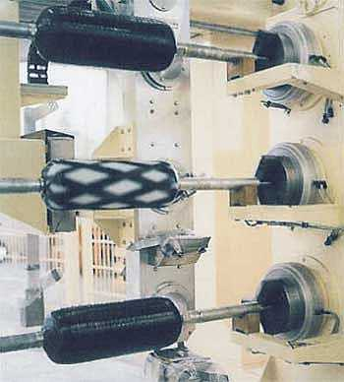
Fig 8.Special machines making the tubular shell
The tanks used in the CAT´s vehicles should last for a period of fifteen years, to be tested every five years and are subject to wear and tear according to conditions of use. The tanks weigh 35 - 40 kg for 100 litres of air at 300 bars. In the MiniCat´s the tanks weigh 70 - 80 kg. For extra security, a protective plate is fixed underneath the vehicle´s chassis and in addition limits access to the circuit of high pressure air. There is also an extraction system to deal with water produced by condensation.
b) Brake power recovery
The MDI vehicles will be equipped with a range of modern systems. For example, one mechanism stops the engine when the car is stationary (at traffic lights, junctions etc). Another interesting feature is the pneumatic system which recovers about 13% of the power used.
c) The body
The MDI car body is built with fibre and injected foam, as are most of the cars on the market today. This technology has two main advantages: cost and weight. Nowadays the use of sheet steel for car bodies is only because of cost - it is cheaper to serially produce sheet steel bodies than fibre ones. However, fibre is safer (it doesn´t cut like steel), is
easier to repair (it is glued), doesn´t rust etc. MDI is currently looking into using hemp fibre to replace fibre-glass, and natural varnishes, to produce 100% non-contaminating bodywork.
d) The Air Filter
The MDI engine works with both air taken from the atmosphere and air pre-compressed in tanks. Air is compressed by the on-board compressor or at service stations equipped with a high-pressure compressor.
Before compression, the air must be filtered to get rid of any impurities that could damage the engine. Carbon filters are used to eliminate dirt, dust, humidity and other particles which, unfortunately, are found in the air in our cities.
This represents a true revolution in automobiles - it is the first time that a car has produced minus pollution, i.e. it eliminates and reduces existing pollution rather than emitting dirt and harmful gases. The exhaust pipe on the MDI cars produces clean air, which is cold on exit (between -15º and 0º) and is harmless to human life. With this system the air that comes out of the car is cleaner than the air that went in.
e) The Chassis
Based on its experience in aeronautics, MDI has put together highly-resistant, yet light, chassis, aluminium rods glued together. Using rods enables to build a more shock-resistant chassis than regular chassis. Additionally, the rods are glued in the same way as aircraft, allowing quick assembly and a more secure join than with welding. This system helps to reduce manufacture time.
f) Electrical system
Guy Nègre, inventor of the MDI Air Car, acquired the patent for an interesting invention for installing electrics in a vehicle. Using a radio transmission system, each electrical component receives signals with a microcontroller. Thus only one cable is needed for the whole car. So, instead of wiring each component (headlights, dashboard lights, lights inside the car, etc), one cable connects all electrical parts in the car. The most obvious advantages are the ease of installation and repair and the removal of the approximately 22 kg of wires no longer necessary. Whats more, the entire system becomes an anti-theft alarm as soon as the key is removed from the car.

7. Models

a)Family

A spacious car with seats which can face different directions. The vehicle´s design is based on the needs of a typical family.
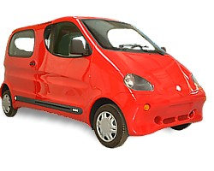
Characteristics: Airbag, air conditioning, 6 seats.

Dimensions: | 3.84m, 1.72m, 1.75m
Weight: | 750 kg
Maximum speed: | 110 km/h
Mileage: | 200 - 300 km
Max load: | 500 Kg
Recharge time: | 4 hours (Mains connector)
Recharge time: | 3 minutes (Air station)

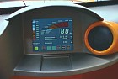
Detail of the on-board computer.

b)Van

Designed for daily use in industrial, urban or rural environments, whose primary drivers would be tradesmen, farmers and delivery drivers.

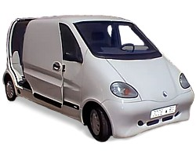
Specifications: Airbag, air conditioning, ABS, 2 seats, 1.5 m3.

Dimensions: | 3.84m, 1.72m, 1.75m
Weight: | 750 kg
Maximum speed: | 110 km/h
Mileage: | 200 - 300 km
Maximum load: | 500 Kg
Recharging time: | 4 hours (Mains connector)
Recharging time: | 3 minutes (Air station)

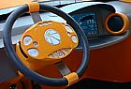
Detail of steering wheel.

c)Taxi

Inspired by the London Taxi, with numerous ergonomic and comfort advantages for the passenger as well as for the driver.

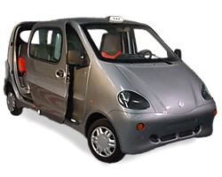
Specifications: Airbag, air conditioning, 6 seats.

Dimensions: | 3.84m, 1.72m, 1.75m
Weight: | 750 kg
Maximum speed: | 110 km/h
Mileage: | 200 - 300 km
Maximum load: | 500 Kg
Recharging time: | 4 hours (Mains connector)
Recharging time: | 3 minutes (Air station)

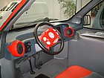
Detail of the driver´s seat.

d)Pick-Up

The "pleasure" car: designed for excursions, outdoor sports or water sports. Also suitable for tradesmen and small businesses.

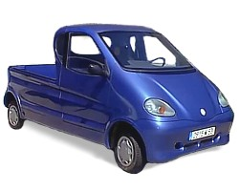
Specifications: Airbag, air conditioning, 2 seats.

Dimensions: | 3.84m, 1.72m, 1.75m
Weight: | 750 kg
Maximum speed: | 110 km/h
Mileage: | 200 - 300 km
Maximum load: | 500 Kg
Recharging time: | 4 hours (Mains connector)
Recharging time: | 3 minutes (Air station)

e)Mini Cat’s

The smallest and most innovative: three seats, minimal dimensions with the boot of a saloon: a great challenge for such a small car which runs on compressed air. The Minicat is the city car of the future.

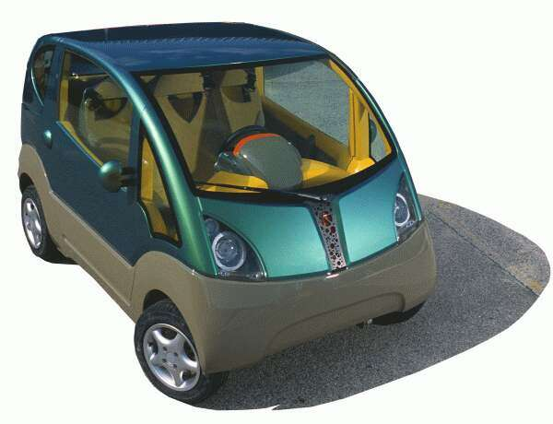
Specifications: Airbag, air conditioning, ABS, 3 seats, 1.5 m3.

Dimensions: | 2.65m, 1.62m, 1.64m
Weight: | 750 kg
Maximum speed: | 110 km/h
Mileage: | 200 - 300 km
Maximum load: | 270 Kg
Recharging time: | 4 hours (Mains connector)
Recharging time: | 3 minutes (Air station)

8. Commercialization

As soon as the MDI engines and vehicles are commercially viable (within 1-3
years, depending on the version) they will have a market, with very limited
competition, if any, for an estimated period of 10-15 years.
The commercial strategy is currently concentrated on the urban markets, with
products including taxis, delivery vans and pickup trucks.

Based on a new concept of local vehicle production and sales, MDI promote
regional manufacturing license rights in the form of franchised turnkey factory
systems. Such a turnkey factory will have a normal production capacity of
2000-4000 vehicles per year and will employ some 130 people. A model factory is
being constructed in Brignoles, France.

A taxi called "TOP" (Taxi ZerO Pollution) and pickups truck, were built. In May
1998, the first road tests of these prototypes were done in Brignoles, France.
A great interest in the zero pollution concept has been expressed by the news
media. Since May 1998, the taxi "TOP" has been the subject of more than 40
television programs and several newspaper and magazine articles around the
world.

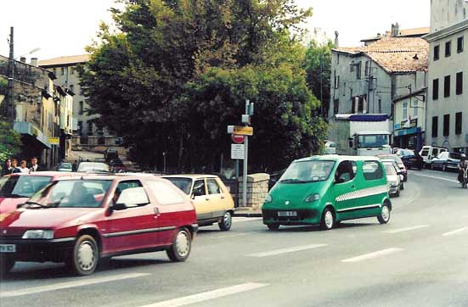
Fig 9. On-road trials of the MDI taxi

To manage the development process successfully, MDI has contracted its product
research and development activities to CQFD Air Solution, a company based in
Brignoles, France. Here, under the direction of Guy Negre, some 30 engineers and
technicians have at their disposal the most modern equipment for engine
and vehicle development, testing and production, supported by the latest in
information technology.

The company says the cars will initially go on sale in France, where the first assembly line is due to start production in the middle of next year.

The MiniCATS three-seater compact, a commercial version of a prototype showcased at the 2002 Paris Motor Show, will be priced at $9,850. The CityCATS six-seater sedan will retail for $16,000.

9.Conclusion

The air car which is the result of a long research and development is a clean, easy to drive, high performance car. MDI has achieved what the large car manufactures have promised in a hundred years time.

The end product is a light weight vehicle that can reach speeds up to 220 km/h (even though the legal limit is 120), a product that does not pollute like twentieth century vehicles and does not take a lifetime to pay off. Essentially, MDI has developed a modern, clean, and cheap car that meets most people’s needs.
The principle advantages for an air powered vehicle are:
- Fast recharge time
- Long storage lifetime (electric vehicle batteries have a limited useful number of cycles, and sometimes a limited calendar lifetime, irrespective of use).
- Potentially lower initial cost than battery electric vehicles when mass produced.

