Introduction
If the water level in a borewell drops below the threshold level for pumping, its pump motor may get air-locked or even burn out due to dry running. It is inconvenient for farmers to walk all the way to their fields at night just to switch the pump motor ’off’. Besides, he may never get to know the problem.
This problem can be solved by using this GSM-based system that will automatically give the user a call on his mobile phone when the water level in the borewell drops below or rises to the threshold level for pumping.
The user can also remotely switch on or switch off the pump motor by sending an SMS from his mobile phone. The system is simple, reliable, portable and affordable.
Circuit diagram
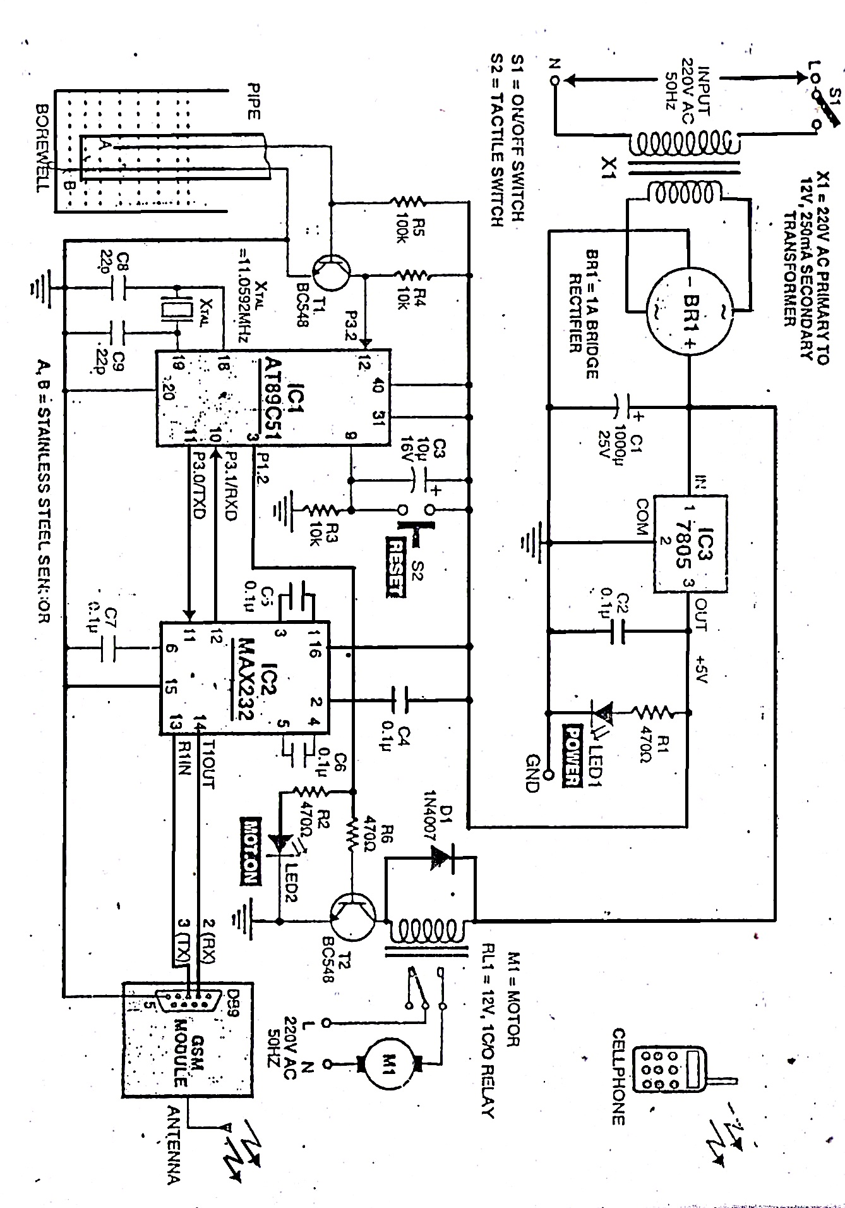
PCB Layout & Schematic
Schematic:

Layouts:
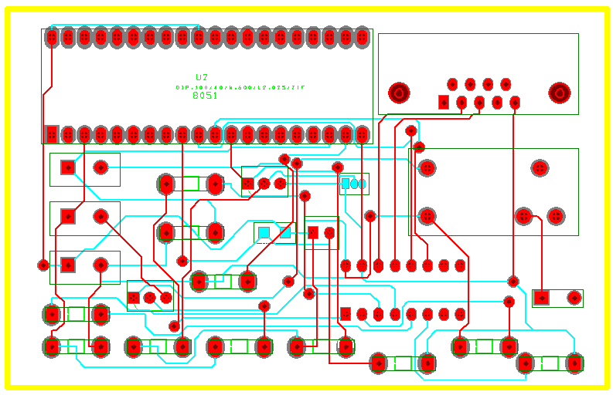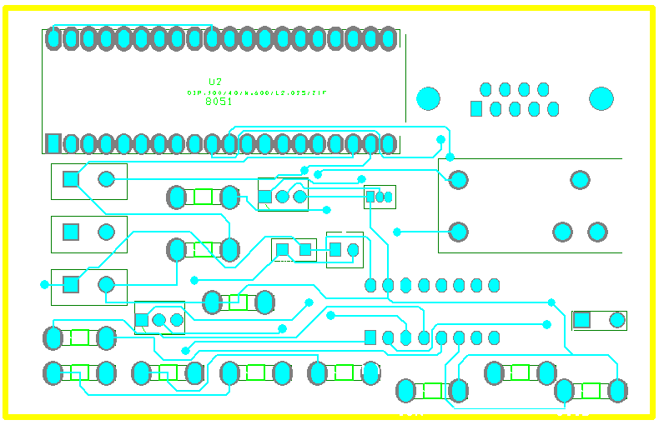
- Global Layer (b) Top Layer

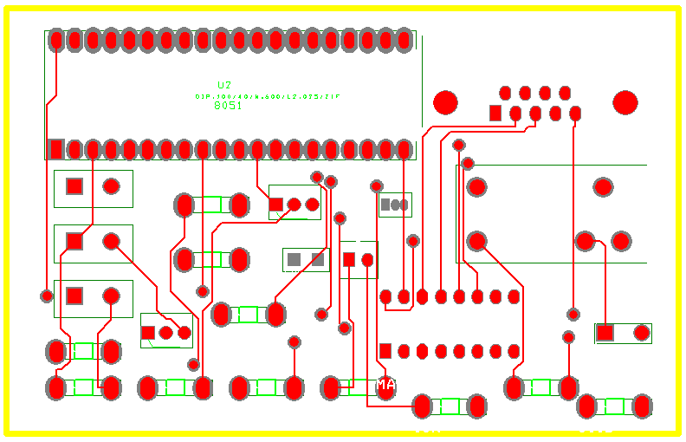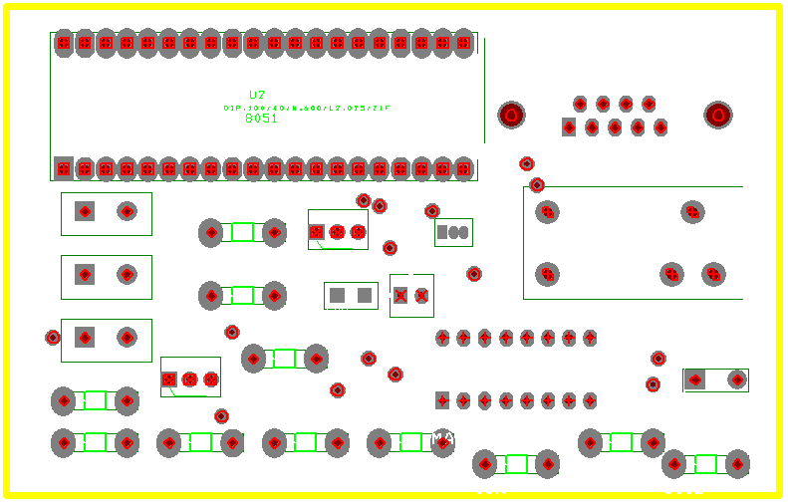
(c) Bottom Layer (d) Drill Layer

Circuit Description & Working

GSM-based monitor is shown in block diagram. It comprises the power supply section, sensor circuit, microcontroller, MAX232 driver, relay driver & GSM-modem. The GSM board has a valid SIM card with sufficient recharge amount to make outgoing calls.
The circuit is powered by regulated 5V DC. The 220V/AC mains are stepped down by transformer X1 to deliver a secondary output of 12V, 250mA. The transformer output is rectified by bridge rectifier BR1, filtered by capacitor C1 and regulated by IC-7805. Capacitor C2 bypasses ripples from the regulated power supply. LED1 acts as the power-‘on’ indicator.
The AT89C51 microcontroller is connected to the sensor circuit, relay driver and MAX232. The microcontroller is programmed to take necessary actions. The mobile number used in the GSM-modem is included in the code before burning the code into the microcontroller.
The sensor circuit comprises transistor T1 as sensor driver and sensor-A is dipped to the threshold point for pumping and sensor-B is dipped below the pipe to the bottom of the device.
When water in the borewell fills to the threshold level, it is sensed by sensor-A and you get a call on your mobile phone. Now you can turn the motor ‘on’ by sending the SMS “motor11 on” from your mobile phone to the SIM number in the GSM-modem. We can turn motor ‘off’ by sending the “motor11 off”.
Sensor-A is connected to the base of transistor t1 (BC548). When there is a high voltage at the base, T1 conducts and a low voltage is available at its collector. This low signal is fed to pin 12 of the MCU. Similarly, for a low voltage input at the base T1 stops conducting and a high voltage signal is available at its collector. So pin 12 of the MCU gets a high signal input. The high or low voltage signal at pin 12 is monitored and processed by the program in the MCU, and decision to turn the monitor ‘off’ taken when the water level dips below sensor-A.
Pin 3(port p1.2) of the MCU is the output pin. It is connected to relay-driver and LED2. T2 driver-relay RL1, witch, in turn, activates the motor transistor T2 and LED2 is on to indicate the motor is on status.
When water level in the borewell dips below sensors A and B breaks. Hence a signal is received by the microcontroller. The microcontroller turns the running motor ‘off’ and makes a call to the user’s cellphone through GSM-modem to indicate that sensing is not connected to on the relay is switched off in this way the device is protected from damage the status of motor level and LED2 are shown in table1. The GSM-modem used in this project is SIM300/V7.03.

Photographs of Hardware Circuitry
- RS232 Cable
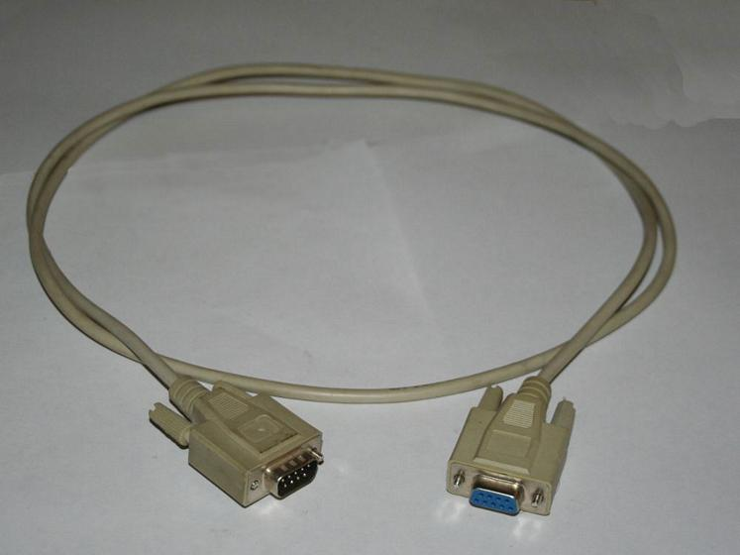

- Microcontroller P89V51RD2
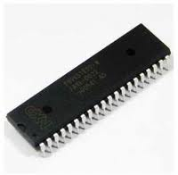

- Microcontroller Board for 8051

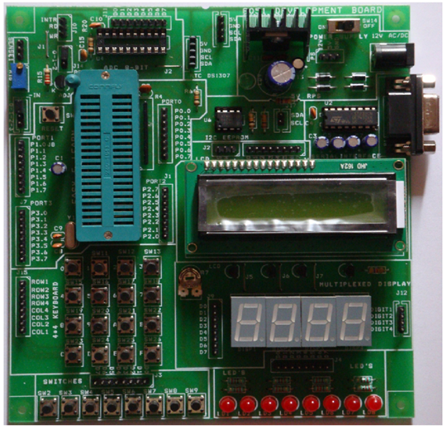
Interfacing LCD with 8051

16×2 LCD module is a very common type of LCD module that is used in 8051 based embedded projects. It consists of 16 rows and 2 columns of 5×7 or 5×8 LCD dot matrices. The module are talking about here is type number JHD162A which is a very popular one. It is available in a 16 pin package with back light, contrast adjustment function and each dot matrix has 5×8 dot resolution. The pin numbers, their name and corresponding functions are shown in the table below.
Pin No: | Name | Function
1 | VSS | This pin must be connected to the ground
2 | VCC | Positive supply voltage pin (5V DC)
3 | VEE | Contrast adjustment
4 | RS | Register selection
5 | R/W | Read or write
6 | E | Enable
7 | DB0 | Data
8 | DB1 | Data
9 | DB2 | Data
10 | DB3 | Data
11 | DB4 | Data
12 | DB5 | Data
13 | DB6 | Data
14 | DB7 | Data
15 | LED+ | Back light LED+
16 | LED- | Back light LED-

VEE pin is meant for adjusting the contrast of the LCD display and the contrast can be adjusted by varying the voltage at this pin. This is done by connecting one end of a POT to the Vcc (5V), other end to the Ground and connecting the center terminal (wiper) of of the POT to the VEE pin. See the circuit diagram for better understanding.
The JHD162A has two built in registers namely data register and command register. Data register is for placing the data to be displayed, and the command register is to place the commands. The 16×2 LCD module has a set of commands each meant for doing a particular job with the display. We will discuss in detail about the commands later. High logic at the RS pin will select the data register and Low logic at the RS pin will select the command register. If we make the RS pin high and the put a data in the 8 bit data line (DB0 to DB7), the LCD module will recognize it as a data to be displayed. If we make RS pin low and put a data on the data line, the module will recognize it as a command.
R/W pin is meant for selecting between read and write modes. High level at this pin enables read mode and low level at this pin enables write mode.
E pin is for enabling the module. A high to low transition at this pin will enable the module.
DB0 to DB7 are the data pins. The data to be displayed and the command instructions are placed on these pins.
LED+ is the anode of the back light LED and this pin must be connected to Vcc through a suitable series current limiting resistor. LED- is the cathode of the back light LED and this pin must be connected to ground.

Circuit diagram
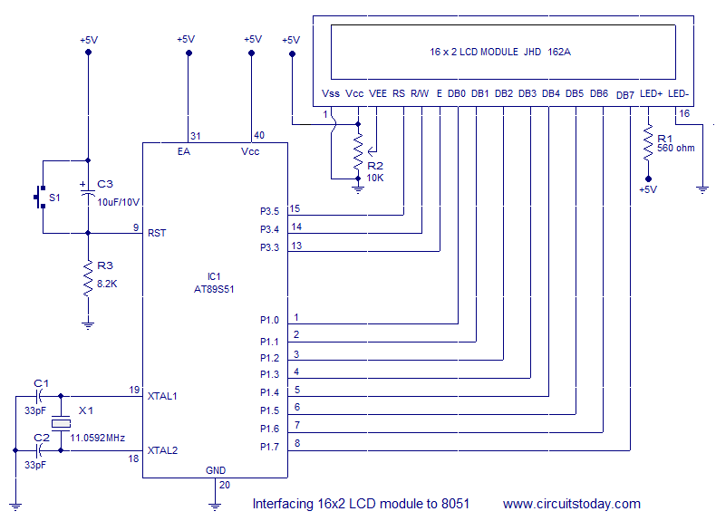

GSM SIM 300 V7.03
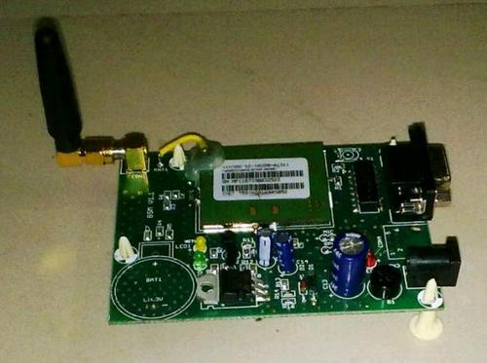
The SIM300 is an all in one GSM/GPRS compact module. With an industry-standard serial interface, the SIM300 offers GSM/GPRS 900/1800/1900MHz performance for carrying out voice, SMS, data, and Fax operation all in one small sized module that is perfect for integration in any handheld device.
It can be used to make GSM based calls, send messages etc through a serial interface from a microcontroller or a computer.
The SIM 300 module comes with a wire antenna, which provide good performance and reception, for better reception an external antenna can be added to the breakout board by soldering an SMA connector to it.
The Module can be easily interfaced with AT commands over a TTL serial interface, which makes it easy to connect it to microcontrollers, computers and other devices.
Features of SIM 300:-

- Provides serial TTL interface for easy and direct interface to microcontrollers

- Can be used for GSM based Voice communications, Data/Fax, SMS,GPRS and TCP/IP stack

- Can be controlled through standard AT commands

- Comes with an onboard wire antenna for better reception. Board provides an option for adding an external antenna through an SMA connector
- The SIM300 allows an adjustable serial baudrate from 1200 to 115200 bps

Some AT Commands for SIM 300:-
- To Dial a Number

  - To dial a number you will have to send the command -> ATD NUM; where NUM is the number you want to dial.

For instance to dial 9008620582, send the command ATD 9008620852;

  - To disconnect the number use the command – ATH
  - To redial a number use the command – ATDL

AT commands to change settings-
- To change the baud rate – AT+IPR=BAUDRATE(Ex 9600)
- To save the settings – AT&W
- To restore factory defaults type AT&F then save it by sending AT&W
Source code

#include <REGX51.H>
// Hex code for Enter is 0DH
// HEX CODE FOR CTRL+Z IS 1AH
// HEX CODE FOR LINE FEED IS 0AH

SFR LCDdata = P1
SBIT EN=P3.5 ; enable pin of LCD
SBIT RS=P3.6 ; Register select pin of LCD
SBIT RW=P3.7 ; Read/write pin of LCD
SBIT INTR=P3.3 ; Interrupt connected with Microcontroller
SBIT MOT=P1.0 ; Motor Controlled by uC.
ORG 0000H
SJMP START

ORG 0100

/////////////////////////////////////////////////////////////////////////////////////////////////////////////////////////////////////
/////////////////////////////////////////////////////// SET B.RATE///////////////////////////////////////////////////////////////////
//////////////////////////////////////////////////////////////////////////////////////////////////////////////////////////////////////
START: MOV TH1, #0FDH ; to set baud rate 9600bps
MOV SCON, #50H ; to set baud rate 9600bps
MOV TMOD, #20H ; to set baud rate 9600bps

SETB TR1 ; START TRANSMISSION AND RECEPTION

///////////////////////////////////////////////////////////////////////////////////////////////////////////////////////////////////
////////////////////////////// TO OBSERVE CHANGE IN INTERRUPT BIT ///////////////////////////////////////////////////////////////
/////////////////////////////////////////////////////////////////////////////////////////////////////////////////////////////////
MOV C, INTR ; COPY STATUS OF INTERRUPT BIT IN TO CARRY ;
MOV P3.2, C ; COPY THE STATUS OF INTERRUPT PIN WHICH IS NOW IN CARRY TO A BIT P3.2 TO SEE CHANGE
CLR C ; CLR CARRY
SETB MOT ; CLR PIN OR STOP MOTOR CONNECTED ON THAT PIN

//////////////////////////// INTERRUPT ENABLE ///////////////////////////////////////////////////////////////////////////////

// MOV IE, #10000100B
// MOV IP, #00000100B
//SETB IT1

////////////////////////////////////////////////////////////////////////////////////////////////////////////////////////////////////
////////////////////////// LCD INITILIZATION //////////////////////////////////////////////////////////////////////////////////////
////////////////////////////////////////////////////////////////////////////////////////////////////////////////////////////////
MOV A, #38H ; initialization LCD 2lines, 5×7 matrix.
LCALL COMM ; call command subroutine.
LCALL LCDDELAY ; call delay subroutine.
MOV A, #0EH ; display on, cursor on
LCALL COMM
LCALL LCDDELAY
MOV A, #01H ; Clear LCD
LCALL COMM
LCALL LCDDELAY
MOV A, #06H ; shift cursor right
LCALL COMM
LCALL LCDDELAY
MOV A, #80H ; cursor at beginning of 1st line
LCALL COMM
LCALL LCDDELAY

LCALL GSMBASEDMONITOR
//**//**//**//**//**//**//**//**//**//**//**//**//**//**//**//**//**//**//**//**//**//**//**//**//**//**//**//**//**//**//**//**
//**//**//**//**//**//**//**//** GSM INITILIZATION /**//**//**//**//**//**//**//**//**//**//**//**//**//**//**//**//**//
//*//**//**//**//**//**//**//**//**//**//**//**//***//**//**//**//**//**//***//**//**//**//**//**//***//**//**//**//**//**/

//////////////////////////// SEND AT ///////////////////////////////////////////////////////////////////////////////////////
MOV A, #"A" ; get data in to Accumulator
LCALL SEND ; call to subroutine to send data into GSM
MOV A, #"T" ; get data in to Accumulator
LCALL SEND ; call to subroutine to send data into GSM
LCALL ENTER ; Call subroutine of ENTER. (Send Enter to finish the Command)

LCALL REC ; wait for reception of OK.

LCALL DELAY ; Provide some delay between two codes

///////////////////////// SEND "AT&W" To set initial config. in MOdule ///////////////////////////////////////////////////////////////////////////////////////
NEXTCOMMAND:
MOV R4, #4 ; Load count for number of char. to send
MOV DPTR, #3565 ; load the address of ROM at which the code is stored.
CLR A ; clear Accumulator
SENDNEXT1: MOVC A,@A+DPTR ; Method to get data from ROM to Accumulator (Get a byte from ROM)
LCALL SEND ; Send this byte serial
INC DPTR ; Point to the next memory location in the ROM
CLR A ; Clear Accumulator to get new byte
DJNZ R4, SENDNEXT1 ; Execute this loop untill all bytes are not sent.

LCALL ENTER ; Send ENTER to indicate Finish of the command
LCALL REC ; Wait to receive the responce OK.
LCALL DELAY ; Provide some delay between two commands.

/////////////////////////////////// SEND "AT+CMGF=1" To select TEXT mode in GSM module //////////////////////////////////////////////////////////////////

MOV R4, #9 ; Load count for number of char. to send
MOV DPTR, #3570 ; load the address of ROM at which the code is stored.
CLR A ; CLear Accumulator
SENDNEXT2: MOVC A,@A+DPTR ; Method to get data from ROM to Accumulator (Get a byte from ROM)
LCALL SEND ; Send this byte serial
INC DPTR ; Point to the next memory location in the ROM
CLR A ; Clear Accumulator to get new byte
DJNZ R4, SENDNEXT2 ; Execute this loop untill all bytes are not sent.

LCALL ENTER ; Send ENTER to indicate Finish of the command
LCALL REC ; Wait to receive the responce OK.
LCALL DELAY ; Provide some delay between two commands.

/////////////////////////////////////// SEND AT+CNMI=2,2,0,0,0 ///////////////////////////////////////////////////////

MOV R4, #17 ; Load count for number of char. to send
MOV DPTR, #3600 ; load the address of ROM at which the code is stored.
CLR A ; CLear Accumulator
SENDNEXT3: MOVC A,@A+DPTR
LCALL SEND
INC DPTR
CLR A
DJNZ R4, SENDNEXT3

LCALL ENTER
LCALL REC
LCALL DELAY

//**//**//**//**//**//**//**//**//**//**//**//**//**//**//**//**//**//**//**//**//**//**//**//**//**//**//**//**//**//**//**//**
//**//**//**//**//**//**//**//** COPY Data from ROM TO RAM /**//**//**//**//**//**//**//**//**//**//**//**//**//**//**//**//**//
//*//**//**//**//**//**//**//**//**//**//**//**//***//**//**//**//**//**//***//**//**//**//**//**//***//**//**//**//**//**//

////////////////////////////////// COPY +CMT: IN TO RAM LOCATION //////////////////////////////////////////////////////////////////////////////
CLR A
MOV R4, #6
MOV R0, #50
MOV DPTR, #3500
NEXTCHAR1: MOVC A,@A+DPTR
MOV @R0, A
INC R0
INC DPTR
CLR A
DJNZ R4, NEXTCHAR1

////////////////////////////////////// COPY MOTORA3 IN RAM /////////////////////////////////////////////////////////////////////////////////

CLR A
MOV R4, #9
MOV R0, #60
MOV DPTR, #3540
NEXTCHAR2: MOVC A,@A+DPTR
MOV @R0, A
INC R0
INC DPTR
CLR A
DJNZ R4, NEXTCHAR2

//////////////////////////////////// POINTER TO SEND COMMAND////////////////////////////////////////////////////////////////////////

//**//**//**//**//**//**//**//**//**//**//**//**//**//**//**//**//**//**//**//**//**//**//**//**//**//**//**//**//**//**//**//**
//**//**//**//**//**//**//**//** SUBROUTINERECEIVE SECTION /**//**//**//**//**//**//**//**//**//**//**//**//**//**//**//**//**/
//*//**//**//**//**//**//**//**//**//**//**//**//***//**//**//**//**//**//***//**//**//**//**//**//***//**//**//**//**//**//

//CALLREC: ALSO REMOVE THIS LABLE WHILE USING GSM
// REMOVED WHILE USING WITHOUT GSM

///AAAAAAAAAAAAAAAAAAAAAAAAAAAAAAAAAAAAAAAAAAAAAAAAAAAAAAAAAAAAAAAAAAAAAAAAAAAAAAAAAAAAAAAAAAAAAAAAAAAAAAAAAAAAAAAAAAAAAAAAAAAAAAAA
////////////////////////////////////////////////// RECEIVE FIRST 6 CHAR ////////////////////////////////////////////////////////

CALLREC: MOV R4, #6 ; load count to compare chars
MOV R0, #50 ; load memeory location as a pointer in which the chars stored

RECCMT:
ACALL REC ; receive chars
HERE: XRL A,@R0 ; compare using XOR logic with the char stored in memory RAM

// MOV IE, #10000100B
// MOV IP, #10000100B
JNZ CALLREC ; if not match then start again
INC R0 ; increment memory pointer to get next char
DJNZ R4, RECCMT ; decrement char count (First 6 chars)

//AAAAAAAAAAAAAAAAAAAAAAAAAAAAAAAAAAAAAAAAAAAAAAAAAAAAAAAAAAAAAAAAAAAAAAAAAAAAAAAAAAAAAAAAAAAAAAAAAAAAAAAAAAAAAAAAAAAAAAAAAAAAAAAAAAA
///////////////////////////////////// 41 UNWANTED CHARACTORS //////////////////////////////////////////////////////////////////////////////////
//AAAAAAAAAAAAAAAAAAAAAAAAAAAAAAAAAAAAAAAAAAAAAAAAAAAAAAAAAAAAAAAAAAAAAAAAAAAAAAAAAAAAAAAAAAAAAAAAAAAAAAAAAAAAAAAAAAAAAAAAAAAAAAAAAAA
MOV R4, #41 ; load count for next 41 unused char. not to compare
REC41: ACALL REC ; rec
DJNZ R4, REC41 ; rec until count! =0.

//AAAAAAAAAAAAAAAAAAAAAAAAAAAAAAAAAAAAAAAAAAAAAAAAAAAAAAAAAAAAAAAAAAAAAAAAAAAAAAAAAAAAAAAAAAAAAAAAAAAAAAAAAAAAAAAAAAAAAAAAAAAAAAAAAA

// REMOVED WHILE USING WITHOUT GSM

//////////////////////////////////////////////////// RECEIVE MSG " MOTORA3 ON or OFF " ////////////////////////////////////////////////////////////////////////

//********************************* CHECK FOR MOTORA3 ONLY ***************************************************************//
MOV R4,#9
MOV R0,#60
RECMOTORA3: ACALL REC
XRL A,@R0
JNZ CALLREC
INC R0
DJNZ R4, RECMOTORA3

//***********************************CHECK FOR ON OR OFF ****************************************************************//
ACALL REC
MOV B, A
XRL A, #"N"
JZ PORTON
MOV A, B
XRL A, #"F"
JNZ CALLREC

ACALL REC
XRL A, #"F"
JNZ CALLREC

CLR MOT
LCALL MOTOROFF
LJMP CALLREC

/////////////////////////////// PORT ON SUB. TO SETB MOT ///////////////////////////////////////////////////////////////////////
PORTON: SETB MOT
LCALL MOTORON
LJMP CALLREC

//**//**//**//**//**//**//**//**//**//**//**//**//**//**//**//**//**//**//**//**//**//**//**//**//**//**//**//**//**//**//**//**
//**//**//**//**//**//**//**//** SUBROUTINE //**//**//**//**//**//**//**//**//**//**//**//**//**//**//**//**//**//**//**//**
//**//**//**//**//**//**//**//**//**//**//**//**//**//**//**//**//**//**//**//**//**//**//**//**//**//**//**//**//**//**//**//**

//////////////////////////////// DELAY /////////////////////////////////////////////////////////////////////////////////////////////

DELAY: MOV R5, #0FFH
A1: MOV R6, #0FFH
DJNZ R6, $
DJNZ R5, A1
RET

/////////////////////////////////////////////////////////////////////////////////////////////////////////////////////////////////////
/////////////////////////////////////////////// ENTER////////////////////////////////////////////////////////////////////////////////
////////////////////////////////////////////////////////////////////////////////////////////////////////////////////////////////////
ENTER: CLR TI
MOV SBUF, #0AH ; HEx code for Line Fee
JNB TI, $
CLR TI
MOV SBUF, #0DH; Hex code for ENTER
JNB TI, $
CLR TI
RET

///////////////////////////////////// SUB FOR SEND //////////////////////////////////////////////////////////////////////////////

SEND: CLR TI
MOV SBUF, A
JNB TI, $
CLR TI
RET

/////////////////////////////////////// SUB FOR REC///////////////////////////////////////////////////////////////////////////

REC: CLR RI

WAIT1: MOV C, INTR ;
MOV 00H, C ;
MOV C, P3.2 ;
MOV 08H, C ; TO COMP TWO BITS
MOV A, 21H ;
XRL A, 20H ;
JNZ CHECKZERO
SJMP WAIT
CHECKZERO: MOV C, INTR
MOV P3.2, C
MOV 21H, 20H
; EXTRA
JNB P3.2, INTERRUPT

WAIT: JNB RI, WAIT1

MOV A, SBUF
CLR RI
RET
//******************************************************************************************************************************//
////////////////////////////////// INTERRUPT /////////////////////////////////////////////////////////////////////////////////////
//******************************************************************************************************************************************//
INTERRUPT: CLR A
LCALL CALLING
MOV 21H, 20H
MOV C, INTR
MOV P3.2, C
CLR C
MOV R4, #16
MOV DPTR, #3630
CLR A
NEXTCHAR4: MOVC A,@A+DPTR
CLR TI
MOV SBUF, A
JNB TI, $
CLR TI
INC DPTR
CLR A
DJNZ R4, NEXTCHAR4
CLR TI
MOV SBUF, #0AH
JNB TI, $
CLR TI
MOV SBUF, #0DH
JNB TI, $
CLR TI

MOV 09, #55
C2: MOV 10, #255
C1: MOV 11, #255
DJNZ 11, $
DJNZ 10, C1
DJNZ 09, C2

LCALL MOTOROFF
CLR MOT ; to turn off device when interrupt occurs *********************************************
//CLR EA
// CLR IE1

LJMP CALLREC

/////////////////////////////////////////////////////////////////////////////////////////////////////////////////////////////////////
////////////////////////////// LCD SUB. ////////////////////////////////////////////////////////////////////////////////////////////
//////////////////////////////////////////////////////////////////////////////////////////////////////////////////////////////////

LCDDELAY: MOV R5, #12
B1: MOV R6, #255
DJNZ R6, $
DJNZ R5, B1
RET
//////////////////// COMMAND SEND ///////////////////////////////////////////////
COMM: MOV LCDdata, A
CLR RS ; DE DATA
CLR RW ; R/W
SETB EN ; ENA

CLR EN
RET
/////////////// DATA SEND //////////////////////////////////////////////////////
DISP: MOV LCDdata, A
SETB RS
CLR RW
SETB EN
LCALL LCDDELAY
CLR EN
RET

////////////////////////////////////// DISPLY MOTOR ON AND OFF ///////////////////////////////////////////////////////////////
///////////////// DISP MOTOR OFF ///////////////////////////////////////
MOTOROFF: MOV A, #01H
LCALL COMM
CLR A
MOV DPTR, #3660
MOV R4, #9
DISPNEXTCHAR1: MOVC A,@A+DPTR
LCALL DISP
//LCALL DELAY
CLR A
INC DPTR
DJNZ R4, DISPNEXTCHAR1
RET

////////////////// DISP MOTOR ON //////////////////////////////////////

MOTORON: MOV A, #01H
LCALL COMM
CLR A
MOV DPTR, #3650
MOV R4, #8
DISPNEXTCHAR2: MOVC A,@A+DPTR
LCALL DISP
// LCALL DELAY
CLR A
INC DPTR
DJNZ R4, DISPNEXTCHAR2
RET

///////////// DISPLY GSM BASED MONITOR ////////////////////////////////
GSMBASEDMONITOR: MOV A, #01H
LCALL COMM
CLR A
MOV DPTR, #3670
MOV R4, #17
DISPNEXTCHAR3: MOVC A,@A+DPTR
LCALL DISP
LCALL DELAY
CLR A
INC DPTR
DJNZ R4, DISPNEXTCHAR3

MOV R4, #20
SHIFT: MOV A, #18H
LCALL COMM
LCALL DELAY
DJNZ R4, SHIFT

LCALL MOTORON
RET

//////////////// DISPLY CALLING /////////////////////////////////////////

CALLING: MOV A, #01H
LCALL COMM
CLR A
MOV DPTR, #3700
MOV R4, #10
DISPNEXTCHAR4: MOVC A,@A+DPTR
LCALL DISP
LCALL DELAY
CLR A
INC DPTR
DJNZ R4, DISPNEXTCHAR4
RET

/////////////// DISPLAY DISCONNECT ////////////////////////////////////////

//****************************************** ROM DATA ********************************************************************************
//***********************************************************************************************************************************
ORG 3500
DB "+CMT:”

ORG 3540
DB "MOTORA3 O"

ORG 3560
DB "AT"

ORG 3565
DB "AT&W"

ORG 3570
DB "AT+CMGF=1"

ORG 3600
DB "AT+CNMI=2, 2, 0, 0, 0"

ORG 3630
DB "ATD 08866572496;"

ORG 3650
DB "MOTOR ON"
ORG 3660
DB "MOTOR OFF"
ORG 3670
DB "GSM BASED MONITOR"

ORG 3700
DB "CALLING..."

Application of Project

GSM Based Monitor Controller for Hotels, Factories, Homes Apartments, Commercial Complexes, Drainage, etc.
It can be fixed for single phase motor, Single Phase Submersibles, Three Phase motors. & open well, Bore well and Sump. Many models available in different ranges.
Switching ON the Geyser or AC before arriving home.
GSM Based Monitor Controller for the Gate and Corridor Lights or a TV of an unoccupied house, to deter any house break.
Controlling industrial process pumps as per required timing.

Features
The system should have one registered GSM SIM.
The system can be made to control the pump starter through your mobile just by sending simple SMS of digit 1 to switch ON and 2 to switch OFF.
The system can be programmed to receive the control command from the single mobile only or from any mobile.
This system communicates with the mobile from which the command signal is sent and confirms the action taken, i.e. the sender will receive the confirmation SMS message as "PUMP ON" or "PUMP OFF" along with Date and Time.
The system can also be programmed to act as auto start system for agricultural pumps. (Auto start systems will automatically switch ON the Pumps always when there is availability of Power Supply.)
The system also comes with dry run preventer for any bore well pump.
These above features make the system also to be very useful in agricultural sector to operate the pump, which will usually be very far from the main house.
The system can also be used to control any other electrical equipment with GSM remote control concept.
In "Manual" mode the Pump or Load can be controlled directly and GSM controller gets completely shut down and bypassed.
Reference
These sites are supported for development of the project.
www.electronicsforu.com
www.alldatasheats.com
www.wikipedia.org
www.electronics-tutorials.ws
www.easy.com
www.circuitstoday.com

