


PROJECT REPORT
ON
METAL OXIDE SEMICONDUCTOR FIELD EFFECT TRANSISTOR
BASED INVERTER WITH
BATTERY
SWAMI SACHCHIDANAND POLYTECHNIC COLLEGE
SANKALCHAND PATEL SAHKAR VIDHYADHAM
GANDHINAGAR-AMBAJI LINK ROAD
KAMANA CHAR RASTA-384315






This is certify that GROUP L Roll no. 9051,9077,9081,9085 of class 5th Electrical. the project METAL OXIDE SEMICONDUCTOR FIELD EFFECT TRANSISTOR BASED INVERTER WITH BATTERY is being submitted by is partial fulfillment for the award of Diploma in ELECTRICAL ENGINEERING by Gujarat Technology University, Gujarat State during the term 07/01/2013 to 04/05/2013 has been carried out by him under strict supervision and guidance within the four wall of laboratory at Swami Sachchidanand Polytechnic College, Visnagar.

Date of submission:_ Signature of Guide:___________

METAL OXIDE SEMICONDUCTOR FIELD EFFECT TRANSISTOR
BASE INVERTER
WITH BATTERY

PREPARED BY:-

1 SATHVARA JIGAR B. 106500309051

2 PRAJAPATI SUNIL B. 106500309077

3 CHAUDHARY SURESH G. 106500309081

4 RAVAL JAYESH R. 106500309085

GUIDE BY:-
PRATIK Y PATEL
( Lecturer in Electrical)

Date of submission:- Staff in charge:-_________

Head of department:-
ACKNOWLEDGEMENT

“Thanks for someone cannot be revelied in words’’
We are heartily thankful for our sirs and madam for providing the help and support for making ours projects successful. They have been helping right from the beginning of this project to the end. They have been providing the help, which we are lacking and be fulfilled without their help.
We are particularly grateful for the project implementation staff leads the project coordinator Patel Pratik Y. and head of the department Mr.Chirag Trivedi.
The preparation of this important document would not have been possible without the support, hard work and endless efforts of a large number of individuals and institutions.

Thanking all of them,

Sathavara Jigar B.
Prjapati Sunil B.
Chaudhary Suresh G.
Raval Jayesh R.

INDEX

SR NO | CONTENTS
1 | GENERAL INTRODUCTION
2 | BASIC OF INVERTER
 | 2.1 DESCRIPTION -
 | 2.2 PRINCIPAL OF INVERTER
 | 2.3 WHAT IS INVERTER
 | 2.4 ABOUT OUR INVERTER
 | 2.5 TECHANICAL SPECIFICATIONS
3 | ABOUT MOSFET
 | 3.1 THE OPERATION PRINCIPAL OF P-N JUNCTION DIODE
 | 3.2 THE OPERATION PRINCIPAL OF MOSFET
 | 3.3 THE OPERATION PRINCIPAL OF C- MOSFET
 | 3.4 INTRODUCTION OF MOSFET
 | 3.5 STEADY-STATE CHARACTERISTICS
 | 3.6 SWITCHING CHARACTERISTICS
 | 3.7 WORKING OF MOSFET
 | 3.8 MOSFET LOGIC & POWER SWITCHING
4 | BLOCK DIAGRAM OF MOSFET BASED INVERTER
5 | ADVANTAGES OF PWM INVERTER OVER OTHER  CONVENTIONAL INVERTER
6 | APPLICATIONS
7 | PARTS LIST
8 | REFERENCE

CHAPTER-1
GENERAL
INTRODUCTION

- GENERAL INTRODUCTION

Currently whatever work one does, in each and every Field one need to use some electrical or electronic device to carry out his/her job and this electrical or electronic device- require electricity to carry out their work. In a developing

Country like outs power .cuts and power line problems are very frequent. This situation gets worse in sue specific such as in summer and rainy season when these problems become a common thing.
•

During the power cut if one needs to use any electrical/ electronic appliance such ,-)s fan light bulb etc. then some kind of device which could provide power to these appliances becomes essential. Inverter is one of most commonly used device for this purpose.

“An inverter is device which can convert the DC supply of battery into AC power supply required by most of the electrical/ electronic equipment”’

The process though which these inverters converter DC in to AC supply is called "inversion". This inversion process is reverse of the rectification process where the AC power is converted into DC power.

, Inverter is the most sophisticated solid state 1C based fully automatic little electric generator) It converts DC power into50Hz regulated 230V AC power from battery. In case of power failure, it switches on automatically to supply power to load and when mains supply is restored, it switches off automatically and battery charger take over which charges battery to next power failure.
- SEMICONDUCTORS
UPS is a power electronic device. Various semiconductor components are used in the system. Before we study UPS, it is essential to be clear about the base semiconductor components used in the system. Some of the semiconductor devices that are widely used in the system are listed below:
- Transistor
- Thyristor
- MOSFET
- IGBT
Let us discuss each of the above semiconductor devices below.

- TRANSISTOR
A transistor consist of two pn junction formed by sandwiching either p-type or n-iv-type semiconductor between a pair of opposite types. By transistor we mean BJT (Bipolar junction Transistor) is termed as bipolar since conduction takes place by motion of charge earners of both the polarities namely electors and holes. There are two types of transistors. Namely
1. n-p-n transistor
2. p-n-p transistor

An N-P-N transistor is composed of two n-type semiconductors separated by a thin section of a p-type as shown in the figure. However a p-n-p transistor-is formed by two p-sections separated by a thin section of n-type as shown in the figure.

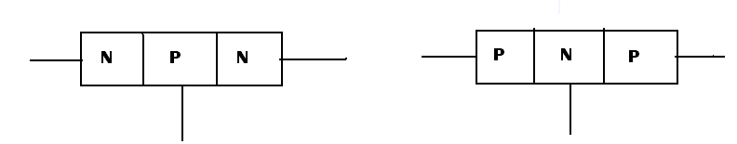

FIG-1.1 N-P-N TRANSISTER FIG-1.2 P-N-P TRANSISTOR

In each type of transistor the following points may be noted :-
1 There are two pn junctions.
2 There a transistor may be regarded as a combination of tow diodes connected back to back
3 The Middle section is very thin layer. This is the most important factor in the function of a transistor.

A transistor has two-pn junction. One junction is forward biased and other is reverse biased. The forward biased junction has a low path. The weak signal is introduced in the low resistance circuit and transfers a signal from a low resistance to high resistance.

- TRANSISTOR TERMINALS

A transistor has three sections of doped semiconductor. The section on one side the emitter and the section on the opposite side is the collector. The Middle Section is called the base and forms two junctions between the emitter and collector.

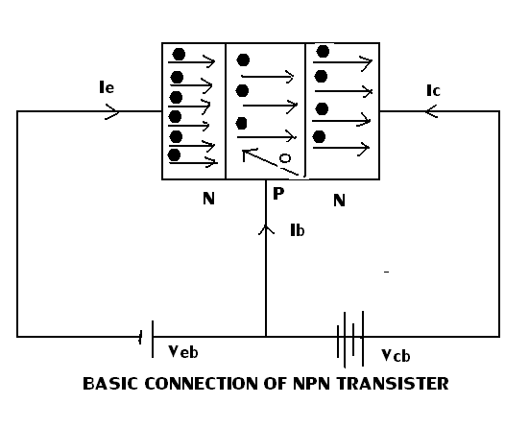

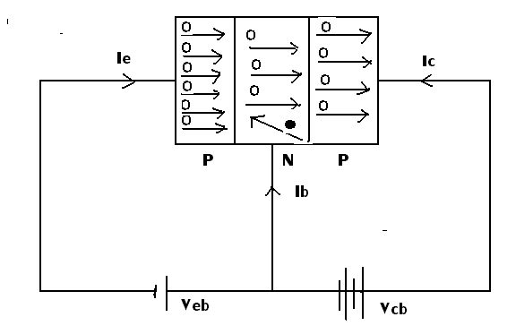

FIG-1.3 BASIC CONNECTION OF AND P-N-P TRANSISTOR

- EMITTER
The section on one side that supplies charge carrier is called the emitter. The emitter is always forward biased w.r.t base so that it can supply a large number of majority carriers. In figure the emitter (p type) of PnP transistor is forward biased and supplies hole charges to its junction with the base. Similarly, in other figure, (he emitter (n type) of PnP transistor has a forward bias and supplies free electrons to its junction with the base.
The section on the other side that collects the charge is called the collector. The collector is al Ways reverse biased. Its function is to remove charges from its junction with the base in figure, the collector (p type) of PriP transistor has a reverse bias and receives hole charges that flow in the output circuit. Similarly in figure the collector (n type) of NPN transistor has reverse bias and receives electrons.
- BASE
The middle section which forms two pn junctions between the emitter and Collector is called the base. The base-emitter junction is forward. Allowing low resistance path to the emitter circuit. The base- collector junction reverse biased and Provides high resistance to the collector circuit.
The resistance of emitter diode is very small as compared to compares to collector diode. Therefore, forward bias applied to the emitter diode is generally Very small whereas Reverse bias on the collector diodes is much higher.
- Transistor Action

The emitter-base junction of a transistor is forward biased whereas collector-base Junction is reversed biased. If for a moment we ignore the presence of emitter-base Junction. Then practically no current would flow in a collector circuit because of the Reverse bias. However, if the emitter-base junction is also present then forward bias on it caused the emitter current to flow. It is seen that this emitter current entirely flows in the Collector circuit. Therefore, the current in the collector circuit depend upon the emitter Current. If the emitter current is zero, men collector current is nearly zero. However, if the Emitter current is 1 mA,
- Working of NPN transistor
Figure shows the NPN transistor with forward bias to emitter-base junction and reverse bios to collector-base junction. The forward bias causes the electrons in the n-type emitter to flow towards the base. This constitutes the emitter current I. as these electrons flow through the p- type base; they tend to combine with holes. As the base is highly doped and very thin, therefore, only a few electrons (less than 5%) combine with holes to constitute
Base current !_{B}- the remainder cross over into the collector region lo constitute collector current IC- In this way, almost the entire emitter current flows in the collector circuit it is clear that emitter current in the sum of collector and base current i.e.
I_{E} = I_{B}+1_{c}

- Working of PNP transistor
The forward bias causes the holes in the p-type emitter to flow towards the base; they tend to combine with the electrons. As the base is lightly doped and very thin. Therefore only a few holes (less than 5%) combine with the electrons. The remainder cross into the collector region to constitute collector current IC In this way. Almost the entire emitter current flows in the collector circuit. It may be noted that current conduction within PnP transistor is by holes. However in the external connecting wires. The current is still by electrons.

- Switching Transistor
A transistor is used as a switch. It has special feature to reduce switch off time and saturation voltage. It is so arranged in the circuit that either maximum current flow through the load or minimum current flows though the load. In other words a switching transistor has two states.
- ON state or when collector saturation current flows through the load.
- OFF state or when collector leakage current flows through the load.
- Switching action of a transistor.
The switching action of a transistor can also be explained with the help of output Characteristic. Figure shows the output characteristic of a typical for a CE configuration. The characteristics are arranged in three region.
- Thyristor

It is a-three terminal unidirectional semi-conductor device which is extensively used to electronic circuits. It acts as a true electronic switch. It can change ac into dc and at the same time can control the amount of power fed to on load. Thus SCR combines the features of a rectifier and a transistor.

- Construction

When a pn junction is added to a junction transistor, the resulting three pp. junction device is called a silicon controlled rectifier. Three terminals are taken one from
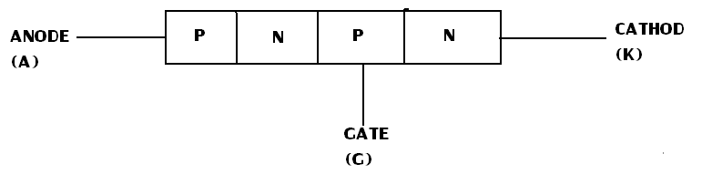

FIG-1.4 CONSTRUCTION

The outer p-type material called anode A. second from the outer n- type material called cathode K and the third from the base of transistor section and is called gate G. in the normal operating conditions of SCR, anode is held a( high positive potential w.r.t cathode and gate at small positive potential w.r.t cathode.

- MOSFET
A metal -oxide -semiconductor field effect transistor is a recent device developed by combining the areas of filed effect concept and MCS Technology
A power MOSFET has three terminals called drain, source and gate in place of the corresponding three terminals collector„ emitter and base for BJT. A BJ F is current controlled device and MOSFET is a voltage- controlled device. The control signal or base current in BJT is much larger then the control signal required in MOSFET. This is because of the fact that gate circuit impedance in MOSFET is extremely high. This large impedance permits the MOSFET gate to be driven directly from microelectronic circuits. BJT suffers from second breakdown voltage whereas MOSFET is free from this problem.

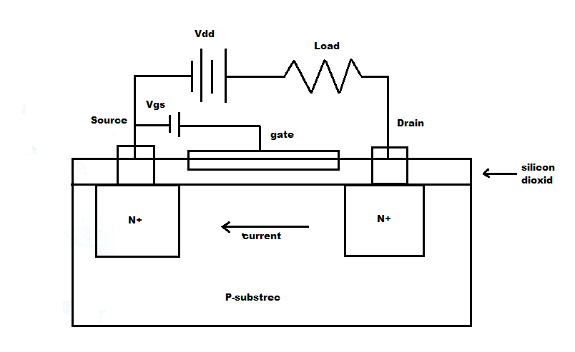

FIG- 1.5 N-CHANNEL ENHENCEMENT POWER MOSFET[[[[[[

Power MOSFETs are of two types: n-channel Enhancement type and p-channel MOSFET Out of these two types, n-channel more common because of higher mobility of electrons.
A simplified structure is shown in the above figure. One- substrate. Two heavily doped n regions are diffused as shown. An insulating layer of silicon dioxide is growth on the Surface.

When gate circuit is open, no current flows from the drain to source and load because of one reverse biased n - p junction. When gate is made positive with respect to source an electric field is established. Eventually induced negative charges in the p-substrate below silicon layer are formed. These negative charges called electrons. From n- channel and current can flow from drain to source as shown by the arrow. It VGS is made more positive, n-channel becomes more deep and therefore more current flows from D to S. this shows that drain current is enhanced by the gradual increase of gate voltage hence the name enhancement MOSFET.

The main disadvantage of n-channel MOSFET is that conducting n-channel in between drain and source gives large on-state resistance. This leads to high power dissipation in n-channel
- RECTIFIER
Rectifier is a device that converts ac into dc. In UPS system, it serves a dual purpose i.e. a single rectifier works as two components:
1. Rectifier 2.Charger
It provides dc input to the inverter when it works as a rectifier and it charges the battery of the Ups system when it works as the charger

In off-line mode. The UPS come into picture only when ac line, is off. At that time. Battery supplies the back up through the inverter and no rectification is required. Hence in such modes. Rectifier works merely as a charger for the battery when ac is available.
In on Line Modes. The UPS is into Picture all the time. When ac line is on. Rectifier Works in the dual mode i.e. it Provides dc input to theinverter and charge the battery simultaneously and when the line is gone the rectifier is idle.
In the UPS manufactured by Hi-real. three-phase full controlled bridge rectifier is used. Let us discuss only it in detail.

CHAPTER-2
BASIC OF
k--; P,,••1. c. P. s'^{N}-k'Fb
INVERTER

- BASIC OF INVERTER

2.1 DISCRETION:

Circuit to understand the working Principle is shown in Figure Battery Switch and a Transformer with centre trapping are connected as shown. Initially the switch is in position B.

When Switch is on current flows through the upper half of the winding of the transformer. Flux is Produced the core in one direction, emf is induced in the secondary and load current flows in one direction.

When Switch is broight quickly to position C, current flows through the bottom half of the winding, flux is produce in the opposite direction. Emf is induced in the secondary winding in the opposite direction and load current flows in the opposite. Actually SCR or transistor is used in place of switch.

  - PRINCIPALE OF INVERTER:

Inverters Converts DC Power into AC Power at The Required Voltage Frequency BJT, MOSFET LGBT<MCT or SCR can be used for making inverter circuit. For reduced Current Rating Device Other Than SCK is used. While for greater rating SCRs are used- Output wave form of SCR may be sinusoidal or non sinuirement For more Power Inverter with low distortion sine wave are used-frequency of the output wave is decided by the on and off time of the device

Input Source of inverter may be battery, soler cell or other DC source. In most of the industrial application, first AC is converted into DC using rectifier. This is filtered and that DC is used to drive inverter. Output voltage of signal phase inverter is 220V, 50Hz or 120V, 60Hz or 220/380V, 115/200V, 400Hz, The output volteg and frequency may be after than this also depending upon the requirement.

2.3 WHAT IS INVERTER?
"Inverter is basically a de ac converter. It is a circuit which converter de power in to ac power at desired voltage
Whatever AC o/p voltage we get, it may be fixed or variable at fixed or variable frequency. Variable o/p voltage can be getting by varying i/o voltage or maintaining gain of inverter constant Gain o( inverter is given by ratio of o/p ac voltage to i/p voltage, in inverter conversion from de power into ac power is done by turn on and turns off device, such as GTO, BGT, MOSFET, lGBT e. Thyristors are normally used for high power application and devices are used for low and medium power application.
The ac output voltage could be fixed at a fixed or variable frequency. For low and medium power output, the above mentioned power device are suite blet for high power output, thyristors should be used the output voltage ivaVeforms of an ideal inverter should be. should. The voltage waveforms of practical inverter are, however, non sinusoidal and contain harmonic. Square wave or quasi-square wave
Voltage may be acceptable for low and medium power application. The output frequency of an inverter is determined by the rate at which the semiconductor devices are switched on and off by the inverter coi_trol Frequency an adjustable frequency ac output is readily provided. When the ac output voltage of an inverter is given to a transformer or ac motor, this output voltage must be varied in conjunction nth frequency to maintain the proper magnetic conditions. Therefore, the output voltage control is and essential feature of an adjustable frequency system.
The de power input to the inverter may be battery, fuel cell, solar cells or other source. But in most industrial applications, it is fed by rectifier. This configuration pf ac to de converter and dc to ac inverter is called a de link converter because it is a two stage static frequency converter in which ac power at network frequency is rectified and then filtered in the dc link before being inverted to ac at adjustable frequency system.

The de power input to the inverter may be bettery, fuel cell, solar cells or other source. But in most industrial applications, it is fed by rectifier. This configuration pf ac to de converter and dc to ac inverter is called a dc link converter because it is a two stage static frequency converter in which ac power at network frequency is rectified and then filtered in the dc link before being inverted to ac at adjustable frequency.

Inverters are mainly classified as voltage source inverters and current source inverters. A voltage fed inverter (VFI), or voltage source inverter 1VSI), is one in which the dc source has small or negligible impedance. In other words, voltage source inverter has stiff d? Voltage of a voltage source inverter remains substantially constant with variations in of a. On the other hand, the current fed or current source,inverter with supplied what a controlled current from a de source high

impedance. Typically, a phase controlled thyristor rectifier feeds the inverter with a regulated current through a large series inductor. Thus, load current rather than load impedance. Because of a large internal impedance, the terminal voltage of a current source inverter changes substantially with a change in 3ad Therefore; if use in multi motor drive, a change in load on any motor. Other motors, some of the important applications of inverters are

- Variable speed ac motor drives
- Induction heating
- Air craft power supplies
- Uninterruptible power supplies(UPS)
- voltage D.C. transmission lines
An inverter can 1-ie classified based on various parameters as we saw above. Let us discuss this classification in brief below. Firstly let us discuss the classification based on source.
- Voltage Source Inverter
A voltage source inverter (VS1), is one in which the dc source has small or negligible impedance. In other words, a voltage source inverter has stiffed dc voltage source at it’s input terminal.
- Current Source Inverter
A current source inverter (CSI) is one, which is fed with adjustable current from a dc source of high impedance i.e. from a stiffed dc current source. In a CSI fed with stiff current source, the load does not affect output current base.
Now, let us discuss the classification based on commutation technique used in inverters.

- Line Commutated Inverter
Line commutated inverter require at the output terminals and existing ac supply which is used for their commutation. This means that line commutated inverters can't function as isolated' ac voltage sources or as-variable frequency generator with the de power at the input. Therefore voltage level, frequency and waveform on the ac side of line commutate inverter can't be changed.
- Forced Commutated Inverter
Force commutated inverter requires a special commutation circuitry for forcing the semi conductor devices to commutate. They provide an independent ac output voltage of adjustable voltage and adjustable frequency and have therefore much wider applications.
- Load Commutation Inverter
Load commutated inverter gets commutated naturally by means of me load connected to its Output terminals. This happens when the duration of the reverse bias across the SCR is more than the SCR turnoff time. In this type of inverters, there is no need of any external commutation circuitry.
The classification based on the construction differs only by the number of phases available at the output side of the inverter and the output voltage. Since we mostly use single-phase full bridge inverter in the UPS systems, we will discuss only this one in detail over here.

- AC voltage control

In this method, an ac voltage controlled is inserted between the output terminals of inverter and the load terminals as shown in figure. The voltage input to the ac load is regulated to the firing angle control of ac voltage controller.

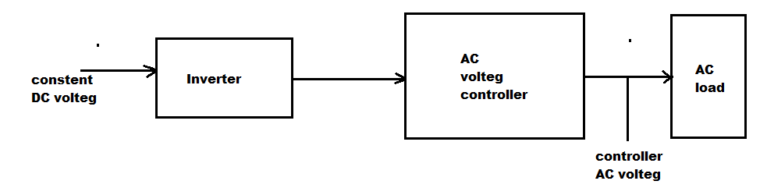

FIG-2.1 A.C. VOLTAGE CONTROL

- Series-inverter Control
This method of voltage control involves the use of two or more inverters in series. The figure illustrates how the output voltage of two inverters can be summed up with the help of transformers to obtain an adjustable output voltage. The inverter output is fed to two transformers whose secondary is connected in series. Phase some of the two fundamental voltages V₀₁ V₀₂ gives the resultant voltage V₀.

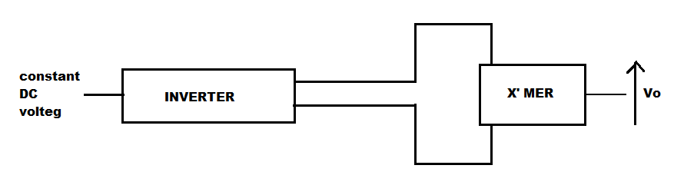

Fig:2.2 Series inverter control of Inverter.

- External Control of DC Output Voltage
In case the available voltage source is ac, then dc voltage input to the inverter is controlled through a fully controlled rectifier, or through an uncontrolled rectifier and chopper, or through an ac voltage controller and an uncontrolled rectifier. If available voltage is dc, then dc voltage input to the inverter is controlled by means of a chopper as a shown in figure.
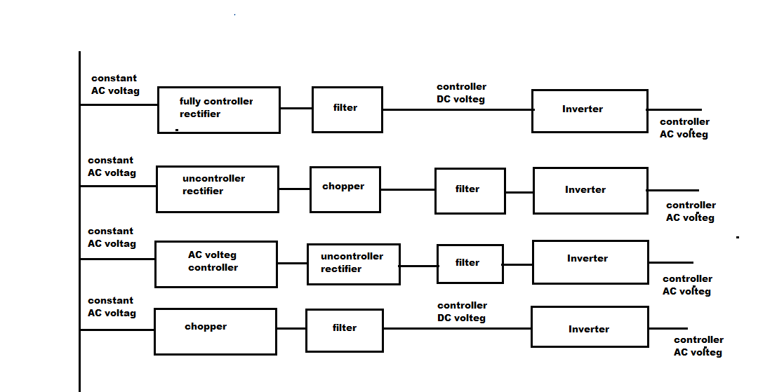

FIG; 2.3 EXTERNAL CONTROL OF DC OUTPUT VOLTAGE
Input voltagevoltage control technique, in which dc voltage input to inverter is controlled by means of components external to the inverter, has the following advantages:
Output voltage waveform and its harmonic content are not affected appreciably as the inverter voltage output is controlled through the adjustment of dc input voltage to the inverter.
This method of voltage control, however, suffers from the following disadvantages;
The number of power converters used for the control of inverter output voltage varies from two to three. More power handling stages result in more losses and reduced efficiency of the entire scheme.

- For reducing the ripple content of the dc voltage input to the inverter, filter circuit is required in all types of schemes shown in fig. Filter circuit increases the cost, weight and size and at the same time reduces the efficiency and makes the transient response sluggish.
- As the dc input is decreased, the commutating capacitor voltage also decreases.
This has the effect of reducing the circuit turn-off time (t = C V/1) for the SCR for a constant load current Therefore for a large variation of output voltage for a constant load current, control of dc input voltage is not conducive. This difficulty can, however, be overcome by a separate fixed dc source for charging the commutating capacitor, but this makes the schemes costly and complicated
- Internal Control of inverter
Output voltage from an inverter can also be adjusted by exercising a control within the inverter itself. The most efficient method of doing this is by pulse-width modulation control used within an inverter. This is discussed briefly in following section:
- Pulse-width modulation control

In this method, a fixed dc voltage is given to the inverter and a controlled ac output voltage is obtained by adjusting on and off periods of the inverter components. This is the most popular method for controlling output voltage and this method is termed as pulse width modulation (PWM) control The advantages processed by PWM technique are as under:
- The output voltage control with this method can be obtained without any additional components.
- With this method, lower order harmonic can be eliminated or minimized along with its output voltage control. As higher order harmonics can be filtered easily, the filtering requirements are minimized. The main disadvantage of this method is that the SCRs are expensive, as they must possess low turn-on and turn-off times.

- PULSE-WIDTH MODULATED INVERTERS.

PWM inverters are gradually taking over other types of inverters in industrial applications. PWM techniques are characterized by constant amplitude pulses. The width of these pulse is, however, modulated to obtain inverter output voltage control and to reduce its harmonic content. Different
PWM techniques are as under:
- Single pulse modulation
- Multiple pulse modulation
- Sinusoidal pulse modu2,1ai.don

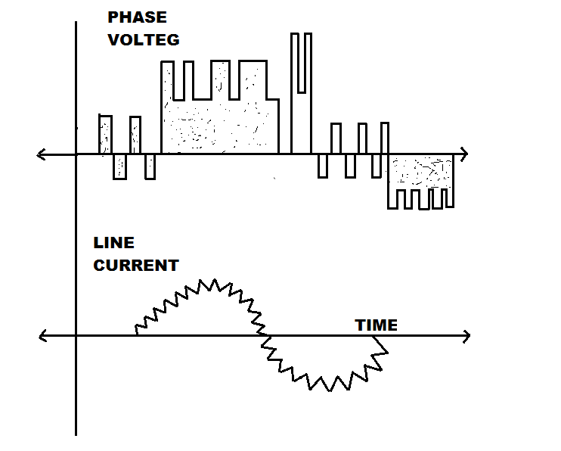

FIG:2.4 PULSE-WIDTH MODULATION INVERTER

In PWM inverters, forced commutation is essential. The three PWM techniques listed above differ from each other in the harmonic content in their respective output voltages. Thus choice of a particular PWM techniques depend upon the permissible harmonic content in the inverter output voltage.
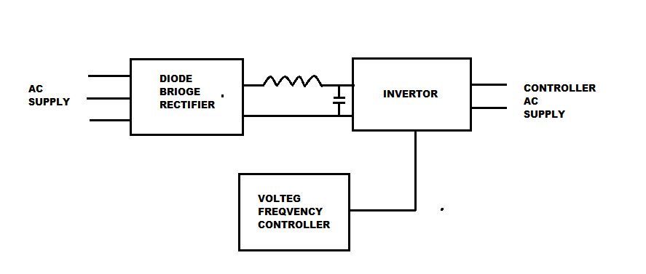

FIG-2.5 PWM INVERTER

In industrial applications, PWM inverter is supplied from a diode bridge rectifier and a LC filters. The inverter topology remains same. But now the devices are switched on and off several times within each half cycle to control the output voltage, which has low harmonic content.
Since we are gong to discuss single and multiple pulse modulation in the control card section and we use sine pulse modulation in the inverter circuit we are going to discuss only pulse modulation in .detain in the following section.

- Sinusoidal Pulse .I.V.KodulaUon (sin M)

In this method of modulation, several pulses per half cycle are used as in the case of multiple pulse modulations. In MPM, the pulse width is equal for all the pulses. But in sin M, the pulse width is a sinusoidal function of the angular position of the pulse in a cycle as shown in the fig.
For realizing sin m, a high Frequency triangular carrier wave V_{c} is Compared with a sinusoidal reference wave VR of the desired frequency. The intersection of these waves determines the switching instants and commutation of the modulated pulse. In figure V_{C} Is the pick value of the triangular carrier wave and the V_{R} that of the reference or modulating signal.

The carrier and reference waves are mixed in a comparator. When sinusoidal wave has magnitude higher than the triangular wave, the comparator output is high, otherwise, it is low. The comparator output is that processed in a trigger pulse generator in such a manner at the output voltage
Wave of the inverter has a pulse width in agreement with the comparator output Pulse width

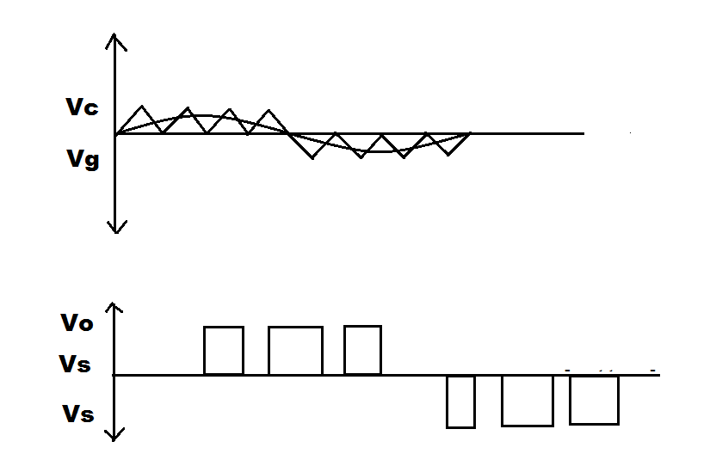

FIG-2.6 SINUSOIDAL PULSE MODULATION

The ratio of VR VC is called the modulation index (Mi) and it controls the harmonic content of the output voltage waveform. The magnitude of the fundamental component of output voltage is proportional to Ml, but MI can never be more than unity. Thus varying Ml controls the output voltage. Harmonic analysis of the output modulated voltage wave reveals that sin M has the following important features:
- For MI less than one, largest harmonic amplitudes in the output voltage are associated with harmonics of order 2N ± 1, where N is the number of pulses per half cycle. Thus by increasing the number of pulses per half cycle, the order of dominant harmonic frequency can be raised which can then be filtered out easily. It is observed from above that as N is increased, the order of significant harmonic increases and the filtering requirements are accordingly minimized. But higher value of N entails higher switching frequency of thyristors. This amounts to more switching losses and therefore impaired inverter efficiency.
- For MI greater than one, lower order harmonics appear, since for MM, pulse width is no longer a sinusoidal function of the angular position of the pulse.

2.4 ABOUT OUR INVERTER
Our inverter is based on power MOSTET. It is one kind of electronics generator DC pure input to it is 12vol battery. It gives square wave output. It can bear load of 250 watt with efficiency of 90%.
2.5 Technical specification
Capacity : 250 watt
I/P dcvoltage : 12 Volt
O/P Voltage : 220,240,260, Volt. /50Hz
Efficiency : 90%
Overload : 130%

CHAPTER – 3
ABOUT MOSFET

- ABOUT MOSFET

The Fully Spelling of MOST FET is Metal Oxide Semiconductor Field Effect Transistor.
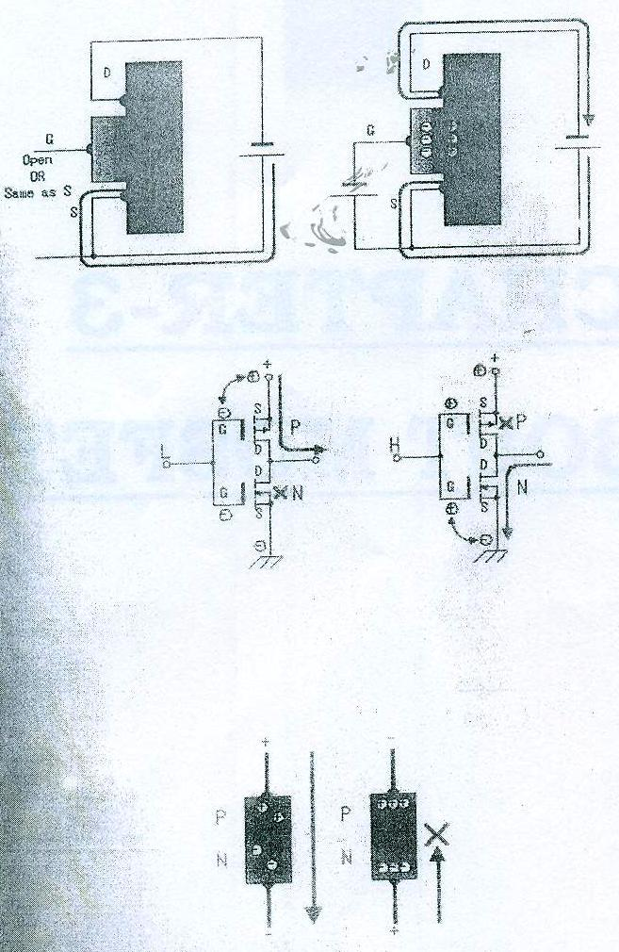

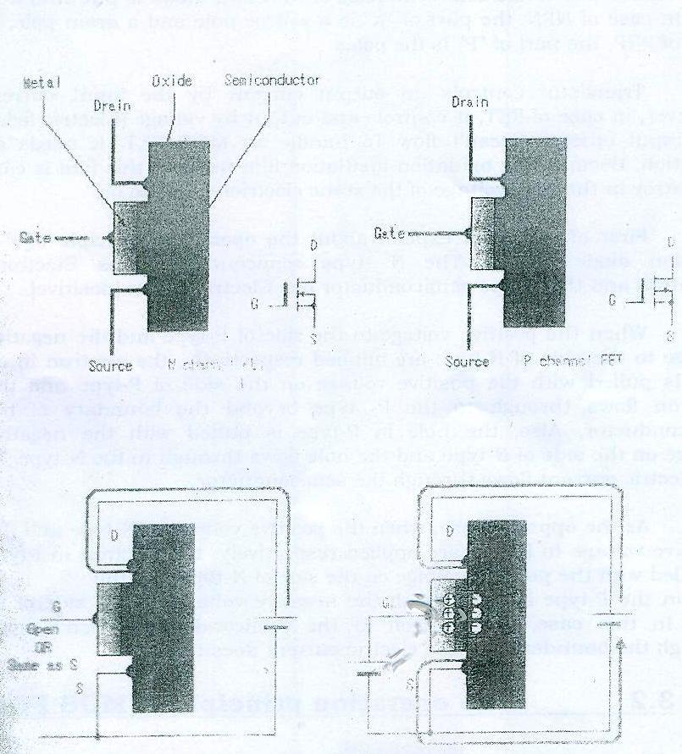

- THE OPERATION PRINCIPLE OF P-N JUNCTION DIODE:

It is the structure which stacked up Metal, Oxide and Semiconductor. There is NPN type and PNP type as the semiconductor part NPN type is called N-channel and PNP type is called P channel. An oxide film is put to the semiconductor of NPN and metal is put onto it as gate In case of NPN, the part of "N" is a source pole and a drain pole. In case of PNP, the part of "P" is the poles
Transistor controls an output current by the input current However, in case of FET, it controls and output by voltage (Electric field). The input current doesn't flow To handle an MOS FET, it needs an attention, Because the oxidation insulation film us thin, this film is easy to destroy in the high voltage of the static electricity and so on.

First of all, I will explain about the operation principle of P-N junction diode simply. The N -type semiconductor has Electrons (Negative) and the P-type semiconductor has Electron holes [positive].

When the positive voltage to the side of P-type and the negative voltage to the side of N-type are applied respectively, the electron in N- type is pulled with the positive voltage on the side of P-type and the electron flows through to the P- type beyond the boundary of the semiconductor, Also, the hole in P-t^{y}pe is pulled with the negative voltage on the side of N-type and the hole flows through to the N-type. In the electric current flows through the semiconductor.
As the opposite case, when the positive voltage to N-type and the negative voltage to P-type are applied respectively, the electron in 1-type is pulled with the positive voltage on the side of N-type and the Hole in the P-type is pulled with the ri-s:a-tive voltage on the side of 1)- type. In this case, the electron in the semiconductor doesn't move through the boundary and the electric current doesn't flow.
- The Operation Principle of MOS FET
The semiconductor part of MOS PET consists of NPN, So, when not '1 plying voltage to the gate, the electric current doesn't flow between drain and source.
When positive voltage is applied to the gate of the N-channel MOS FET, the electrons of N -channel of source and drain are attracted to the gate and go into the P-channel semiconductor among both. With the move of these electrons, it becomes the condition like spans a bridge for electrons between drain and source. The size of this bridge is controlled by the voltage to apply to thegate.In case of P-channel MOSFET, the voltage is opposite but does similar operation. When negative voltage is applied to the gate of P-channel MOS FET, the holes of P-channel of source and drain are attracted to the gate and gointo the N-channel semiconductor among both. With the move ofthese holes, a bridge for holes is spanned and the electric current flows between drain and source. Because there is an oxide film between gate and semiconductor, the electric current doesn't flow through the gate, an
Electric current flow between drain and source is controlled only with the
Voltage which is applied to the gate.

- The operation principle of C-MOS FET

C-MOS FET is the abbreviation of Complementary MOS FET, is the circuit which combined a P-channel MOSFET and a N-channel MOSFET. When the input is an L level, the P-MOS FET becomes ON condition and when input is an H level, the N-MOS FET becomes ON condition. At the C-MOS FET circuit, the N- MOIS FET and the P-MOS FET do the operation which is always opposite. The important characteristic of this circuit is that the comparatively big output current can be controlled when the input becomes an L level; the output is connected with the power supply by the P-MOS FET and becomes H level. Also, when the input becomes H level, the output is connected with the grounding by the N-MOS FET and becomes an L level. Phase of the input and the output is opposite.
He drain current of MOS FET is cutoff even if the gate voltage doesn't become 0V Lit may depend on the kind of the FET but a drain current is cutoff when the gate voltage is lower than IV or 2V in case of C-MOS circuit, P-MOST FET and N-MOS FET don't become ON condition at the same time

- INTRODUCTION OF MOSFET:-

A bipolar junction transistor is a current -controlled device and requires base current flow in the collector, since the collector current is dependent on the input; the current gain is knightly dependent on the junction temperature.
A Power MOSFET is a voltage controlled device and requires only small input current the switching speed is very high and the switching times are of the order to nanoseconds Power MOSFETs. Are finding increasing application in low power high Frequency converters. MOSFET
Not have the problems of electrostatic discharge and required special care in handling. In addition. It is relatively difficult to protect under short circuited fault condition.
MOSFETs are two types:
- Depletion MOSFET
- Enhancement MOSFET
N-channel type depletion MOSFET is a formed on a type silicon substrate as shown in fig. with two heavily doped n-f- silicon for low layer. The three terminals called gate, drain and source. The substrate . is normally connected in the n-channel area will be repelled and a depletion region will be created below the oxide layer, resulting in a narrower effective channel and a high resistance from the drain to source Rds and there will be no current flow from the drain to source Ids-Q the value of Vos when this happens is called pinch-off voltage Vp. On the other hand, Vgs is made positive the channel become wider, and Ids increases due to reduction in Rds. With a p-channel depletion-type Mosfet, the polarities of Yds, Ids and Vds are reversed.
At n-channel enhancement-type MOSFET has no physical channel, as shown in figure, If Vgs is positive, and induced voltage will attract the electrons from the p-Substrate and accumulate them at the surface beneath the oxide layer. If Vgsos greater than or equal to a value known as threshold voltage, Vt a sufficient number of electrons are accumulated to form a virtual n-channel and the current flows from the drain to source. The polarities of Yds, Ids, and Vgs are reversed for a p- channel enhancement type MOSFE,Ts of various sizes are shown in figure.

STEADY-STATE CHARACTERISTIC:-
The MOSFET are voltage controlled devices and have very high input impedance the gate draws a very small leakage current, in the order of anon amperes. The current gain, which is the ration of drain current (ID) to input gate current (JO) is typically on the order of 109. However, the current gain is not an important parameter, The Tran conductance, which is the ratio of drain current to the gate voltage, defines the transfer characteristics and is a very important parameter.
The transfer characteristics of n-channel and p-channel MOSFETs are shown in figure. Figure shows the output characteristics of an n- channel enhancement MOSFET,
There are three region of operation;
- cut off region
- Pinch of voltage or saturation region
3. Linear region

MOSFETs are orated in the linear region for switching action. In the saturation region„ the drain current remains almost constant for an increase in the value of VDs and the transistor are used in this region for voltage amplification. It should be noted that saturation has the opposite meaning to that for bipolar transistor, the steady state model which is the same for the both depletion type and enhancement type MOSFE'Fs is is shown in figure the Iran-conductance (Gm) is define as

Gm = Id / Vgs
The output resistance is normally very in the pinch off region, typically on the order of mega ohms and is very small in the linear region, typically on the order of milliohms.

For the depletion type MOSFETs, The gate voltage could be either positive or negative. But the enhancement type MOSFETs respond to appositive gate voltage only. The power MOSFETs are generally of enhancement type. However, depletion type MOSFETs would be advantageous and simply falls and Vgs becomes zero, The characteristics of depletion type MOSFETs will not be discussed further.

SWITCHING CHARACTERISTICS:-
Without any gate signal an enhancement type MOSFETs may be considered as two diodes connected back to back or as an NPN transistor. The gate structure has parasitic capacitances to the source, Cgs, and to the drain Cgs the NPN transistor has a reverse bias junctions form the drain to source and offers a capacitance Cdc. Fig shows the equivalent ckt of a parasitic bipolar transistor is shorted at the chip by metal zing the source terminal and the resistance from the base to emitter due to bulk resistance of n and p regions, RBE ,is small. Hence MOSFETs may be considered as having and internal diode and the equivalent it is shown in figure. The parasitic capacitances are depended on their respective voltage.

The switching model of MOSFETs is shown in figure. The typical switching wave forms and times are shown in fig. The turn on delay Td is the time that is required to charges the input capacitance to threshold voltage level The rise time.
TR is the gate charging time from the threshold level to the full gate voltage Vgs, which is required to drive the transistor into the linear regain. The turn-off delay time Td is required for the input capacitances to discharge from the overdrive gate voltage VI to the pinch off region. Vgs must decrease significantly Vds Begins to rise. The fall time that is required for the input capacitances to discharge from the pinch-off region to threshold
Voltage's Vgs<Vt the transistor turns off.

- WORKING OF MOSFET:-

MOSFET has two type of working mode.

1. Depletion mode.
2. Enhancement mod

(1) WORKING OF MOSFET IN DEPLETION MODE

It is obvious from fig. that is no P-N junction between and channel here the diffused channel neither insulating electric Si02 layer and the metal layer of the gate forms a parallel plate capacitor. For the depletion mode, the gate is maintained at positive potential. When voltage gate and source; zero, a significant current flows for a given Vds, like FET. Let negative potential is applied at the gate. In this case positives are induced in N-transit through S102 as shi

This serves to deplete the channel of majority carriers so the conductivity decreases. Greater the negative voltage on gate, greater is the reduction in number of electrons in the channel and consequently, lesser is its conductivity. Here it should be remembered that because of the voltage drop due drain current Id, the channel region near the source. Here too much negative gate voltage can be pinch off the channel. Hence MOSFET behaves like a FET.

(2) WORKING F MOSFET ENHANCEMENT MODE

The semiconductor channel [P-type substrate], the insulating dielectric Si02 layer and metal layer of the gate form a parallel plate capacitor. When a positive potential is applied at the gate with respect to substrate (which is usually groulided), negative charges, induced on P-type substrate consist of electrons and forms an inversion layer as shown in fig. The inversion layer forms an effective N-type channel. When the positive potential at the gate is increased, the magnitude of the induce N-channel increased. Accordingly the drain current increase. Thus for a constant drain voltage, the drain current positive drain voltage increases. In another words the drain current has been enhanced by the application
Of positive gate voltage. For this region, this MOSFER is termed as enhancement MOSFET.

MOSFET LOGIC AND POWER SWITCHING:-
The other kinds of FET switch applications are logic and power switching circuits. The distinction is simple; in analog signal switching you use a PET as series switch, passing or blocking a signal that has some range of analog voltage. - The analog signal is usually low level signal, a at insignificant power levels. In logic switching, on other hand, MOSFET switches open and close to generate full swings between the power supply voltages. The signals here are really digital, rather than analog-they swing between the power supply voltages, representing the two states HIGH and LOW. In between voltages are not useful or desirable; in fact, they arc not even legal. Finally, power switching refers to turning on or off the power to load as lamp, relay coil, motor winding; in these applications, both voltages and currents tend to be large.
• LOGIC SWITCHING;-
Fig shows the simplest kind of logic switching with MOSFETs; both circuits use a resistor as load and perform the logical function of inversion a HIGH input generates a LOW output and vice versa. The N- channel version pulls the o/p to ground when the gate goes HIGH for ground (LOW) I/p. Note that the MOSFETS in these circuits are used as common-source inverters, rather than as source followers. In digital logic circuits like this we are usually interested in the o/p swing to the drain supply when PET is off. Although we are using the same inverter circuit in the power switching application we are interested instead interning the load on and off.
- POWER SWITCHING
We want to control power MOSFET from the output ofThe digital logic. Although there are logic families that generateSwings of 10v or more, the most common logic families us9Levels of +5v or +2.4v. Figure shows how to switch loads from these three logic families. In the first circuit, the +10v gate drive will fully turn on any MOSFET, so we choose the VN0106, and inexpensive transistor that specifies Ron<5ohms at Vgs=5v. The diode protects against inductive spike; the series gate resistor, though not essential is good idea. Because MOSFET drain-gate capacitance can couple the loads inductive transients back to the delicate CMOS logic. In the second circuit we have 5v of gate drive, still fine for the VN01/VP01 series; for variety we have used P-channel MOSFET, driving a load return to ground.Our inverter is based on power MOSFET. Here is some advantage of Power MOSFET:
- It can operate on low level signal
- It is less expensive.
- It reduces circuit size.
- It does not require pre-amplifier from input signal.
- It has inherent high speed turn on and off capacity.
- It is more reliable.

CHAPTER – 4
BLOCK DIAGRAM OF MOSFET BASED INVERTER

- CHAPTER4 BLOCK DIAGRAM OF MOSFET BASE INVERTER
Connect the car battery to the circuit using crocodile clips. The red clip should be connected to the positive terminal of the battery & the black clip should be connected to the Negative terminal of the battery. If crocodile clip should be connected to the wrong terminals of the battery LED glows to alert you.

MOSFET BASE INVERTER WITH CHARGE

- General Descri
This MOSFET base power inverter is capable of generating approximately 35oyb power) the inverter provides enough power up to 350W if we use car battery 8s it is fully charged. For the testing purpose you can use any 12V 7 Ah (or more) battery. Output is 230Vac 50Hz.
As seen from the block diagram this inverter consists following stages. Power supply, charger ckt. For the 12V 7Ah battery, Oscillator circuit, divider circuit, battery low ckt. Power amplifier Inverter transformer.

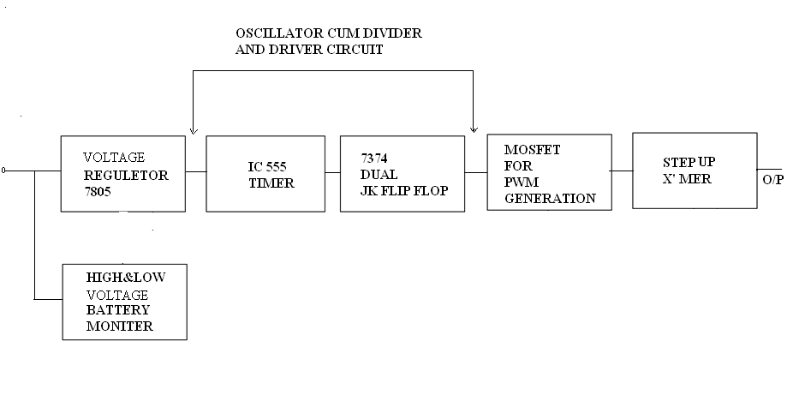

FIG: 4.1 BLOCK DIAGRAM OF MOSFET BASE INVERTER
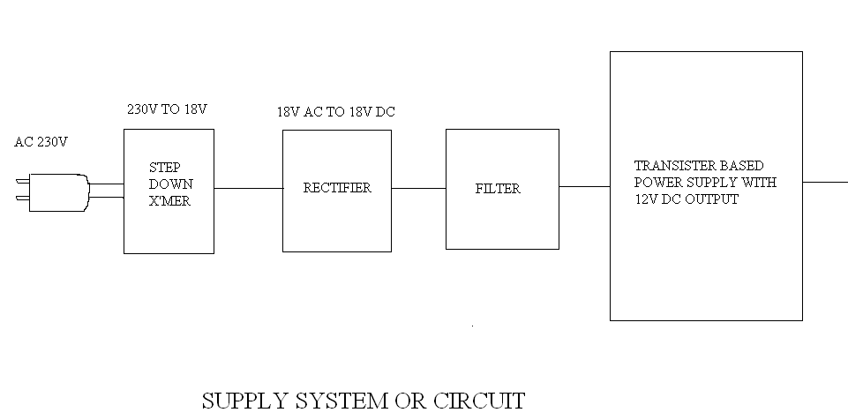

FIG-4.2 BLOCK DIAGRAM OF MOSFET BASE INVERTER

- BLOCK DIAGRAM OF MOSFET BASE INVERTER
Connect the car battery to the circuit using crocodile clips. The red clip should be connected to the positive terminal of the battery &, the black clip should be connected to the negative terminal of the battery. If crocodile clip are connected to the wrong terminals of the battery LED glows to alert you.
eX".
Now switch on the unit. LED glows to indicate power is on & 12V DC reaches regulator 1C 7805. Tile regulated output is fed to the oscillator- cum-divider and driver while the center terminal of the inverter transformer primary is connected to the positive terminal of the battery. Capacitor Cal functions as a reservoir capacitor.

- Low battery indicator:- For long life of the battery, it
Should not be allowed to discharge to a voltage below 10V. Even a single event of deep discharge can reduce the charge-holding capacity of the battery permanently, for audio -visual indication of the low-battery level, a LM741 1C is used. A fixed reference voltage of 5. IV is applied to its inverting pin of the 1C. While the sensing voltage is applied to its non-inverting input. Set preset P1 such that the piezobuzzer sounds when the on-load battery voltage fails below 10V.
When the battery voltage drops below 10V, the sense input voltage drops below 5.1V and output pin 6 of the op amp 1C goes high to sound the buzzer and light up LED.
- Oscillator-Cum.-Divider:-
The oscillator-cum-divider section is built around timer 1C LM555 and dual J-K flip-flop IC 7473. Only one flip-flop of the dual J-K- flip-flop is used here. Timer 1C LM555 is wired as an as table multivibrator. Whose time period is decided by resistors R7 and RS and capacitor C5. It produces 100Hz at output pin 3. Which is given to the pin no 5 of 1C 7473. This 1C will produce 50 Hz with 50% duty cycle. When the inverter is switched ON 1C2 starts producing 100 Hz, while the J- K flip-flop produces 50 Hz at its output pin 8 &, 9. The output of the timer 1C2 can be checked using the oscilloscope at pin no. 3.
- Driver circuit:-
The flip-flop output is fed to MOSFET driver transistors Ti 86 T2 via a diode-transistor network. At any instant, if the voltage of pin no. 8 of IC3 is +5 V, the voltage at its pin no. 9 will be OV, and vice versa. Therefore when transistor Ti conducts, transistor T2 is cut off and vies versa Whenever output pin 8 of IC3Goes high, NPN transistor Ti conducts and the corresponding set of MOSFETs (T3-T5) remains cut off while the collector of transistor T2 is at 5V. Thus the current flows through half of the inverter transformer's primary winding. Similarly, when output pin no 9 of IC3 goes high, npn transistor T2 conducts and the corresponding set of MOSFETs {T6-T8) remains cut off while the collector of transistor Ti is at 5V.Thus current flows through the inverter transformer's primary winding.
- Power amplifier:-
The power amplifier section comprises two
Sets of three power MOSFETs connected in parallel for operation of the inverter. The output of IC3 drives the MOSFETs via transistors Ti 86 T2 to generate 5011z, 230V AC at the output of inverter transformer XI
- Fabrication:-You call _3_ssemble the circuit on given P.C.B. However, an actual-size PCB for the medium-power inverter circuit is shown. Piaf configuration of MOSFET IRFZ44, regulator IC 7805 and npn transistor BD139 are given. After construction, enclose the entire circuit in any portable box. Use separate heal sinks for each MOSFET set Construction, enclose the entire circuit in any portable box. Use separate heat sinks for each MOSFET set

CHAPTER – 5 ADVANTAGES OF PWM INVERTER OVER OTHER CONVENTIONAL INVERTER

- ADVANTAGE OF PWIVI INVERTER OVER OTHER CONVENTTONAL INVERTER;-

- It can operate on low level power signal with economically.
- It is less expensive as compared to other inverter for small power
Application.
- It reduces the circuit size.
- The other conventional inverter e have running and moving parts so they
Have higher losses where as in PWM inverter running and
Moving
Part so power consumption is less.
- Power MOSFER has high speed turn on and turn off capacity so
Compare to other inverter.
- It is more reliable
- The efficiency is high about 90%

CHAPTER – 6 APPLICATIONS

- APPLICATION

- In home, shops, office, hospitals, cinemas etc.
- It is used to run electrical or electronics devise such as
FAN, TV, VCR, TUBE, & BULB etc.

General application of an inverter
In industry application such as
- Variable Speed AC moter drive
- In U.P.S. (Un interruptible Power Supply)
- Air Craft Power Supplies

CHAPTER – 7 PARTS LIST

INVERTER

- RESISTORS:-
R1, R3, R9 --- 1.2KΩ -- Brown Red Red Golden
R2.121.2, TO R 16 ---- 1K2Ω
R6, R8 --- 330Ω
R7 ---- IΩ / 1W
R4 ---- 560Ω
R5 ---- 1.0KΩ
R11 ---- 15KΩ
R10 ---- 220Ω
PI ---- 50KΩ Horizontal Preset
- CAPACITORS:-
Cl, C2, C3 0.1µF-104 -
C4 100 µF/25V
C5 0.47 µF/63V
C6 0.01 µF/25V
C7 1000 µF/25V
- SEMECONDUCTOR:-
D1, D4 ---- 5.1V Zener diode
D2, D3 ---- IN4148
D5, D6, D7, D8 ---- IN4007
Q1, Q4 ---- BC547
Q2, Q3 ---- BD 139
TI TO T6 ---- IRFZ44
IC1 ---- 7805
UI ---- LM741
U2 ---- NE555
U3 ---- 74LS73
L2, L5 ---- Red KED
L4 ---- Yellow LED
L1 ---- Green LED
RL1 ---- 12 V, 200Q I CO Relay
S1 ---- on/off Switch
Transformer :- 0-12V,1A for battery charging
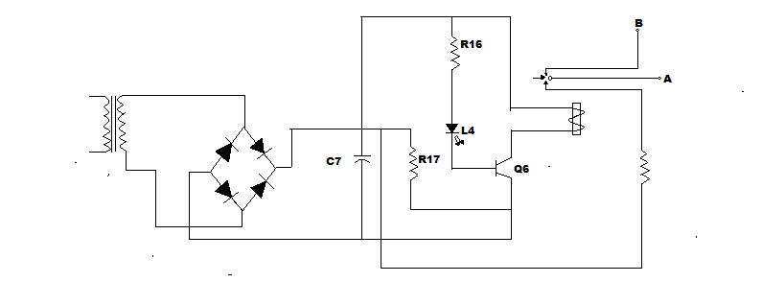
Fig :7.1 Supply system or circuit

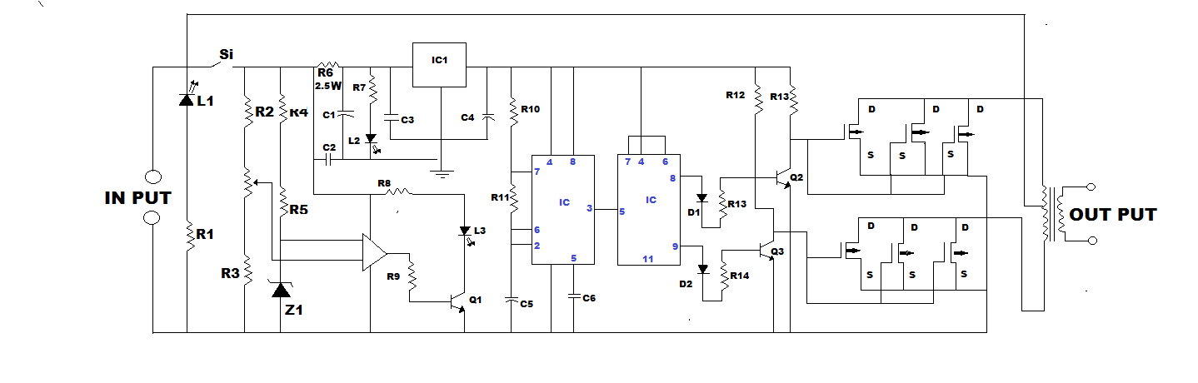

FIG-7.2 MOSFET BASED INVERTER

CHAPTER – 8 REERENCE

- REFERENCE:

- WWW.Google.com
- WWW.ciruitstody.com
- Electronic for you magazine

