**INDEX**

|  |  |
| --- | --- |
| **CHAPTER**  **NO.** | **TOPIC** |
| **Chapter-1** | **Introduction** |
| **Chapter-2** | **Introduction Grinding Process** |
| **Chapter-3** | **Introduction About IDP** |
| **Chapter-4** | **Details Description of IDP** |
| **Chapter-5** | **Conclusions** |
| **Chapter-6** | **Reference** |

***1. Company Profile***

**1.1 Introduction**

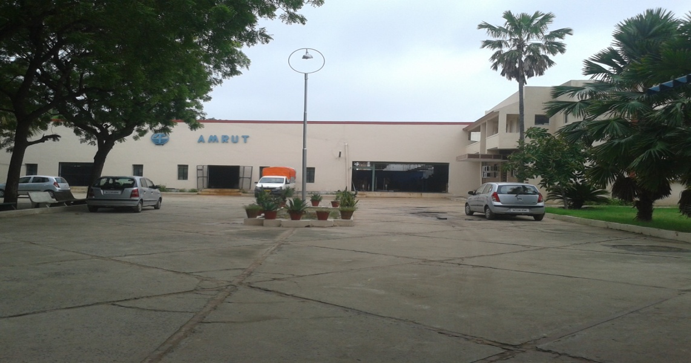

As a part of Project subject, we visited Amrut Engineering Pvt Ltd situated in Visnagar. It is medium scale, private limited organization. It is one of the leading Manufactures in India and Exporters of submersible pump and mono block pumps sets to African Countries, UAE, Bangladesh, Sri Lanka, Nepal, Sudan, Morocco, South East Asian Countries etc.

Amrut Engineering Pvt Ltd has made huge investment in plant & latest machinery, implementation of their R&D Department and maintenance of international quality system. They believe in 100% customer satisfaction as Quality and Customers are their major strength. Their continuous research and up gradation of their latest technology in the field of Submersible Pump and Mono Block Pump manufacturing industry helps them to grow as one of the major supplier.

Amrut Engineering Pvt Ltd strongly believes in periodical maintenance of International Quality Systems and Implementation of latest Technologies. Company have fully equipped with measuring instruments and tooling machines at machine shop to ensure standardization of products.

They have established Quality Management System in accordance with ISO 9001:2008.

* 1. **Company Address**

|  |  |
| --- | --- |
| **Corporate office** | **Industry** |
| Post Box No 4141, Second Floor,Motilal Centre, Near Dinesh Hall, Ashram Road, Ahmedabad-380009  Phone No: +91 79 27546932.  Email: [amrutpump@jindalonline.net](mailto:amrutpump@jindalonline.net) | 115/1-2, GIDC Estate,  Kansa Road,  Visnagar - 384315  Dist.Mehsana, Gujarat  Phone No: (02765) 220840  Email: [amrutpump@jindalonline.net](mailto:amrutpump@jindalonline.net) |

**1.3 History**

A part from the struggle that took place in the life of MR.A.L.PATEL, the present managing director, finally visualized the need and demand of submersible pump in this area. In 1972, he finalized dealership of ATLANTA pumps with one working partner in MR.S.J.PATEL, in name of M/S. AMRUT TRADERS at Visnagar. After three years i.e. in 1975 he started repair workshop in order to render effective after sales services to his clients. In 1977 he started assembly of submersible pump set with few spares purchased from the market.

1978, he started of own manufacturing activities in the same location and inducted AMRUT brand submersible pump set successfully and manufactured 227 sets in first year and 329 sets in second year. The production was restricted up to 15 HP in V6 frame size and up to 45 HP in V8 frame Amrut engineering co. Two more working partners in Mr. M. Sheth for technical matters was inducted in the organization.

In 1984, started another firm and started of AMRUT and EMPIRE brand pump sets from corporate office in swastick super market, Ahmadabad. Finally shifted this firm 1987 in present location in name of Amrut engineering Pvt. Ltd, 115/1-2GIDC Estate, Kansa road in the area of 10400 sq meters and started full fledge manufacturing factory along with 20 ancillaries. Amrut engineering was established located at Ahmadabad, keeping the same AMRUT brand name. Presently we have registered capacity up to 150 hp and 900 sets per shift per month. But installed capacity has been such that conveniently we can give 1600 sets per shift per month from this capacity.

* 1. **Organization**

Organization establishes the pattern of relationship by giving duties and responsibility to an individual or group. In the same concerned, Amrut Engg. Pvt ltd has decided management as well as production organization as describe next.

* + 1. **Management Organization**

Figure 1.1 shows management organization at the company.

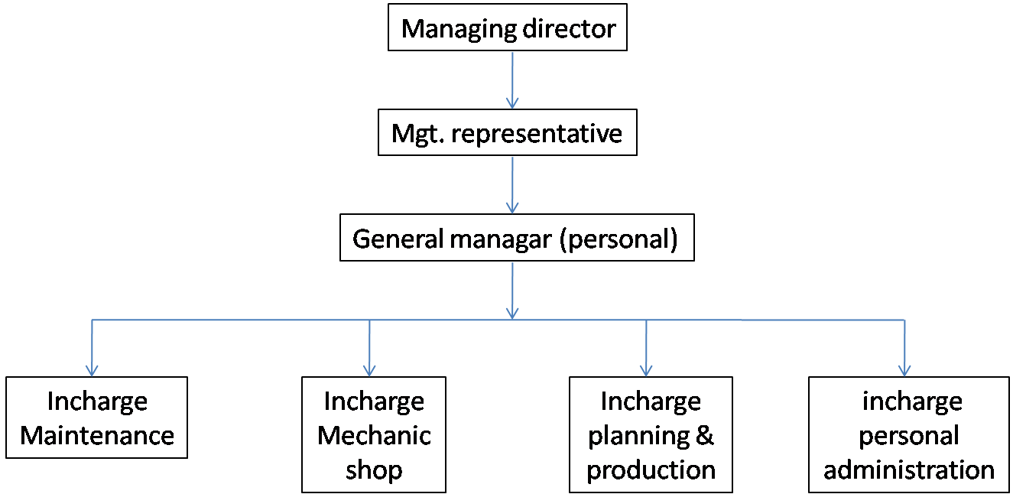

Figure 1.1 Management Organizations

* + 1. **Production Department**

Management of Amrut Engg. Pvt. Ltd looks after the production as per given below figure 1.2.

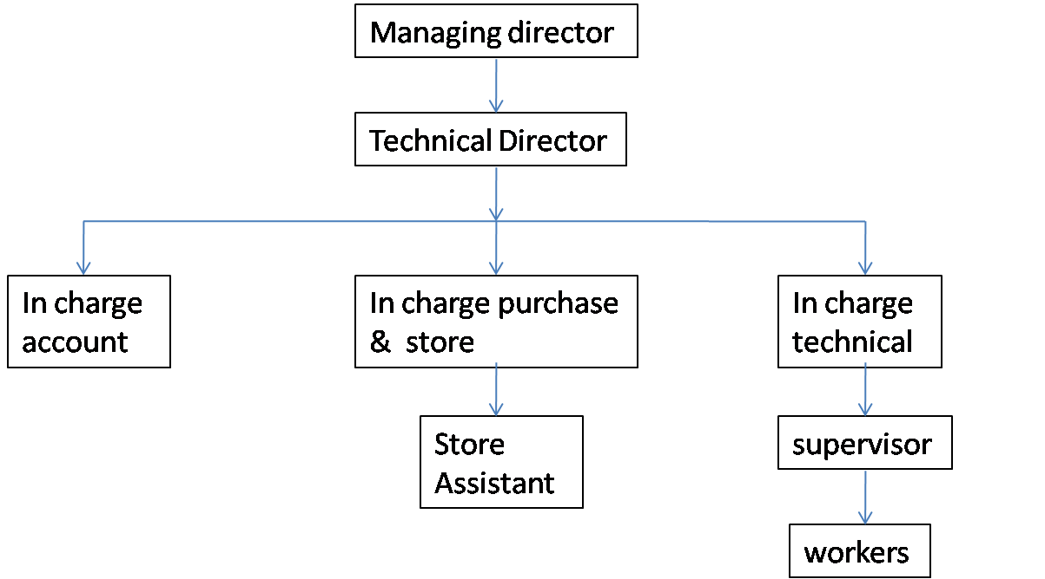

**Figure 1.2 Production Department**

* 1. **Company Product**

Company is manufacturing various products with efficient quality. The next is the detail of the products and its specification.

* + 1. **Vertical Submersible Pump**

The vertical submersible pump is used to lift the water from the dip well. The main use of it is to supply water for farming. Figure 1.3 shows the vertical submersible pump.

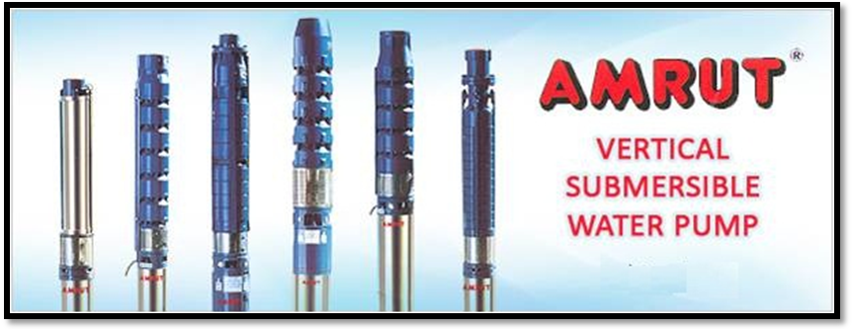

Figure 1.3 Vertical Submersible Pump

* + 1. **Horizontal Submersible Water Pump**

Horizontal submersible water pump is used to supply the water for High rise Buildings, Bungalows / Housing Colonies, Sprinkler Systems, Cooling Plants

Fountains, Riverbed, Sump / Jackwell, Fire Fighting Systems, Canals, Open Wells, Lift Irrigation. Figure 1.4 shows horizontal submersible pump.

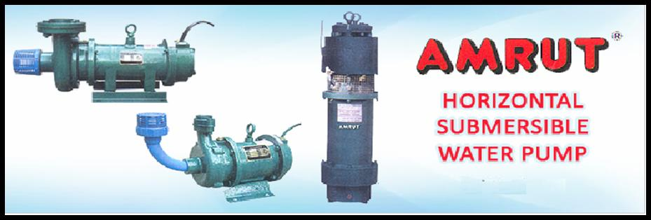

Figure 1.4 Horizontal Submersible Pumps

* + 1. **De Watering Drainage Water Pump**

Dewatering drainage water pump is used to discharge the drainage of wastage water which has been already utilized in the process industries. Figure 1.5 shows the De Watering Drainage Water Pump.

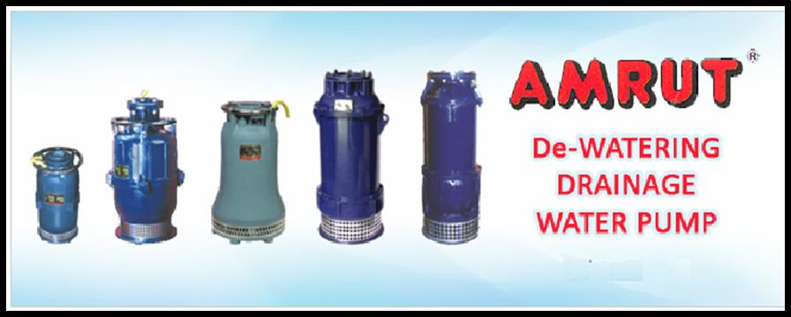

**Figure 1.5 De Watering Drainage Water Pump**

**2. Introduction Grinding Process**

**2.1 Introduction**

Manufacturing is derived from the Latin word manufactus, means made by hand. In modern involves making products from raw material by using variousprocesses, by making use of hand tools, machinery oreven computers. It is therefore a study of the processesrequired to make parts and to assemble them in machines.The study of manufacturing reveals those parameterswhich can be most efficiently being influenced to increaseproduction and raise its accuracy.

Grinding is a metal removal process that employs an abrasivGW whose cutting elements are grains of abrasive materials of high hardness and high refractoriness The sharp-edged and hard grains are held together by bondingmaterial. Projecting grains (Figure 1) abrade layers ofmetal from the work in the form of very minute chips as the

wheel rotes at high speeds of up to 60 m/s.



Figure 1. Cutting Principles and Main Variables of a Surface

**2.2**  **Grinding Process**

System Elements - The system elements consist of inputs,disturbances, productive outputs, and non-productive outputs. The elements of a grinding system are illustrated in figure 2. Work piece material, Shape, hardness, stiffness, thermal.

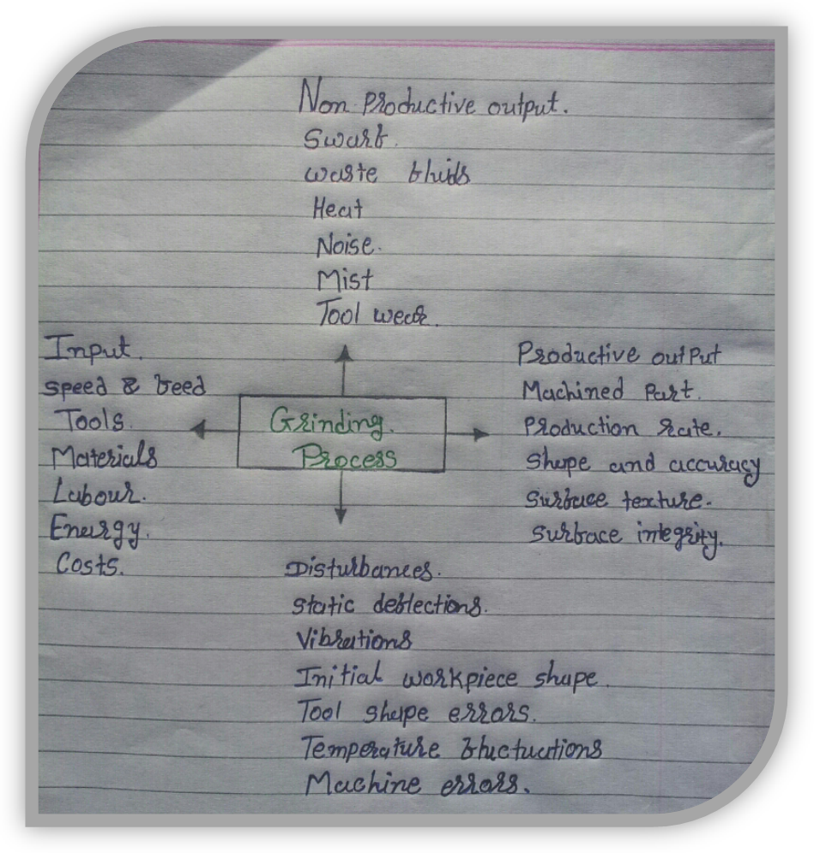

**Figure 2. Inputs and Outputs of a Grinding Process**

**2.2.1 Properties.**

* Grinding machine: Type, control system, accuracy, stiffness, temperature stability, vibrations.
* Kinematics: The geometry and motions governing the engagement between the grinding wheel and the workpiece.
* Grinding wheel: Abrasive, grain size, bond, structure,

hardness, speed, stiffness.

* Dressing conditions: Type of tool, speeds and feeds,

cooling, lubrication.

* Grinding fluid: Flow rate, velocity, pressure, physical,

chemical properties.

* Atmospheric environment: Temperature, humidity, and

effect on environment.

* Health and safety: Risks to the machine operators and

the public.

* Waste disposal.
* Costs.

Dry-machining - some Factors for Consideration [7]

• Adopting a ‘dry machining’ strategy will only make sense,if all the cutting processes in the part’s manufacture canbe performed without coolant,

• Only by utilizing specialized cutting tool geometries, can‘dry-machining’ be possible and effective,

• Tooling typically having special hard multi-layered, ordiamond-like coatings, etc., to isolate heat and createminimal thermal conduction across the tool/chip interface,

• Employing cutting tool materials producing sharp edgegeometries – to reduce heat,

• For drilling operations, utilize ‘soft-glide’ coatings –forlubrication, with the necessary and appropriate efficientchip transportation geometries,

**2.3 THE TAGUCHI SYSTEM OF QUALITY ENGINEERING**

The major steps of implementing the Taguchi method are:

1)to identify the factors/interactions,

2) to identify the levelsof each factor,

3) to select an appropriate orthogonal array(OA),

4) to assign the factors/interactions to columns of theOA,

5) to conduct the experiments,

6) to analyze the dataand determine the optimal levels, and

7) to conduct the confirmationexperiment.

**2.4 SIGNAL-TO-NOISE RATIO**

In the field of communication engineering a quantity calledthe signal-to-noise (SN) ratio has been used as the qualitycharacteristic of choice.

The SN ratio transforms several repetitions into one valuewhich reflects the amount of variation present and the meanresponse. The discretew case will be explained later.

1) Nominal is Best Characteristics

2) Smaller the Better Characteristics

3) Larger the Better Characteristics

**2.5 ORTHOGONAL ARRAYS**

An orthogonal array is a fractional factorial matrix which assures a balanced comparison of levels of any factor or interactionof factors. It is a matrix of numbers arranged in rowsand columns where each row represents the level of the factors in each run, and each column represents a specific factorthat can be changed from each run. The array is calledorthogonal because all columns all columns can be evaluated independently of one another.

* 1. **Advantages & Applications**

**Advantages**

* + Dimensional accuracy
  + Good surface finish
  + Good form accuracy

**Application**

* + Descaling, deburring
  + Finishing of flat as well as cylindrical surface
  + Grinding of tools and cutters and resharpening of the same.
  + Surface finishin

**3. Introduction about IDP**

**3.1 CONSTRUCTION OF A GRINDING WHEEL**

* In order make the grinding wheel suitable for different work situations, the features such as abrasive, grain size, grade, structure and bonding materials can be varied.
* A grinding wheel consists of an abrasive that does the cutting, and a bond that holds the abrasive particles together.

**3.2 Abrasives**

* Abrasives can be natural or manmade.
  + Natural include:
    - Sand stone
    - Emery
    - Diamond
    - Garnet
    - Quartz

Manmade (1891 time frame most commonly used today)

* + - Silicon Carbide
    - Aluminum Oxide
    - Cubic Boron Nitride
  1. **Bonding materials**
* Vetrified bonds
* Mineral bonds
* Organic bond

**3.4 Types of grinding wheels**

Acco. To bonding material:

1. Vitrified grinding wheel
2. Silicate grinding wheel
3. Elastic grinding wheel
4. Resiniod grinding wheel
5. Welkenize grinding wheel
6. Oxy chloride grinding wheel

**3.5 Acco. to wheels grade:**

1. Soft grade wheel
2. Hard grade wheel

Acco.to structure:

1. Open structure wheel
2. Closed structure wheel
3. Acco.to shape of grinding wheel

Selection of grade depends on hardness of workpiece material, grinding speed, contact area of grinding wheel with the workpiece, capability of grinding machine. Grinding wheels are named as soft, hard or medium hard wheels depending on their grade. Abrasives of hard grinding wheels get blunt quickly so these are recommended to grind workpiece of low hardness and soft grinding wheels are recommended for hard material workpieces.

**3.6 Wheel Forms**

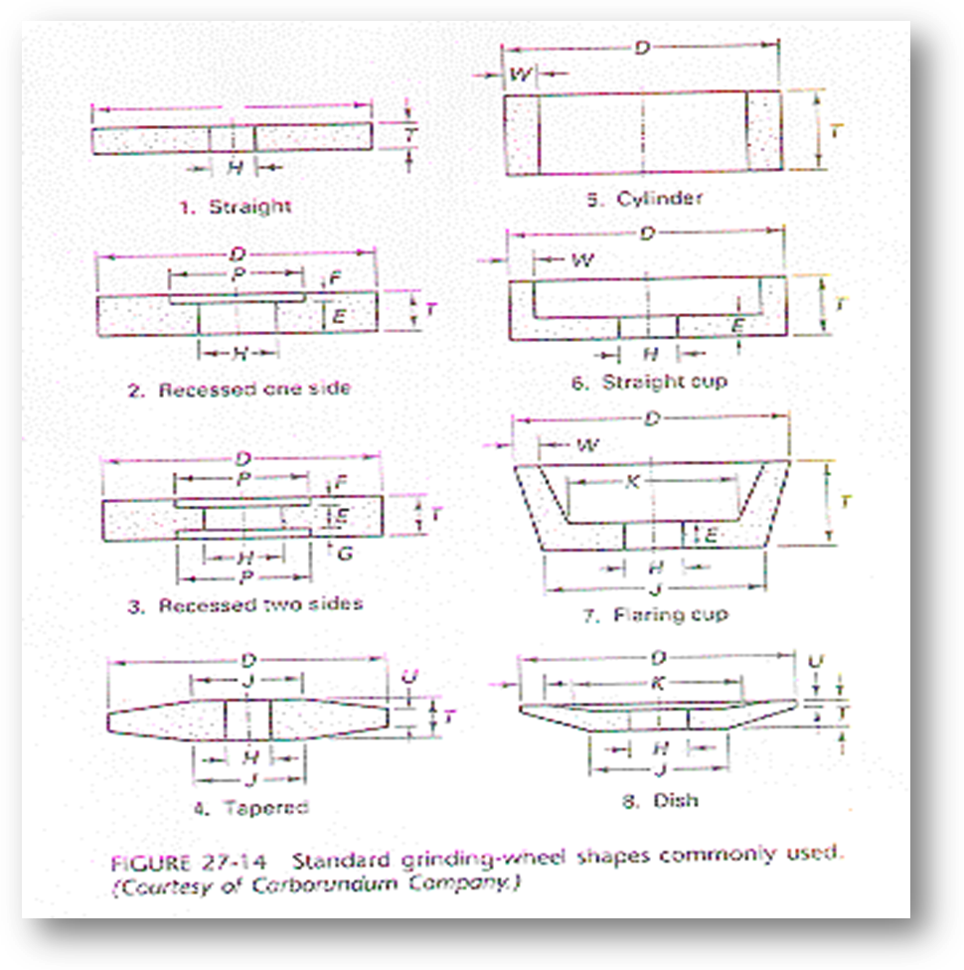

**3.7 Different shape of grinding wheel**

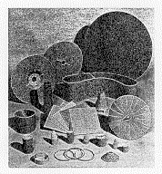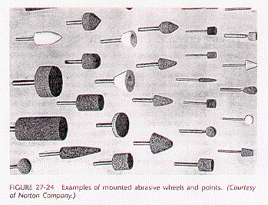

**3.8 STRUCTURE**

* This indicates the amount of bond present between the individual abrasive grains, and the closeness of the individual grain to each other. An open structured wheel will cut more freely. That is, it will remove more metal. In a given time and produce less heat.

**3.9 BOND**

A bond is an adhesive material used to held abrasive particals together; relatively stablethat constitute a grinding wheel. Different types of bonds are :

Vitrified bond (V) Silicate bond (S)

Shellac bond (E) Rubber bond (R)

Resinoid bond (B)

* These bonds are being explained here in brief.

**Vitrified Bond**

This bond consists of mixture of clay and water. Clay and abrasives are

thoroughly mixed with water to make a uniform mixture. The mixture is mouldedto shape of a grinding wheel and dried up to take it out from mould. Perfectlyshaped wheel is heated in a kiln just like brick making. It this way clay vitrifiesand fuses to form a porcelain or glass grains. High temperature also doesannealing of abrasive. This wheel posses a good strength and porosity to allowhigh stock removal with coal cutting. Disadvantage of this type of wheel are, it issensitive for heat, water, oil and acids. Their impact and bending strengths are alsolow. This bond is denoted by symbol ‘V’ in specification.

**Silicate Bond**

Silicate bonds are made by mixing abrasive particals with silicate and soda orwater glass. It is moulded to required shape, allowed to dried up and then takenout of mould. The raw moulded wheel is baked in a furnace at more than 200oCfor several days. These wheel exhibits water proofing properly so these can beused with coolant. These wheels are denoted by ‘S’ in specification.

**Shellac Bond**

These are prepared by mixing abrasive with shellac than moulded by rolling andpressing and then by heating upto 150oC for several hours. This bond exhibitgreater elasticity than other bonds with appreciable strength. Grinding wheelshaving shellac bond are recommended for cool cutting on hardened steel and thin sections, finishing of chilled iron, cast iron, steel rolls, hardened steel cams and aluminium pistons. This bond is denoted by ‘E’ in specifications.

**Resinoid Bond**

These bonds are prepared by mixing abrasives with synthetic resins like backelite and redmanol and other compounds. Mixture is moulded to required shape and baked upto 200oC to give a perfect grinding wheel. These wheels have good

grinding capacity at higher speed. These are used for precision grinding of cams, rolls and other objects where high precision of surface and dimension influence the performance of operation. A resinoid bond is denoted by the letter ‘B’.

**Rubber Bond**

Rubber bonded wheels are made by mixing abrasives with pure rubber and sulpher. After that the mixture is rolled into sheet and wheels are prepared by

punching using die and punch. The wheels are vulcanized by heating then in furnace for short time. Rubber bonded wheels are more resilient and have larger abrasive density. These are used for precision grinding and good surface finish. Rubber bond is also preferred for making thin wheels with good strength and toughness. The associated disadvantage with rubber bond is, these are lesser heat resistant. A rubber wheel bonded wheel is denoted by the letter ‘R’.

**Oxychloride Bond**

These bonds are processed by mixing abrasives with oxides and chlorides of magnesium. The mixture is moulded and baked in a furnace to give shape of a grinding wheel. These grinding wheels are used for disc grinding operations. An oxychloride bonded wheel is specified the letter ‘O’.

**3.10 SURFACE GRINDING OPERATIONS**

* Rough grinding
* Precision grinding
* Surface grinding
* Cylindrical grinding
* Centreless grinding
* Form grinding & Profile grinding
* Plunge cut grinding

**3.11 GENERAL SAFETY**

* Keep the floor and gangways clean and clear.
* Don’t touch or handle any equipment/machine unless authorized to do so.
* Don’t walk under suspended .
* Use the correct tools for the job.
* Keep the tools at their proper palace.
* Wipe out split oil immediately.
* Ensure adequate light in the workshop.

**3.12 Grinding Wheel Operating Procedures**

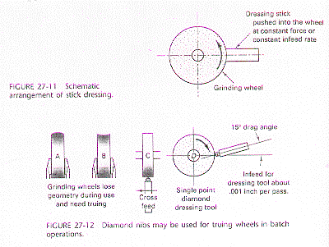

**3.13 Wheel Classification,**

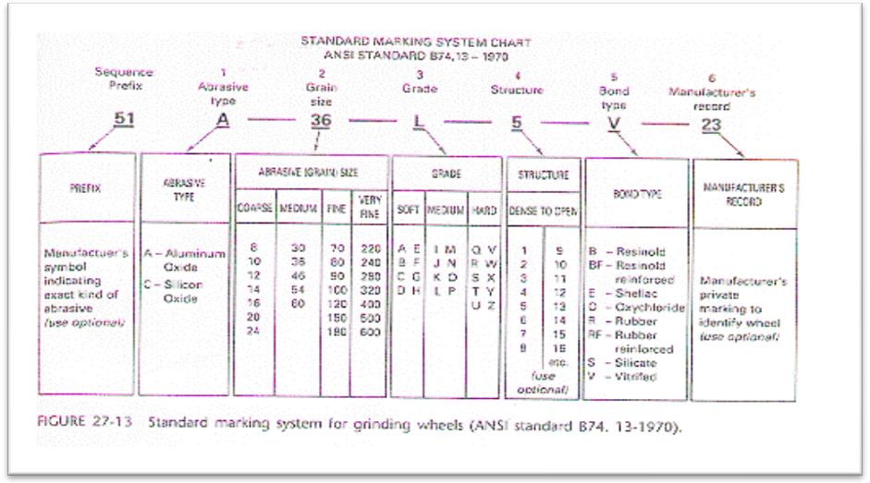

Nomenclature of grinding wheel

* Manufacturer symbol
* Types of abrasive
* Grain size
* Grade
* Structure
* Types of bonds
* Manufacturer Marko

**4. Details Description of IDP**

* 1. **Analysis of grinding wheel with different speed**

**PERIPHERICAL SPEED OF GRINDING wHeel**

When the rotation speed decreases, the grinding wheel behaves as if it were softer, thus improving its grinding capacity. As a general guide, with every 5-8 mt/sec reduction in peripheral speed the grinding wheel loses approximately 1 degree of hardness. In contrast, if we need the grinding wheel to retain its profile or to produce a better finish (i.e. behave as if it were harder) the peripheral speed should be increased. Within reason, however: a grinding wheel that turns too slowly tends to lose its grains before the abrasive granules have the chance to work. Conversely, when increasing the speed, the limit is the maximum allowable speed indicated on the label of the grinding wheel, which absolutely must not be exceeded to avoid the risk of the tool exploding. Normally the recommended peripheral speed is slightly lower than the maximum indicated on the grinding wheel.

**SPEED OF WORKPIECE**

When the speed of the workpiece is reduced, each granule has to remove a larger quantity of material and is therefore subjected to greater pressure, meaning that the grinding wheel self-dresses more easily, and so behaving as if it were softer. The desired effect is not always achieved, however. Often on grinding wheels of medium-to-high hardness the greater stress to which they are subjected cancels out the self-dressing action of this expedient. As a rule, the speed of the workpiece can range between 10 and 20 metres per minute. For surfaces grinding this value corresponds to the table speed.

**4.2 PARAMETERS OF GRINDING OPERATION**

Normal parameters used in grinding operation are cutting speed, feed rate and depth ofcut. These parameters are described below.

**Cutting Speed**

Cutting speed is grinding wheel is the relative peripheral speed of the wheel with respectto the workpiece. It is expressed in meter per minute (mpm) or meter per second (mps).The cutting speed of grinding wheel can be calculated as mpm

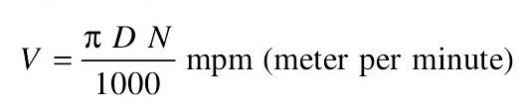

where, *D* is diameter of grinding wheel in mm. *N* are the number of revolution of grinding wheel if *N* is expressed in number of revolutions per minute, *V* will be in mpm,if *N* is expressed in number of revolution per second, *V* will be in mps.

**Feed Rate**

Feed rate is a significant parameter in case of cylindrical grinding and surface grinding. Feed rate is defined as longitudinal movement of the workpiece relative to axis of grinding wheel per revolution of grinding wheel. Maximum feed rate should be upto 0.9 time of face width of grinding wheel for rough grinding and upto 0.6 times of face width of grinding wheel for finish grinding. Feed can not be equal to or more than the width of grinding wheel. Feed is used to calculate the total grinding time as given below.

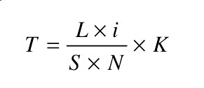

where *T* is the grinding time (min) *L* is the required longitudinal travel in mm. *i* is the number of passes required to cover whole width *S* is the longitudinal feed rate (mm/rev.). *N* is the rpm and *K* is the coefficient depending on the specified grade of accuracy and class of surface finish for rough grinding *K* = 1 to 1.2 and for finish grinding *K* = 1.3 to 1.5.

**Depth of Cut**

Depth of cut is the thickness of the layer of the metal removal in one pass. It is measured in mm. normally depth of cut is kept ranging 0.005 to 0.04 mm. Smaller depth of cuts are set for finish and precision grinding. The table given below shows recommended bonds and cutting speed for type of a workpiece.

|  |  |  |  |
| --- | --- | --- | --- |
| **TYPE OF WORKPICE** | **BOND** | **CUTTING SPEED** |  |
| Tool Steel | Vitrified | 15 TO 25 | PRECISION  GRINDING |
| High Speed Steel | Vitrified | 15 TO 25 |
| Cemented Carbide | Resin or Rubber | 15 TO 25 |
| CAST IRON | Resin or Rubber  or  Vitrified | UP TO 30 | ROUGH  GRINDING |
| STEEL | UP TO 25 |
| Bronze | UP TO 20 |
| Soft Iron | UP TO 20 |

**4.2 GRINDING FLUIDS**

Application of grinding fluids has been found to be effective in reducing the adverse thermal effects and high work surface temperature. All cutting fluids can be used as coolant in grinding operations and so these can also be named as grinding fluids.

Normally grinding fluids remove heat from grinding zone and wash the clips away. Generally two types of grinding fluids are used :

(a) Water based fluids, and

(b) Oils based fluids.

Water based fluids remove heat from grinding zone but these do not provide any lubrication to the grinding zone. However, oil based fluids provides lubrication properties also. Heat removing capability of oil base fluid is more due to their high specific heat. Examples of water based fluids are dissolved chemicals into water like sulfur chlorine, phosphorus, etc. Examples of oil based fluids are oils originated from petroleum, animals and vegetables. They can be emulsified oils suspended in water in the form of droplets. Cutting fluids can be recycled in flow after filtering them by separating out chips and dirt.

**4.3 DEFECTS AND REMEDIES IN GRINDING**

Major and inevitable defects in grinding are glazing of grinding wheels. Its remedy will be discussed later. After the continuous use grinding wheel becomes dull or glazed. Glazing of the wheel is a condition in which the face or cutting edge acquires a glass like appearance. That is, the cutting points of the abrasives have become dull and worn down to bond. Glazing makes the grinding face of the wheel smoother and that stops the process of grinding. Sometimes grinding wheel is left ‘loaded’. In this situation its cutting face is found being adhering with chips of metal. The opening and pores of the wheel face are found filled with workpiece material particals, preventing the grinding action. Loading takes place while grinding workpiece of softer material.

**Dressing**

The remedies of glazing and loading is dressing of grinding wheels. Dressing removes the loading and breaks away the glazed surface so that sharp abrasive particals can be formed again ready for grinding. Different type of dressing operations are done on a grinding wheel. One of them is the dressing with the help of star dresser. It consists of a number of hardened steel wheels with sharp points on their periphery. The total is held against the face of revolving wheel and moved across the face to dress the whole surface. Another type of wheel dresser consists of a steel tube filled with a bonded abrasive. The end of the tube is held against the wheel and moved across the face.

**Truing**

Truing is the process of restoring the shape of grinding wheel when it becomes worn and break away at different points. Truing makes the wheel true and concentric with the bore.

**4.4 BALANCING OF GRINDING WHEEL**

Due to continuous used a grinding wheel may become out of balance. It con not be balanced either by truing or dressing. Here it is important to explain the meaning of a balanced wheel. It is the coincidence of centre of mass of wheel with it axis of rotation. Wheels which are out of balance produce poor quality of surface and put undue strains on the grinding machine. Balancing of wheel is normally done at the time of its mounting on the grinding machine with the help of

moving weights around a recessed flange.

**4.5 SURFACE CONTACT AREA**

The surface contact area between grinding wheel and workpiece is very important. The smaller it is, the more the grinding wheel cuts and does not become clogged. If greater grinding capacity is required, reducing the surface contact area is strongly recommended, especially when grinding using vertical-axis wheels, for example cup or segmented wheels. In this case simply executing a chamfer on the edge of the cup wheel of reducing the number of segments fitted on the head of the grinding machine solves a lot of problems.  
The following table summarises the effect of changing operating parameters on the behaviour of the grinding wheel.

**4.6 INFLUENCE OF OPERATING PARAMETERS ON GRINDING WHEEL BEHAVIOUR**

|  |  |  |  |  |
| --- | --- | --- | --- | --- |
| **PARAMETERS** |  | **HARDNESS** | **CAP.ASP.** | **FINISH** |
| **peripheral speed of wheel** | **> <** | **> <** | **< >** | **> <** |
| **feed rate** | **> <** | **< >** | **> <** | **< >** |
| **depth of cut per pass** | **> <** | **< <** | **> <** | **< >** |

It is clear that by varying the operating parameters appropriately it is possible to use the same grinding wheel for more than one kind of machining process. Of course, when large numbers of pieces need to be produced it is always advisable to use a dedicated grinding wheel.

**5. Conclusions**

As discussion of various parameter in previous chapter-4 surface finishing is always affected on schronimazation of parameters like, Speed, Feed, Depth of cut, Material. It is recomanded to schronimaze said parameter to achieve better surface finishing.

**6. Reference**

1 – www. Google.com

* Photo of grinding operation

2-www.grinding weel.com

3-www.wikipedia.com

* Detail of grinding

**Book**

1-material tool and technology

2-working principal of grinding

3-process planning

