TABLE OF CONTENTS

Acknowledgement
Table of Contents
List of Figures List of Symbols, Abbreviations and Nomenclature
List of table
Abstract

Chapter 1: INTRODUCTION TO PROJECT
  - Brief History about conventional and Non-conventional Process
  - About abrasive jet machine
  - Process parameters of AJM
    - Carrier Gas (Medium)
    - Abrasive
    - Velocity of Abrasive
    - Work Material
    - Nozzle
    - Nozzle Tip Distance(NTD)
  - Characteristics of different parameters
  - Components of AJM
  - Process
  - Advantages
  - Disadvantages
  - Applications of AJM

Chapter 2: LITERATURE REVIEW 2.1 Introduction to AJM
2.2 Working principle of AJM
2.3 Experimental Set-up
2.4 Literature survey

Chapter 3: PROJECT METHODOLOGY

Chapter 4: EXPECTED OUTCOMES AND FUTURE SCOPE
4.1 Expected outcomes
4.2 Future scope

Chapter 5: REFRENCES

LIST OF FIGURE

FIGURE NO. | FIGURE DESCRIPTION
1.1 | Schematic Layout Of Abrasive Jet Machine
1.2 | The vibrator assembly
1.3 | Vortex type mixing chamber
1.4 | Nozzle
1.5 | Input &Output Parameter
1.6 | Components of AJM
2.1 | Schematic representation of AJM
2.2 | Working principle of AJM
2.3 | Schematic Diagram Of Experimental Set-Up
2.4 | Nozzle Assembly
2.5 | Vortex Type Mixing Chamber
2.6 | Effect Of Nozzle Tip Distance (NTD) On Diameter Of Hole
2.7 | Effect Of Nozzle Tip Distance (NTD) On Material Removal Rate
2.8 | Effect Of Abrasive Mass Flow Rate And Mixing Ratio On Material Removal Rate (MRR)
2.9 | Graph Shows The Relationship Between Pressure And Material Removal Rate (MRR) At Thickness 8 mm And NTD 12 mm
2.10 | Graph Shows The Relationship Between Pressure And Material Removal Rate (MRR) At Thickness 12 mm And NTD 12 mm
2.11 | Graph Shows The Relationship Between Nozzle Tip Distance And Top Surface Diameter Of Hole At A Set Pressure Of 5.5 Kg/ cm²
2.12 | Graph Shows The Relationship Between Nozzle Tip Distance And Bottom Surface Diameter Of Hole At A Set Pressure Of 5.5 Kg/ cm²
2.13 | Graph Shows The Relationship Between Nozzle Tip Distance And Top Surface Diameter Of Hole At A Set Pressure 6.5 Kg/ cm²
2.14 | Graph Shows The Relationship Between Nozzle Tip Distance And Bottom Surface Diameter Of Hole At A Set Pressure 6.5 Kg/ cm²
2.15 | Relationship Between Standoff Distance And Material Removal Rate
2.16 | Effect Of Nozzle Diameter (D) On The Material Removal Rate Of The Glass
2.17 | Graph Shows The Relationship Between Pressure And Material Removal Rate (MRR)
2.18 | Graph Shows The Relationship Between NTD And Diameter Of Hole
2.19 | Typical Curves Showing The Variation Of Erosion With Impact Angle

List of Symbols, Abbreviations and Nomenclature

Abbreviations/ symbols Meaning

AJM Abrasive Jet Machine
NTD Nozzle Tip Distance
SOD Standoff Distance
MRR Material Removal Rate
AMF Abrasive Mass Flow
WJM Water Jet Machine
HJM Hydrodynamic Jet Machine
AFM Abrasive Flow Machine
USM Ultrasonic Machine
Q Volume of Material Removed
C Constant
N Constant
Ø Impingement Angle
M Mass of Particle
V Velocity of Particle
Ϭ Minimum Flow Stress
Α Mixture Ratio
m_{a} Mass Flow Rate of Air
m_{p} Mass Flow Rate of Abrasive Particle
N No. of Abrasive Particle
k Constant
d Diameter of Abrasive Particle

LIST OF TABLE
____________________________________
Table No | Table Description
1.1 | Various Process Parameters of AJM
1.2 | Characteristics of different parameters
2.1 | Effect of pressure on material removal rate (MRR)
2.2 | Effect of NTD on diameter of hole
2.3 | Principle Factors Affecting The Erosion Wear Of Brittle Materials By Solid Particle Impact

ABSTRACT

Abrasive Jet Machining (AJM) or Micro Blast Machining is a non-traditional machining process, wherein material removal is effected by the erosive action of a high velocity jet of a gas, carrying fine-grained abrasive particles, impacting the work surface. The process is particularly suitable to cut intricate shapes in hard and brittle materials which are sensitive to heat and have a tendency to chip easily. As Abrasive jet machining (AJM) is similar to sand blasting and effectively removes hard and brittle materials. AJM has been applied to rough working such as debarring and rough finishing. With the increase of needs for machining of ceramics, semiconductors, electronic devices and L.C.D., AJM has become a useful technique for micromachining.
Our project report deals with various experiments which were conducted to assess the influence of abrasive jet machining (AJM) process parameters on material removal rate and diameter of holes of glass plates using various types of abrasive particles.
The experimental results of the present work are used to discuss the validity of proposed model as well as the other models. With the increase in nozzle tip distance (NTD), the top surface diameter and bottom surface diameter of hole increases as it is in general observation of abrasive jet machining process. As the pressure increases, the material removal rate (MRR) is also increased. The present study has been introduced a mathematical model and the obtained results have been compared with that obtained from the theoretical.

CHAPTER 1: INTRODUCTION TO PROJECT

  - Brief History about conventional and Non-conventional Process

Last century has witnessed beginning of rapid development of science and technology. Introduction of varieties and inventions and product mostly to suit human comfort. The obvious consequence was the design of products which may be characterized by:
- Constructional and complexity (to suit the operating principle, efficiency and economy).
- New component materials to guarantee desired performance and economy.

When these materials usually hard and brittle in nature reachable shop floor for processing the limitations of conventional metal cutting processes where metal removal is assisted by shear action through interaction between harder tool and soft work were soon discovered. The main features of the traditional metal cutting process responsible for limiting its capability may be listed as:
- Physical contact between the work piece and tool.
- Energy distribution over wide area.
- Metal removal in the form of chip by shearing action.

The attempt to solve the problems of machining new materials and alloys entails a history of the development of new technology, AJM. The new technology of metal cutting encompasses wide variety of processes employing for the processes for chip-less machining processes are:
- The small machining gap between tool and work-piece.
- Energy focused on small area.
- Chip-less metal removal.

  - About abrasive jet machine

Abrasive jet machining (AJM) is a non-traditional machining process that can machine material without generating heat and shock and also without formation of chips.

Abrasive processes are usually expensive, but capable of tighter tolerances and better surface finish than other machining processes chances, delectability, costs and safety aspect etc. Abrasive jet machining (AJM) is a process of material removal by mechanical erosion caused by the impingement of high velocity abrasive particles carried by a suitable fluid (usually a gas or air) through a shaped nozzle on to the work piece. Common examples include Cutting, Drilling, Surface finishing, Etching, grinding, honing, and polishing.

Fig.1.1 Schematic Layout Of Abrasive Jet Machine

The erosion phenomenon in an AJM study may be considered in two phases. The first phase consists of transportation problem, that is, the quantity of abrasive particles flown, and the direction and velocity of impinging particles as determined by the fluid flow condition of solid-gas suspension. The second phase of the problem is the determination of the material removal rate or the erosion rate.

The erosion of a surface by impacting solid particles is a discrete and accumulative process. Hence, the models are first made on the basis of a single particle impact. The mechanism of erosion in such cases is complex, involving mechanical, chemical and material properties.

The erosion is a function of several variables such as
- Speed and angle of impact;
- Ductility and! or brittleness the impinging particles;
- Elasticity of the material; of the material and
- Shape and geometry of impinging particles;
- Impinging particle diameter to work-material, thickness ratio;
- Average flow stress;
- Material and density; and
- Distance between the nozzle mouth and work piece

An AJM set-up may be of two types: one employing a vortex-type mixing chamber and the other employing a vibratory mixer. In the former, abrasive particles are carried by the vortex motion of the carrier fluid, whereas in the latter type abrasive particles are forced into the path of the carrier gas by the vibrating motion of the abrasive particle container.
Fig. 1.2 The vibrator assembly
Fig. 1.3 Vortex type mixing chamber
  - Process parameters of AJM

    - Carrier Gas (Medium):
- Carbon dioxide,
- Nitrogen,
- air.
Air is most widely used. But oxygen never used as a carrier gas due to fire hazards.

    - Abrasive:
Abrasives are available in many sizes ranging from 10 micron to about 1.3 mm. the smaller sizes produce a finish cut and are suitable for polishing, cleaning and grooving.
The larger sizes are more suitable for cutting and peening because of their faster cutting action.
- Alluminium oxide suitable for cutting, grooving and debarring operations.
- Silicon carbide used for similar operation but for harder material.
- Sodium bicarbonate is useful for light duty work like cleaning, cutting and debarring for soft materials.
- Dolomite also is suitable for fine etching or polishing work only.
- Glass beads can be used for polishing surface to a matte finish and debarring work.

    - Velocity of abrasive: The jet velocity is a function of nozzle pressure & design. The range of jet velocity is 150-300 m/min.

    - Work Material: It is recommended for processing of hard, brittle, and glass sheets material.

    - Nozzle: AJM nozzles generally made of WC or Sapphire to resist abrasive wear due to the high velocity abrasive stream. The nozzle have either a right angled or straight edge shape.
Fig. 1.4 Nozzle

    - Nozzle Tip Distance (NTD): It is the distance between the nozzle tip & work material. It is also called as Standoff Distance (SOD).

The variables that influence the rate of metal removal are:
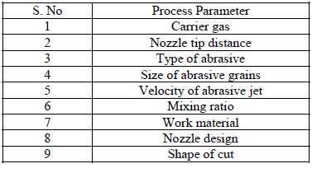
Table 1.1Various Process Parameters of AJM

Fig. 1.5Input &Output Parameter

1.4 Characteristics of different parameters

Table 1.2 Characteristics of different parameters

1.5 Components of AJM

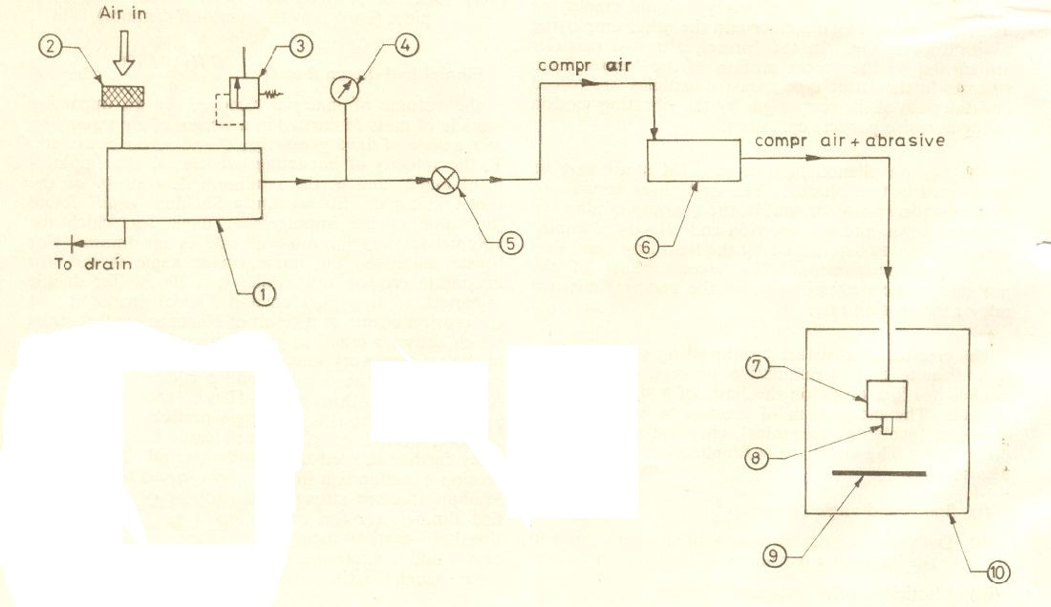
Fig. 1.6 Components of AJM
- Compressor
- Air filter cum drier
- Relief Valve
- Pressure Gauge
- Opening Valve
- Mixing Chamber
- Nozzle Holder
- Nozzle
- Work piece
- Working Chamber

1.6 Process
Glass was used as a test specimen, was cut into square and rectangular shape for machining on AJM.
Specimens were cleaned using air jet and weighed on a sensitive scale, accurate to 0.001 gm.
The compressed air from the compressor enters the mixing chamber partly prefilled with fine grain abrasive particles. The vibratory motion of the air created in the mixing chamber carries the abrasive particles to the nozzle through which it is directed on to the work-piece.
The nozzle and the work-piece are enclosed in a working chamber with a Perspex sheet on one side for viewing the operation.
The abrasive particles used were SiC, Al₂O_{3,} Sodium Bicarbonate (grain size 60 microns and 120 microns).The nozzle material was stainless steel and the nozzles used were of different diameters. This type of set-up has the advantage of simplicity in design, fabrication and operation. The equipment cost is much less except the compressor.
The machine work-piece was then removed, cleaned and weighed again to determine the amount of material removed from the work piece.
The size of hole at the top surface and bottom surface was measured and the results were tabulated.

1.7Advantages
- Ability to cut intricate holes shape in materials of any hardness and brittleness.
- Ability to cut fragile and heat sensitive material without damage.
- No change in microstructure as no heat is generated in the process.
- The process is characterized by lower consumption and capital investment.
- There is no contact between the tool and work-piece.
- Good surface finish of 10 to 50 microns are possible with the process using finer abrasive.
- Cutting action is cool because the carrier gas serves as a coolant.

1.8Disadvantages
- Material removal rate is low about 15 mm³ / min.
- The parts manufactured by this process have to be cleaned.
- Embedding of the abrasive in the work-piece surface may occur while machining softer material.
- The abrasive material may accumulate at nozzle and fail the process if moisture is present in the air.
- It cannot be used to drill blind holes.
- Nozzle wear rate is high and abrasive particles may get embedded in the work surface.

1.9Applications of AJM

- Machining of hard and brittle materials like ceramics, quartz, glass, sapphire, mica etc.
- Fine drilling and micro-welding.
- Machining of semi-conductors.
- Production of intricate profiles on hard and brittle materials.
- Cleaning and finishing of plastic compounds. Ex. Nylon, Teflon.

CHAPTER 2: LITERATURE REVIEW

2.1Introduction to AJM
The conventional method of machining work-piece by formation of chips which is very inefficient and expensive methods on many counts.

In view of these adverse and limiting characteristics of above conventional machining process, considerable effort has been made during the last few decades in developing and perfecting a number of newer methods, AJM is one of them which do not produce chips like conventional machining type.

Abrasive Jet Machine (AJM) is affordable costing project which is not required heavy engineering workshop. Raw material is easily available in the local market.

Abrasive processes are usually expensive, but capable of tighter tolerances and better surface finish than other machining processes chances, delectability, costs and safety aspect etc.

Fig. 2.1 Schematic representation of AJM
Abrasive jet machining (AJM) is a process of materialremoval by mechanical erosion caused by the impingementof high velocity abrasive particles carried by asuitable fluid (usually a gas or air) through a shapednozzle on to the workpiece. Common examples include Cutting, Drilling, Surface finishing, Etching, grinding, honing, and polishing.

2.2 Working principle of AJM
Fine particles are accelerated in gas stream.The particles are directed towards the focus of machining.As the particle impacts the surface, it causes a small fracture, and the gas stream carries both the abrasive particles and the fractured (wear) particles away.
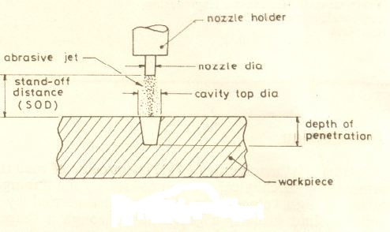

Fig. 2.2 Working principle of AJM
Abrasive jet machining (AJM), also known as abrasive micro-blasting, pencil blasting and micro-abrasive blasting.

“Abrasive blasting machining process that uses abrasives propelled by a high velocity gas to erode material from the work piece.”

The working principle of Abrasive jet machining (AJM) is similar to sand blasting in which AJM effectively removes hard and brittle materials. AJM has been applied to rough working such as debarring and rough finishing.

Common uses include cutting heat-sensitive, brittle, thin, or hard materials. Specifically it is used to cut intricate shapes or form specific edge shapes.

A machining operation is basically a material removal process, where material is removed in the form of chips. In a machining operation, the output parameter is achieved by controlling various input parameters.
Drilling of glass sheets with different thicknesses have been carried out by Abrasive Jet Machining process (AJM) in order to determine its machinability under different controlling parameters of the AJM process.

2.3 Experimental Set-up
The experimental set-up is shown schematicallyin Fig 2.3.
Fig 2.3Schematic Diagram Of Experimental Set-Up
The compressed air from the compressor enters the mixing chamber partly prefilled with fine grain abrasive particles. The vortex motion of the air created in the mixing chamber carries the abrasive particles to the nozzle through which it is directed on to the work-piece. The nozzle and the work-piece are enclosed in a working chamber with a Perspex sheet on one side for viewing the operation. The nozzle and mixing chamber are shown in Figs 2.4 and 2.5, respectively.
Fig. 2.4 Nozzle Assembly
Fig. 2.5 Vortex Type Mixing Chamber
The abrasive particles used were SiC (grain size 60 microns and 120 microns). The nozzle material was stainless steel and the nozzles used were of diameters 1.83 mm and 1.63 mm.
This type of set-up has the advantage of simplicity in design, fabrication and operation. The equipment cost is much less except the compressor. The mixtureratio is controlled by the inclination of the mixing chamber.

The mixture ratio is defined as

Wherem_{p}is the mass flow rate of the abrasive particlesand m_{a}the mass flow rate of air.

2.4 Literature survey

The literature study of Abrasive Jet Machining reveals that the Machining process was started a few decades ago. Till date there has been a through and detailed experiment and theoretical study on the process.

Most of the studies argue over the hydrodynamic characteristics of abrasive jets, hence ascertaining the influence of all operational variables on the process effectiveness including abrasive type, size and concentration, impact speed and angle of impingement.

Other papers found new problems concerning carrier gas typologies, nozzle shape, size and wear, jet velocity and pressure, standoff distance (SOD) or nozzle tip distance (NTD). These papers express the overall process performance in terms of material removal rate, geometrical tolerances and surface finishing of work pieces, as well as in terms of nozzle wear rate. Finally, there are several significant and important papers which focus on either leading process mechanisms in machining of both ductile and brittle materials, or on the development of systematic experimental statistical approaches and artificial neural networks to predict the relationship between the settings of operational variables and the machining rate and accuracy in surface finishing.

The influence of other parameters, viz. Nozzle pressure, mixing ratio and abrasive size are insignificant. The SOD was found to be the most influential factor on the size of the radius generated at the edges.

As the NTD increases the diameter of hole increases which is shown in Fig.2.6
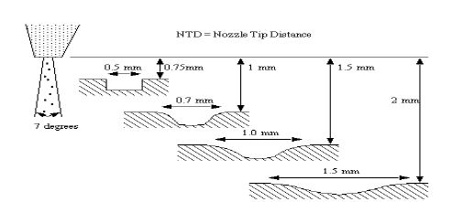
Fig.2.6 Effect Of Nozzle Tip Distance (NTD) On Diameter Of Hole

The effect of SOD or NTD on material removal rate (MRR) is shown in fig.2.7 as the NTD increases the diameter of hole increases which is general observation in abrasive jet machining.

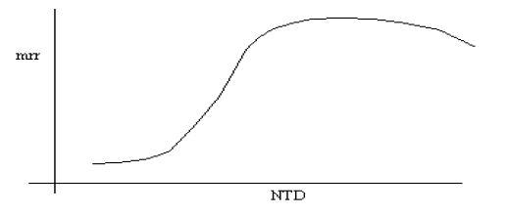
Fig.2.7 Effect Of Nozzle Tip Distance (NTD) On Material Removal Rate

The effect of abrasive flow rate (AMF) on material removal rate (MRR) is shown in Fig.2.8 as the abrasive massflow rate increases the material removal rate (MRR) increase which is also general observation in abrasive jet machining.

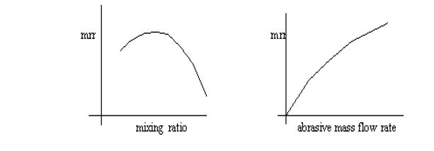
Fig.2.8 Effect Of Abrasive Mass Flow Rate And Mixing Ratio On Material Removal Rate (MRR)
The effects of standoffdistance on MRR and penetration rates have been reported by Ingulli, Sarkar and Pandey, VermaandLal. These investigations indicate that after a threshold pressure, the MRR and penetration rates increase with nozzle pressure. For brittle materials, normal impingement results maximum MRR and for ductile materials, an impingement angle of 15-20 degrees results in maximum MRR. The effects of abrasive grit size and mixing ratio which is the ratio of the weight of the abrasive powder to the weight of the abrasive powder and the air have been thoroughly investigated by many investigators. As the abrasive grit size and mixing ratio increase, the MRR and penetration rate increase but the surfaces finish value which is measured in Ra decreases.
Fig.2.9 Graph Shows TheRelationship Between Pressure And Material Removal Rate (MRR) At Thickness 8 mm And NTD 12 mm

Fig.2.10 Graph Shows TheRelationship Between Pressure And Material Removal Rate (MRR) At Thickness 12 mm And NTD 12 mm

Verma and Lal studied the effects of SOD on the penetration rate and cavity top diameter;they observed that penetration rate reaches an optimum value with the increase in SOD after MRR has reached its optimum.

Fig.2.11 Graph Shows The Relationship Between Nozzle Tip Distance And Top Surface Diameter Of Hole At A Set Pressure Of 5.5 Kg/ cm²

Fig.2.12 Graph Shows The Relationship Between Nozzle Tip Distance And Bottom Surface Diameter Of Hole At A Set Pressure Of 5.5 Kg/ cm²

Fig.2.13 Graph Shows The Relationship Between Nozzle Tip Distance And Top Surface Diameter Of Hole At A Set Pressure 6.5 Kg/ cm²

Fig.2.14 Graph Shows The Relationship Between Nozzle Tip Distance And Bottom Surface Diameter Of Hole At A Set Pressure 6.5 Kg/ cm²

Balasubramaniam reported that as the particle size increases, the MRR at the centre line of the jet drastically increases; but the increase in the MRR nearer to periphery is very less. As the standoff distance increases, the entry side diameter and entry side edge radius also increase. Increasing standoff distance also increases the MRR.

Fig.2.15 Relationship betweenStandoff Distance AndMaterial Removal Rate

F.C. Wakuda and Yamauchi reported that the softest abrasive, aluminumoxide leads to roughing of the alumina surface but causes no engraving, due to the lack of the abrasive hardnessagainst that of the work piece. AJM with silicon carbide abrasive produce smooth faced dimples, although itexhibits relatively low material removal rates. The material response to the abrasive impacts indicates a ductile behavior, which may be due to the elevated temperature during machining.

A.Ghobeity and Getu reported that the introduction of a mixing device within the pressure reservoir ensured that the powder remained loose and able to flow through the orifice to the air stream. This produced a significant improvement in AJM repeatability.

J.M. Fan reported that predictive mathematical models for the erosion rate in hole and channel machining on glasses by micro abrasive air jets on glasses are in good agreement with the corresponding experimental data. These models provide an essential basis for the process optimization of this micromachining technology to achieve efficient and effective operations in practice.

Domiaty and Hafez reported that cutting time decreases with increase in standoff distance. The increase of the nozzle diameter increases the MRR due to the increase of the flow rate of the abrasive particles. In the present study the cutting variables were standoff distance or nozzle tip distance of the nozzle from the work surface; work feed rate and jet pressure. The evaluating criteria of the surface produced were width of cut, taper of the cut slot and work surface roughness. It was found that in order to minimize the width of cut; the nozzle should be placed close to the work surface. Increase in jet pressure results in widening of the cut slot both at the top and at exit of the jet from the work. However, the width of cut at the bottom (exit) was always found to be larger than that at the top. It was found that the taper of cut gradually reduces with increase in standoff distance and was close to zero at the standoff distance of 4 mm. The jet pressure does not show significant influence on the taper angle within the range of work feed and the standoff distance considered. Both standoff distance and the work feed rate show strong influence on the roughness of the machined surface. Increase in jet pressure shows positive effect in terms of smoothness of the machined surface. With increase in jet pressure, the surface roughness decreases. This is due to fragmentation of the abrasive particlesinto smaller sizesat ahigher pressure and due to the fact that smaller particles produce smoother surface.

Fig.2.16 Effect Of Nozzle Diameter (D) On The Material Removal Rate Of The Glass

jet pressure considered, the work surface is smoother near the top surface and gradually it becomes rougher at higher depths.

Drilling of glass has been carried out by M. Roopa Rani and S.Seshan. Their results are used in the present work to compare the validation of our experimental work on abrasive jet machining. They have conducted some experiments on AJM test rig. At department of mechanical engineering, Indianinstitute of science, Bangalore. These results were shown here in tables 2.1 and 2.10 and graphs (Fig.2.18 and 2.19) whichshows the effect of pressure on the material removal rate and effect of NTD on diameter of hole in AJMprocess.

Table 2.1 Effect Of Pressure On Material Removal Rate (MRR)
Fig.2.17 Graph Shows theRelationship Between Pressure And Material Removal Rate (MRR)

Table 2.2 and Fig.2.19 shows the effect of nozzle tip distance (NTD) on diameter of hole. As the distancebetween the face of nozzle and the working surface of the work increases, the diameter of hole alsoincreases because higher the nozzle tip distance allows the jet to expand before impingement which mayincrease vulnerability to external drag from the surrounding environment. It is desirable to have a lower nozzle tip distance which may produce a smoother surface due to increased kinetic energy.

Table 2.2 Effect of NTD on diameter of hole
Fig.2.18 Graph Shows theRelationship BetweenNTD And Diameter Of Hole

The abrasive size and the impact angle effects were studied by Wensink and Elwenspoek. Their results showed that smaller abrasive size and less impact angle improve the machinability.

Finnie had shown that
WhereQ is the volume of material removed by an impacting particle of mass M carried in a stream of air expanding in a nozzle of fixed geometry; C and n, the constants; V, the velocity of impacting particle; ø the impingement angle; and ϭ the minimum flow stress of the target material. Subsequently Sheldon found the value of the impingement angle for which the volumetric material removal rate is maximum. For brittle materials, the impingement angle is 90° for maximum erosion rate while it is 20°-30° for ductile materials.
Fig.2.19 Typical Curves Showing the Variation Of Erosion With Impact Angle

Later, Sheldon and Finnie proposed that the erosion occurs as a result of Hertzian contact stress which causes a crack to grow from a pre-existing flaw in the existing work-material. The stress at which the crack propagation occurs is related to the distribution of surface flaws through Weibull statistics, where it is assumed that the risk of rupture is proportional to a function of the stress and the volume of the body. They further showed that the velocity exponent in the erosion equation is a function of the flaw parameter of Weibullfracture strength distribution.
Table 2.3 Principle Factors Affecting the Erosion Wear Of Brittle Materials By Solid Particle Impact

Bitter modified Finnie's erosion equation with the concept of threshold particle energy below which 'brittle erosion' ceases and a minimum effective angle of impingement below which 'ductile erosion' ceases.

Neema and Pandey proposed an equation for material removal rate by equating the kinetic energy of the impacting particle to the work of deformation during indentation. They gave
Wherek is a constant; N, the number of abrasive particles taking cut a time; d, the size or diameter of an abrasive particle;$ρa$, the density of the abrasive material; v, the velocity of the abrasive particle; and ϭ_{y}, the yield stress of the work material.

Pandey and Bhattacharya studied the effects of abrasive flow rate (AFR) and stand-off distance on the material removal rate (MRR). They observed that MRR reaches an optimum value with the increase in AFR and SOD, and then falls with the increase in these parameters. In case of micro-drilling, it is the erosion depth (or the depth of penetration) which is of importance.

The nozzle pressure effect has been reported in many. They proved that after threshold pressure, the Material Removal Rate (MRR) and the penetration rates have increased with increasing the nozzle flow pressure. Similarly, the effect of impingement angle has been reported and concluded that the maximum MRR for brittle material is obtained when normal impingement was applied.

Effect of abrasive grit size and mixing ratio, which is the ratio of the weight of the abrasive powder to the weight of the air and abrasive grits, has been thoroughly investigated by many researchers.The stand-off-distance which is the distance between the work piece and the nozzle has also great effect on the material removal rate as well as the generated surface quality.

Abrasive Jet Machining has high degree of flexibility, and hence it is typically used for machining of glass and ceramic materials. Manufacturers are trying to reduce the operation cost and increase the quality of products. The surface roughness and MRR are significant characteristics in machining of glass using AJM. There is a need to optimize the process parameters in a systematic way to achieve the output characteristics /responses by using experimental methods and statistical models.

The design of nozzle and variable parameters like pressure of carrier media, abrasive types and size, abrasive flow rate and stand-off distance have effects on MRR and it has been discussed by experimental investigations. Drilling of glass sheets with different thicknesses have been carried out by AJM in order to determine its machinability under different controlling parameters.

The machining process produces no heat and hence changes in microstructure or strength of the surface is unlikely. The air acts as a coolant and hence AJM process has ahigh potential as damage free micromachining method. The fracture toughness and hardness of the target materials are critical parameters affecting the material removal rate in AJM. However, their influence on the machinability varied greatly with the employed abrasives.

In recent years abrasive jet machining has been gaining increasing acceptability for debarring applications. The influence of abrasive jet debarring process parameters is not known clearly. AJM debarring has the advantage over manual debarring method that generates edge radius automatically. This increases the quality of the debarred components. The process of removal of burr and the generation of a convex edge were found to vary as a function of the parameters jet height and impingement angle, with a fixed SOD. The influence of other parameters, viz. nozzle pressure, mixing ratio and abrasive size are insignificant. The SOD was found to be the most influential factor on the size of the radius generated at the edges. The size of the edge radius generated was found to be limited to the burr root thickness.

CHAPTER 3: PROJECT METHODOLOGY

- Literature survey made to investigate various parameters of Abrasive Jet Machine (AJM).
- Collection of different components and materials.
- Define procedure followed during investigation of different parameters of AJM.
- AJM machine setup to obtain greater accuracy and continuous operation.
- Selection and consideration of all parameters which is affected the AJM.
- Fixed one parameter and change other parameters.
- Observe the effect of these parameters change on Material Removal Rate (MRR).
- Prepare the observation tables showing the effect of one fixed parameter on other varying parameters.
- Repeat this procedure for subsequent parameters.
- Plot the graphs from the tables.
- Obtain the conclusion by investigation of parameters.

CHAPTER 4: EXPECTED OUTCOMES AND FUTURE SCOPE

4.1 Expected Outcomes
We will be investigate the various process parameters of AJM by using different types of work material and abrasives by changing the other parameters of AJM like pressure, Nozzle tip distance, size of abrasive grains. From that we can decide the most appropriate condition for Material Removal Rate (MRR).
4.2 Future Scope
It is very clear that AJM is greater Non-conventional machining process which is used as a multipurpose system. It is also a most effective among various affordable systems. This system is eco-friendly. Even some of the companies in India like ABB, L & T and ESSAR are already using this system with CNC programming. This system is also use as Water Jet Machining (WJM) in whichabrasives such as garnet, diamond or powders can be mixed into the water to make slurry with better cutting properties than straight water. Further development in WJM is called Hydrodynamic Jet Machining (HJM) which combines the principle of Water Jet Machining and Abrasive Jet Machining process. AJM is also used as Abrasive Flow Machining (AFM), Ultrasonic Machining (USM).

CHAPTER 5: REFRENCES

WEBSITES

- www.elgi.com
- www.scopus.com
- www.4shared.com
- www.sciencedirect.com

BOOKS
- An ”EXPERIMENTAL STUDY OF ABRASIVE JET MACHINING”, A.P.VERMA and G.K.LAL
- P C Pandey and H S Shan. 'Modern Machining Processes'.Tata McGraw-Hill publishing Co, New Delhi, 1980.
- A Bhattacharya. 'New Technology'. The Institution of Engineers(India), 1976.
- “Elements of workshop technology”, S K HajraChoudhury, S K Bose, A K Hajrachoudhury, Niranjan Roy, Vol‐II, Media promoters and media publications.
- “Modern machining process”, S Pandey and H N Shah, S. Chand and co.

