PROGRESSIVE DIE
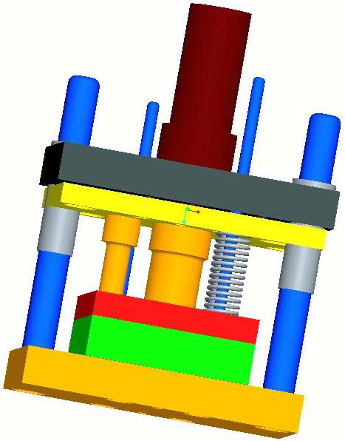

SR.NO | TOPIC NAME | PAGE NO
1 | ACKNOWLEDGEMENT | 4
2 | LIST OF FIGURE | 6
3 | ABSTRACT | 8
CHAPTER 1 | INTRODUCTION  - DEFINATION OF PROJECT  DIE MANUFACTURING  - TYPES OF DIE | 9
CHAPTER 2 | PROGRESSIVE DIE  - INTRODUCTION  - DEFINATION  - OPERATION  - SHEET METAL WORKING IN PROGRESSIVE DIES | 12
CHAPTER 3 | PROGRESSIVE DIE DESIGN  - METAL CUTTING PRINCIPLE  - THE AMOUNT OF SHEARING CLEARANCE PER SIDE  - FORCE CALCULATION  - ASSEMLY OF PROGRESSIVE DIE | 24
CHAPTER 4 | CONCLUSION | 31
INDEX

2.LIST OF FIGURE

SR. NO. | FIGURE NAME | PAGE NO.
1. | SIMPLE DIE | 1
2. | COMPOUND DIE | 11
3. | PROGRESSIVE DIE | 12
4. | CUTTING OPERATION | 18
5. | PARTING OPERATION | 18
6. | BLANKING OPERATION | 18
7. | PIERCING OPERATION | 19
8. | TRIMMING OPERATION | 19
9. | NOTCHING OPERATION | 19
10. | SHAVING OPERATION | 19
11. | TWISTING OPERATION | 20
12. | STRECHING OPERATION | 20
13. | EMBOSSING OPERATION | 20
14. | BLUNGING OPERATION | 20
15. | FLANGING OPERATION | 21
16. | COINING OPERATION | 21
17. | SWEGING OPERATION | 21
18. | BENDING OPERATION | 21
19. | SHEARING OPERATION | 22
SR.NO | FIGURE NAME | PAGE NO
20. | BENDING OPERATION | 23
21. | PROGRESSIVE DIE | 26

ABSTRACT

Before converting raw materials to a finished product we need an accurate design of the product and also data required for manufacturing. If the design is not accurate then defects will occur in the manufactured product; small mistakes in designing a product makes the manufactured product useless so more amount time is allotted for designing a new product (or) for modifying the existed design.
In this work the use of software namely Pro/E for designing a progressive die to manufacture washer for the M 12 bolt has been incorporated. A progressive die is a multiple station die. In this work authors have designed a progressive die which has two stages of operation. The former operation is piercing and is followed by blanking. In both operations a finite volume of metal is removed from the sheet metal.
If the final product happens to be removed portion then the operation is blanking, on other hand if pierced sheet metal is the final product then the operation is piercing. Both the operations are performed simultaneously in a single stroke of press, thus enabling the user to obtain the final product in a single stroke. This design procedure can also be extended for manufacturing washers for M-series bolts by modifying the punch and die plate dimensions

CHAPTER 1
INTRODUCTION

  - DEFINATION OF PROJECT:-
The main tool typically attached to the lower portion of the die set. The die contains a recess that provides space for the shaping or shearing of sheet metal.

  - DIE MANUFACTURING :-
A die is a specialized tool used in manufacturing industries to cut or shape material using a press. Like molds, dies are generally customized to the item they are used to create. Products made with dies range from simple paper clips to complex pieces used in advanced technology.
Forming dies are typically made by tool and die makers and put into production after mounting into a press. The die is a metal block that is used for forming materials like sheet metal and plastic. For the vacuum forming of plastic sheet only a single form is used, typically to form transparent plastic containers (called blister packs) for merchandise. Vacuum forming is considered a simple molding thermoforming process but uses the same principles as die forming. For the forming of sheet metal, such as automobile body parts, two parts may be used, one, called the punch, performs the stretching, bending, and/or blanking operation, while another part, called the die block, securely clamps the work piece and provides similar, stretching, bending, and/or blanking operation. The work piece may pass through several stages using different tools or operations to obtain the final form. In the case of an automotive component there will usually be a shearing operation after the main forming is done and then additional crimping or rolling operations to ensure that all sharp edges are hidden and to add rigidity to the panel.

1.3 DIE COMPONENT
1.3.1 The main components for Die Toolsets are:
- Die block - This is the main part that all the other parts are attached to.
- Punch plate - This part holds and supports the different punches in place.
- Blank punch - This part along with the Blank Die produces the blanked part.
- Pierce punch - This part along with the Pierce Die removes parts from the blanked finished part.
- Stripper plate - This is used to hold the material down on the Blank/ Pierce Die and strip the material off the punches.
- Pilot - This is used to keep the material being worked on in position.
- Guide / Back gage / Finger stop - These parts are all used to make sure that the material being worked on always goes in the same position, within the die, as the last one.
- Setting (Stop) Block - This part is used to control the depth that the punch goes into the die.
- Blanking Dies - See Blanking Punch
- Pierce Die - See Pierce Punch.
- Shank-used to hold in the presses. it should

1.4TYPES OF DIE:-

1 Simple Dies

2 Compound Dies

3 Progressive Dies

- Simple Dies:-
A simple die typically perforates holes in a part or blanks of the part using Punches in conjunction with mated lower die components (matrixes). Simple Dies also commonly produce basic forms as well as perform notching and lancing operations. Simple dies require a press operator to load and unload parts and part Material before and after each press cycle.

- Compound Dies:-
A compound die blanks and perforates a part at the same time in the same Station. In most cases this operation perforates a hole or holes down, while the part blanks up. This allows slugs from those holes to fall through the die. This method leaves the part in the die, requiring some means of part Removal. Compound dies commonly run as single-hit dies. They can run continuously with a feeder, provided you can remove the part in a timely manner. Open Back Inclinable (OBI) presses - in the inclined position along with an air blow off-aid in part removal.

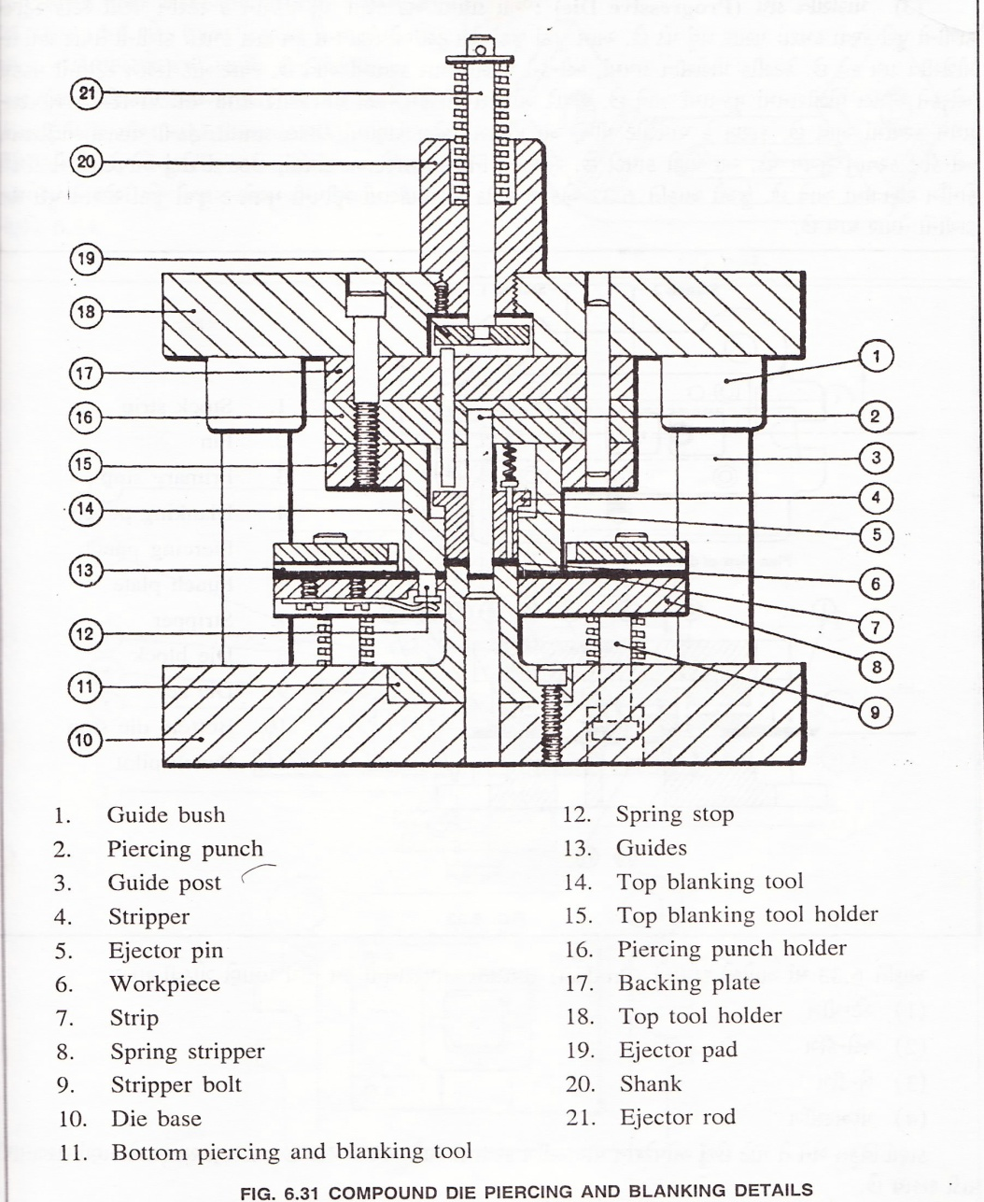

1.4.1 Advantages of a compound die include:
- Minimal space in the press
- All burrs in one direction
- Superior accuracy between holes and trim edges
- More economical to build than a progressive die
A disadvantage of a compound blank die is its limited Space that tends to leave die components thin and weak. This concentrates the load and shock on punches and matrixes, resulting in tooling failures.

CHAPTER 2
PROGRESSIVE DIE:-

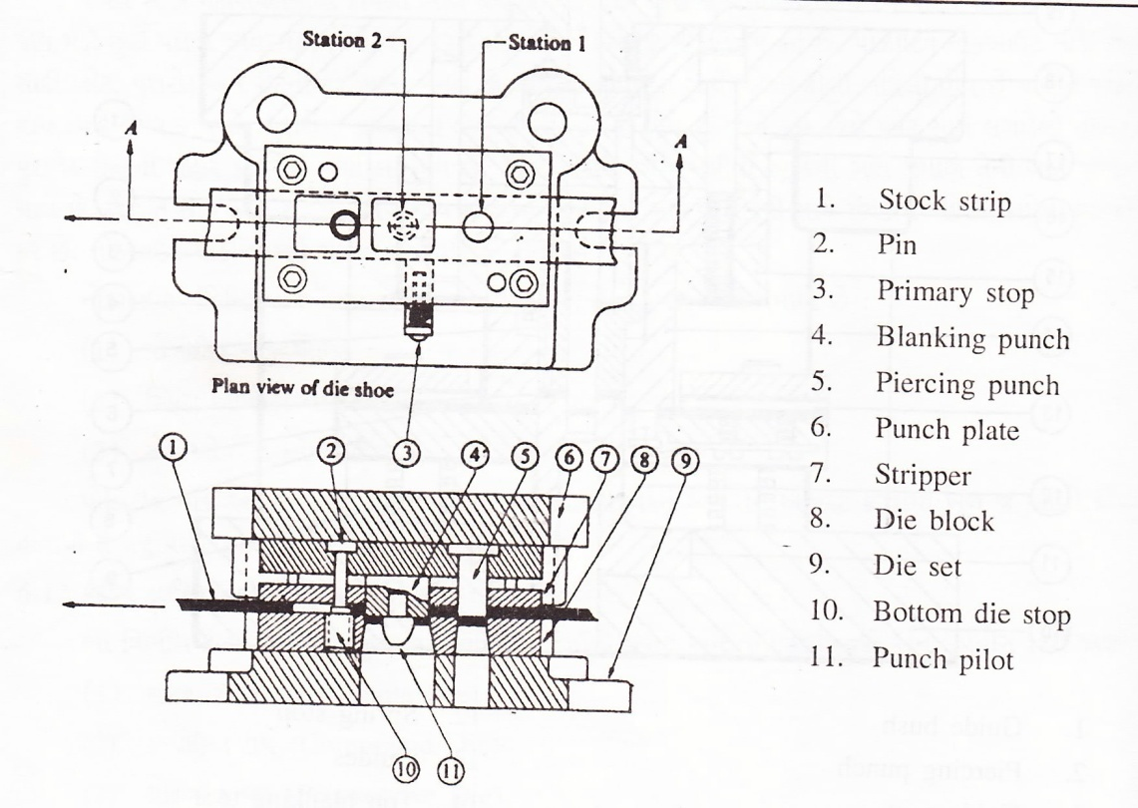
Progressive dies provide an effective way to convert raw coil stock into a finished product with minimal handling. As material feeds from station to station in the die, it progressively works into a completed part. Progressive dies usually run from right to left. The part material feeds one progression for each press cycle. Early stations typically perforate holes that serve as pilots to locate the stock strip in later stations. There are many variations of progressive die designs. The design shown here illustrates some common operations and terminology associated with progressive dies.

2.1 PROGRESSIVE DIE COMPONENT

2.1.1The main components for Die Toolsets are:
- Die block - This is the main part that all the other parts are attached to.
- Punch plate - This part holds and supports the different punches in place.
- Blank punch - This part along with the Blank Die produces the blanked part.
- Pierce punch - This part along with the Pierce Die removes parts from the blanked finished part.
- Stripper plate - This is used to hold the material down on the Blank/ Pierce Die and strip the material off the punches.
- Pilot - This is used to keep the material being worked on in position.
- Guide / Back gage / Finger stop - These parts are all used to make sure that the material being worked on always goes in the same position, within the die, as the last one.
- Setting (Stop) Block - This part is used to control the depth that the punch goes into the die.
- Blanking Dies - See Blanking Punch
- Pierce Die - See Pierce Punch.
- Shank-used to hold in the presses. it should be align and situated at the center of gravity of the plate.

2.2 OPERATION IN DIES:-

Bending: The bending operation is the act of bending blanks at a predetermined angle. An example would be an "L" bracket which is a straight piece of metal bent at a 90° angle. The main difference between a forming operation and a bending operation is the bending operation creates a straight line bend (such as a corner in a box) as where a form operation may create a curved bend (such as the bottom of a drink can).
Blanking: A blanking die produces a flat piece of material by cutting the desired shape in one operation. The finish part is referred to as a blank. Generally a blanking die may only cut the outside contour of a part, often used for parts with no internal features.
Three benefits to die blanking are:
Accuracy: A properly sharpened die, with the correct amount of clearance between the punch and die, will produce a part that holds close dimensional tolerances in relationship to the parts edges.
Apperance: Since the part is blanked in one operation, the finish edges of the part produce a uniform appearance as opposed to varying degrees of burnishing from multiple operations.
Flatness: Due to the even compression of the blanking process, the end result is a flat part that may retain a specific level of flatness for additional manufacturing operations.
- Broaching: The process of removing material through the use of multiple cutting teeth, with each tooth cutting behind the other. A broaching die is often used to remove material from parts that are too thick for shaving.
- Bulging: A bulging die expands the closed end of tube through the use of two types of bulging dies. Similar to the way a chefs hat bulges out at the top from the cylindrical band around the chefs head.
- Bulging fluid dies: Uses water or oil as a vehicle to expand the part.
- Bulging rubber dies: Uses a rubber pad or block under pressure to move the wall of a work piece.
- Coining: is similar to forming with the main difference being that a coining die may form completely different features on either face of the blank, these features being transferred from the face of the punch or die respectively. The coining die and punch flow the metal by squeezing the blank within a confined area, instead of bending the blank. For example: an Olympic medal that was formed from a coining die may have a flat surface on the back and a raised feature on the front. If the medal was formed (or embossed), the surface on the back would be the reverse image of the front.
- Compound operations: Compound dies perform multiple operations on the part. The compound operation is the act of implementing more than one operation during the press cycle.
- Compound die: A type of die that has the die block (matrix) mounted on a punch plate with perforators in the upper die with the inner punch mounted in the lower die set. An inverted type of blanking die that punches upwards, leaving the part sitting on the lower punch (after being shed from the upper matrix on the press return stroke) instead of blanking the part through. A compound die allows the cutting of internal and external part features on a single press stroke.
- Curling: The curling operation is used to roll the material into a curved shape. A door hinge is an example of a part created by a curling die.
- Cut off: Cut off dies are used to cut off excess material from a finished end of a part or to cut off a predetermined length of material strip for additional operations.
- Drawing: The drawing operation is very similar to the forming operation except that the drawing operation undergoes severe plastic deformation and the material of the part extends around the sides. A metal cup with a detailed feature at the bottom is an example of the difference between formed and drawn. The bottom of the cup was formed while the sides were drawn.
- Extruding: Extruding is the act of severely deforming blanks of metal called slugs into finished parts such as an aluminum I-beam. Extrusion dies use extremely high pressure from the punch to squeeze the metal out into the desired form. The difference between cold forming and extrusion is extruded parts do not take shape of the punch.
- Forming: Forming dies bend the blank along a curved surface. An example of a part that has been formed would be the positive end(+) of a AA battery.
- Cold forming (cold heading): Cold forming is similar to extruding in that it squeezes the blank material but cold forming uses the punch and the die to create the desired form, extruding does not.
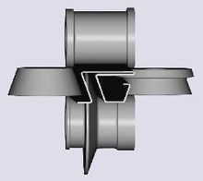
Roll Forming Stand
- Roll forming: a continuous bending operation in which sheet or strip metal is gradually formed in tandem sets of rollers until the desired cross-sectional configuration is obtained. Roll forming is ideal for producing parts with long lengths or in large quantities.
- Horning: A horning die provides an arbor or horn which the parts are place for secondary operations.
- Hydro forming: Forming of tubular part from simpler tubes with high water pressure.
- Pancake die: A Pancake die is a simple type of manufacturing die that performs blanking and/or piercing. While many dies perform complex procedures simultaneously, a pancake die may only perform one simple procedure with the finished product being removed by hand.
- Piercing: The piercing operation is used to pierce holes in stampings.
- Progressive die: Progressive dies provide different stations for operations to be performed. A common practice is to move the material through the die so it is progressively modified at each station until the final operation ejects a finished part.
- Shaving: The shaving operation removes a small amount of material from the edges of the part to improve the edges finish or part accuracy. (Compare to Trimming).
- Side cam die: Side cams transform vertical motion from the press ram into horizontal or angular motion.
- Sub press operation: Sub-press dies blank and/or form small watch, clock, and instrument parts.
- Swaging: Swaging (necking) is the process of "necking down" a feature on a part. Swaging is the opposite of bulging as it reduces the size of the part. The end of a shell casing that captures the bullet is an example of swaging.
- Trimming: Trimming dies cut away excess or unwanted irregular features from a part, they are usually the last operation performed

2.3 REVIEW OF SHEET METAL WORKING:-

2.3.1 SHEET METAL WORKING IN A PROGRESSIVE DIE:-

Sheet metalworking involves many types of manufacturing processes that shapes apiece of sheet metal into the desired shape through material removal and/or material deformation. Sheet metalworking is generally classified into three categories: shearing, bending and forming. Shearing processes are those in which the applied force causes the material to tear away and separate, allowing the material to be cut or removed. Bending and forming processes are those, in which the applied force causes the material to plastically deform, but bending is mainly deformed along a line and forming is on a surface or volume.
Usually some authors may classify the sheet metalworking into more detailed levels, for example, regroups the forming processes into three processes: drawing, forming and compression. And on the other hand, has carefully organized the processes as shown in the Figure and their definition and example are shown in Figure The forming and joining processes involve many different types work and they usually have to be dialed independently, this research only handle the shearing and bending operations. Moreover, idle stage, which means that no operation is perform at one stage, in many case, used for strengthening progressive die or stabilizing the strip.

2.4 PROGRESSIVE DIE OPERATION:-

- CUTTING: Cutting off by edges, wasted, material free, burr directions are opposite in separated half.

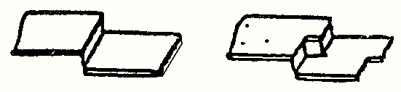

- Parting: separated by removing material in between, burr direction remains the same.

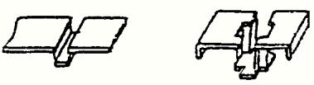
3.Blanking: cut of a part from an enclosed envelope.

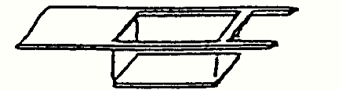

4.Piercing: cut of waste metal from an enclosed envelope.

5.Trimming: Shaving an outer boundary from edges of a formed part.

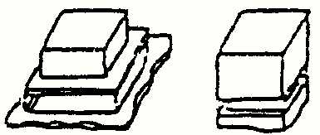

6.Notching: cut of material from side off material , creates an open notch.

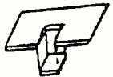

7.Shaving: Removing small amount of material from internal surface puff hole for smoothness.
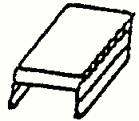

8.Twisting: twist both ends into opposite direction.

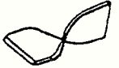

9.Stretching: using stretching ability of material to from shape.

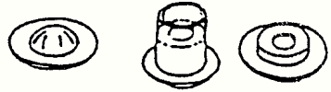

10.Embossing: a shallow free-from shape, for creating a strip effect on surface.

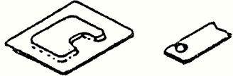
11.Bunging: extending the internal by stretching ability of material.

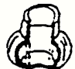

12. Flanging: forming edges into an upward or downward flange.

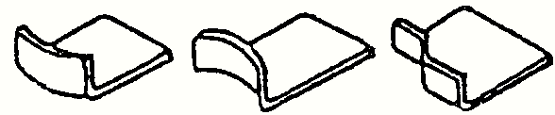

13. Coining: Intensively compress a metal into a shape.

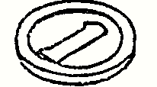

14. Swinging: A compression force rotary action surface plane to extend horizontally.

15. Bend: joining through bending.

  - SHEARING OPERATION:-

Shearing or cutting, of sheet metal is achieved by shearing action between two sharp cutting edges one belongs to the shearing punch and the other belongs to the shearing die.

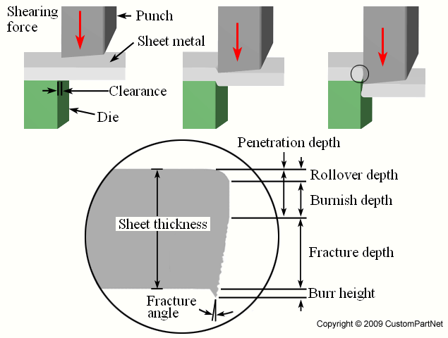

A variety of shearing operations that utilize shearing forces exist to separate or remove material from a piece of sheet stock in different ways. Sheet metal parts can be fabricated with cutout and profiles of any 2D geometry by such shearing operations.
Shearing: A straight line is sheared to separate a large sheet into two smaller ones.

  - BENDING: OPERATION:

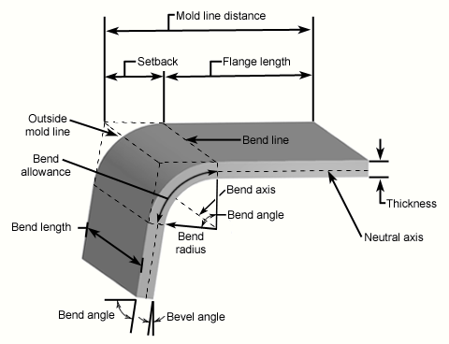

Bending is a metal forming process in which a force is applied to a piece of sheet metal, cashing it to strain along a straight axis at angel and from desired shape. A bend can be characterized by several different parameters.

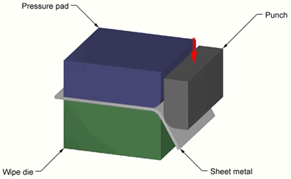

Bending operation are conducted using bending punch and bending die tooling. A variety of bending operations are possible to from different bent features.

  - REVIEW OF PROGRSSIVE DIE:-

Because of good accuracy, strength and cost and cost effectiveness with mass production sheet metal parts are widely used in human life a survey has shown that an average American family will have up to 10,000 Piece in the house. There are many types of sheet metal die, but when making small and delicate parts E.G the connectors used in communication products or lead frames for lead frames the I.C industry, the progressive die is the first choice.

CHAPTER 3

PROGRESSIVE DIE DESIGN

  - DESIGN OF PROGRESSIVE DIE:-

A progressive die performs a series of fundamental sheet metal operations at two or more stations during each press stroke in order to develop a work piece as the strip stock moves through the die. The work piece on progressive dies travels from one station to another, with separate operations being performed at each station. Usually the work piece is retained in the stroke until it reaches the final station, which cuts off the finished piece .All station work simultaneously at different points along the work strip, which advances on station at each stroke of ram. Thus a complete part is produced with each stroke .Progressive dies generally include blanking and piercing operations but a complicated progressive die can do the operation of bending, forming, curling and heading also .Each workstation performs one or more distinct die operation, but the scrip must move from the first through each succeeding station to produce a complete part .One or more idle station may be incorporated in the die ,not to perform work on the metal but to locate the strip, to facilitate inter station Strip travel, to provide maximum size die sections or to simplify their
The operation performed in a progressive die could be done individual dies as separate operations but would require individual feeding and producing .In a progressive die the part remains connected to the stock strip, which is fed through the die with automatic feeds and positioned by pilots with speed and accuracy. The linear travel of the strip stock at each press stock is called the progression, advance or pitch and is equal to the interaction distance. The unwanted parts of the strip are cutout as it advances through the die, and one or more tabs are left connected to each partially completed part to carry it through the stations of the die. Sometimes parts are not made from individual blanks, neither a part of, nor connected to a strip in such cases mechanical fingers or other devices are employed for the station to station movement of work piece. The selection of any multi-operation tool, such as progressive die, is justified by the principle that the number of operations achieved with one handling of the stock and produced part is more economical than production by a series of single operation dies and a number of handling for each single die.
Where tool production requirements are high, particularly of production rates are large, totally handling cost is saved by progressive fabrication compared with a series of single operation are frequently greater than the costs of the progressive die. A progressive die should be heavily constructed to withstand the repeated shock and continuous runs to which it is subjected, precision guide post and bushings should be used to maintain accuracy .Lifters should be provided in die cavities to lift up or eject the formed parts and carrier rails or pins should be provided at the last station .When practical, punches should contain shudder or kicker pins to aid in disposal of slugs. Adequate piloting should be provided to ensure proper location of the strip as it advances through the die. The striper plates should engage guides before contacting the strip. The dropping of the work pieces through the die is the most desirable method of part ejection, but cannot always be obtained. Cutting the scrap in to small section simplifies the material handling problems and produces a greater price and return when sold as scrap metal.
In the present project the progressive die set is used to produce component that is washer the specification are as follows
Stock strip material is mild steel.
Thickness of strip: 1.6mm
Outer diameter: 26mm
Inner diameter: 12.5 mm

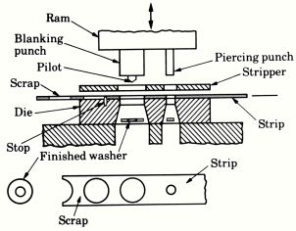

  - PRINCIPLE OF METAL CUTTING:-

The metal is brought to the plastic stage by pressing the sheet between two shearing blades so that fracture is initiated with the movement of the upper shear, finally result in the separation of the slug from the parent strip.
The metal under the upper shear is subjected to both compressive and tensile stresses. In an ideal shearing operation. The upper shear pushes the metal to a depth equal to about the third of its thickness. Because of pushing the material into the lower shear the area of cross-section of the metal between the cutting edge of the shear decreases and causes the initiation of the fracture. The portion of the metal which is forced into the lower shear is lightly burnished and would appear as a bright band around the blank lower portion. The fractures which are initiated at both the cutting points would progress further with the movement of the upper shear and if the clearance is sufficient, would meet, thus completing the shearing action.
The two shearing elements of the press tool are the hardened punch and the die plate having sharp edges and a certain shearing clearance. Both the shapes of the punch and the die opening conform to the required shape of the component. The punch is connected to the ram of the power press and while descending contacts the stock, exerts pressure over the stock around the cutting edges and shears it through. Exactly the same phenomenon that takes place where in blanking (or) in piercing (or) in any other shearing operation.
In the process of shearing four important stages are usually distinguished according to the observation.

STAGE: 1 (PLASTIC DEFORMATION):-
The stock material has been placed on the die and the punch is driven towards the die. The punch contacts the stock material and exerts pressure upon it. When the elastic limit of the stock material is exceeded, plastic deformation takes place.

STAGE: 2 (PENETRATION):-
As the driving force of the ram continues, the punch is forced to penetrate the stock material and the blank or slug is displaced into the die opening a corresponding amount. This is true shearing part in of the cutting cycle, from which the term “shearing action” is derived.

STAGE: 3 (FRACTURE):-
Further continuation of the punching pressure that causes fractures to start at the cutting edges of the punch and the die. Under proper cutting conditions, the fractures extended toward each other and meet. When this occurs, the fracture is complete and the blank or slug is separated from the original stock material. The punch then enters the die opening, pushing the blank or slug slightly below the die cutting edge.

STAGE: 4:-
As the punch completes the down stroke up to the lower point, the component of slug is pushed through the die opening. Strictly speaking this action is a consequence of the dynamic fracture at the stage III and only in certain case the push through takes place where the punch takes place where the punch travels beyond the land of the die.
This is the simplest approach on the shearing action. Before dealing with the details of the phenomenon, the attention is drawn on the same other allied factors which calls for deeper deliberations on the shearing process.

  - THE AMOUNT OF SHEARING CLEARANCE PER SIDE:-

At a certain value of shearing clearance, which depends on the thickness, kind and its heat treated conditions of the stock, the crack line meet, resulting in easy action, low vertical force, low horizontal force, low stripping, low wear high die life but fairly distorted sheared contour. At narrower clearance secondary cracks develop that is the two cracks do not meet, resulting in unfavorable increase in forces but some improvement is found in the quality of the cut contour, due some burnishing of the shaped secondary cracks.

  - IMPORTANCE OF CLEARANCE:-
Proper cutting clearance is necessary to the life of the die and the quality of the piece part. Excessive cutting clearance results in objectionable piece part characteristics, insufficient cutting clearance causes undue stress and wear on the cutting members of the tool because of greater punching effort required. If the amount of clearance is optimum, then the two fracture lines meet and a clean edge is obtained after the operation.
If the clearance is too small then the fracture lines miss each other and a secondary deformation taken place resulting in an unclear edge.
When the amount of clearance is too large obvious that significance amount of drawing action takes place and the quality of the work piece is again quite poor.
Angular clearance is of vital importance in any die where blanks or slugs pass through the die opening. Like cutting clearance, angular clearance is a “per side” measurement. A clearance of ¼ per side is suggested for die work of good quality when the stock material is less than 1.5mm thick. All die-opening walls should have smoothly finished surfaces throughout. Owing to the lessening of the back pressure from blanks or slugs, small or delicate punches will also benefit from slightly increased angular clearance in the die opening.

    - FORCE CALCULATION:-
The punching and blanking process cannot strictly speaking group under forming operations. In these processes a finite volume of sheet metal is removed by using a die and a punch. The shape and size of the portion removed are determined by the geometry of the die and the. Punch. If the final product happens to the removed portion, then the operation is termed as blanking. On the other hand if the pierced sheet metal is the final product then the operation is called punching.

BLANKING:-
It is a process in which the punch removes a portion of material from the stock which is a strip of sheet metal of the necessary thickness and width. The removed portion called a blank and is usually further processed to be of some use.

PEIRCING:-
This operation consist of simple hole punching is piercing is making holes in a sheet it is identical to blanking except if the fact that the punched out portion coming out through the die in piercing is scrap .piercing is always accompanied by the blanking operation either before , after(or) at the same time.

3.4.2 PUNCHING FORCE:-
The force required to be exerted by the punch in order to shear out the blank from the stock can be estimated from the actual shear area and shear strength of the material using formulae
P= L × T × τ
Τ → shear strength (mm)
L →perimeter of cut (mm)
T →stock thickness (mm)

3.4.3 SHEARING FORCE:-
FSH = L × T × τ
L = Length of cutting edge
T = Thickness of the stock strip
τ = shear strength of the material Newton/sq.mm

FORCE REQUIRED FOR PEIRCING:-
F1=L ×T× τ
=π×12.5×1.6×390
=24504.4N

FORCE REQUIRED FOR BLANKING OPERTION:-
F2 =L × T × τ
=π×26×1.6×390
=50969.199N

TOTAL SHEARING OPREATION:-
F=F1+F2 =75473.62N
Taking factor of safety=1.5
The capacity of press required is 113.21KN

  - BLANKING AND HOLDING FORCE:-

Blank holding force or stripping force is the force, which controls the metal flow .It is the force applied by the blank holder on the blank to control the flow of the metal in to the die cavity. Important consideration in tooling for sheet metal forming wrinkling of sheet as it is being formed. Hold down can best be provided by hold down ring .However by using mechanical spring or an auxiliary air cylinder, hold down can be provided in a single action press.
Stripping force required =k × L × T × τ

K=stripping constant
=0.0207(for low carbon steels above 1.5 mm thickness)
=0.0207×π× (12.5+26) ×1.6×390
=497.3N
=0.4973KN Total force=shearing force + stripping force
=113.21+0.4973
=113.70KN Capacity of press required for punching operation
=113.7KN

3.6 SPRING DESIGN:-
Springs are used to obtain the required blank holding forces:
Spring has to take up the total force and it should be designed for this load.
P max=Shearing force + blank holding force
=113700N Springs has to be designed for this force
δ/n=(8×W×D3)/(Gd4)
δ=deflection of spring
n=number of active coils
W=axial load in spring
D=mean diameter
G=modules of rigidity for spring material
d =diameter of spring wire In the present project
δ =10mm D=22mm
W=113700N 10/n
= (8×113700×223) / (84000×d4) -------------- (1)
We also know that free length of spring
Lf= Solid length + maximum compression + clearance between adjacent coils
=n|×d+C+0.15×C
Where
n|=n C=max compression
Lf=35mm 35=nd+10+0.15×10---------------- (2)
Solving (1) & (2)
n=3turns d =12.00mm D=22mm

CHAPTER 4

CONCLUTION
By the implementation of computer in design field accuracy of design is improved and design process time is reduced drastically than by traditional method. In the process of creating the documentation for the product design much of required data base to manufacture the product is also created.
Regarding progressive die design of progressive die is simple. Advantage of progressive die is it performs two or more operations simultaneously by a single stroke. Progressive die is used for high rate of production

CHAPTER 5
REFERENCE
www.google.com
www.wikipedia.com
www.classle.net
www.technicaljournalsonline.com

BOOKS:

TOOL ENGINEERING TEXT BOOK.
A TEXT BOOK OF MACHINE DESIGN R.S.KHURMI
DIGITAL DESIGN(3RD EDITION) M.MORRIS
BASIC AUTOMOBILES C.P.NAKRA

