ABSTRACT
Patan City is city and a municipality of Patan district in the Indian state of Gujarat. Patan City is educational hub of Patan. According to 2011, the population of Patan City city is 1, 33,737 it has an average elevation of 76 meters. Patan City is located at 23°50'56.00"N/ 72° 7'36.90" E.

A smart city is an urban development vision to integrate multiple information and communication technology solution in a secure fashion to manage city’s assets- the city’s assets include but not limited to local development information system, schools, library, transportation system, hospital, power plant, water supply network, waste management, law enforcement and other community service.

Smart city application are developed with the goal of improving the management of urban flows and allowing for real time response to challenge. A smart city may therefore be more prepared to respond to challenges than one with a simple ‘transitional’ relation with its citizens.

INDEX

No. | Sub. No. | Title | Page no.
 |  | CERTIFICATE | 2
 |  | ACKNOWLEDGMENT | 3
 |  | ABSTRACT | 4
1 |  | INTRODUCTION | 7
 | 1.1 | General | 7
 | 1.2 | Aim | 8
 | 1.3 | Objectives | 8
 | 1.4 | Solid Waste | 9
 | 1.5 | Drainage System | 9
 | 1.6 | Transporatation System | 10
 | 1.4 | Purpose | 10
 | 1.5 | Concepts | 11
 | 1.6 | Pillars | 12
 | 1.7 | Study Methodology | 15
2 |  | STUDY AREA PROFILE
 | 2.1 | General | 16
 | 2.1.1 | About Patan City | 16
 | 2.2 | Population of Patan City | 17
 | 2.3 | Demography | 16
 | 2.4 | Map Of Patan City | 18
 | 2.5 | Location Map in Patan City | 19
3 |  | LITERATURE RIEVIEW
 | 3.1 | Definition | 20
 | 3.2 | Features of smart city | 20
 | 3.3 | Urbanization | 21
 | 3.4 | Building bye-laws | 23
 | 3.5 | List of smart city | 24
 | 3.6 | Case Study | 26
4 |  | DATA COLLECTION
 | 4.1 | General | 28
 | 4.2 | Inventory data | 28
5 |  | PROPOSALS
 |  | Parking facility | 29
 |  | Green Building | 34

- INTRODUCTION

  - GENERAL:
Patan City is the most Educational/Commercial city in District of Patan in Gujarat. Patan City is city and a municipality of Patan district in the Indian state of Gujarat. Major Institutes and industries in Patan City.Patan City is educational hub of NorthGujrat. The area of PatanCity in according to 23.46 Km². The population of Patan Citycity is 1, 33,737 it has an average elevation of 76 meters.

A smart city is an urban development vision to integrate multiple information and communication technology solution in a secure fashion to manage city’s assets- the city’s assets include but not limited to local development information system, schools, library, transportation system, hospital, power plant, water supply network, waste management, law enforcement and other community service.

Smart city applications are developed with the goal of improving the management of urban flows and allowing for real time response to challenge. A smart city may therefore be more prepared to respond to challenges than one with a simple ‘transitional’ relation with its citizens.

The government if India, under the dynamic leadership of prime minister shrinarendramodi has a vision of developing ‘one hundred smart cities’, as satellite towns of larger cities and by modernizing the exiting mid-sized cities.

India is at a point of transition where the pace of urbanization will speed up. With increasing urbanization, urban areas are expected to house 40% of India’s population and contribute 75% of India’s GDP by 2030.

This requires comprehensive development of physical, institutional, social and economic infrastructure. All are important in improving the quality of life that will attract people as well as investments to the city, setting in motion a virtuous cycle of growth and development of smart cities is a step in that direction.

  - AIM:
Aim of the project is Patan City convert in to smart city.

  - OBJECTIVES:
The object of project is,
- To provide good drainage system in Patan City.
- To provide storm water including in Patan City.
- To provide good road network in Patan City.
- To provide safe transport system.
- To provide good parking facilities.

  - SOLID WASTE :
Waste management or waste disposal are all the activities and actions required to manage waste from its inception to its final disposal. This includes amongst other things collection, transport, treatment and disposal of waste together with monitoring and regulation. It also encompasses the legal and regulatory framework that relates to waste management encompassing guidance on recycling.
The term normally relates to all kinds of waste, whether generated during the extraction of raw materials, the processing of raw materials into intermediate and final products, the consumption of final products, or other human activities, including municipal (residential, institutional, commercial), agricultural, and social (health care, household hazardous waste, sewage sludge). Waste management is intended to reduce adverse effects of waste on health, the environment or aesthetics.
Waste management practices are not uniform among countries (developed and developing nations); regions (urban and rural area), and sectors (residential and industrial.

  - DRAINAGE SYSTEM :

A sustainable drainage system is designed to reduce the potential impact of new and existing developments with respect to surface water drainage discharges. The term sustainable urban drainage system is not the accepted name, the 'Urban' reference having been removed so as to accommodate rural sustainable water management practices.

  - TRANSPORTATION SYSTEM :
Transport or transportation is the movement of humans, animals and goods from one location to another. Modes of transport include air, rail, road, water, cable, pipeline and space. The field can be divided into infrastructure, vehicles and operations. Transport is important because it enables trade between people, which is essential for the development of civilizations.
Transport infrastructure consists of the fixed installations including roads, railways, airways, waterways, canals and pipelines and terminals such as airports, railway stations, bus stations, warehouses, trucking terminals, refueling depots (including fueling docks and fuel stations) and seaports. Terminals may be used both for interchange of passengers and cargo and for maintenance.
Vehicles traveling on these networks may include automobiles, bicycles, buses, trains, trucks, people, helicopters, watercraft, spacecraft and aircraft

  - PURPOSE:
Purpose of The Report Are Different Feature Provide Patan City like, 24 Hours Light and Electricity, Smart Parking, Smart Urban Lighting, Waste Management, Intelligent Transport System, Drainage System, Storm water.

A smart city is an urban development vision to integrate multiple information and communication technology solution in a secure fashion to manage city’s assets- the city’s assets include but not limited to local development information system, schools, library, transportation system, hospital, power plant, water supply network, waste management, law enforcement and other community service.

Smart city applications are developed with the goal of improving the management of urban flows and allowing for real time response to challenge. A smart city may therefore be more prepared to respond to challenges than one with a simple ‘transitional’ relation with its citizens.

1.5 CONCEPT OF SMART CITY:
The concept of smart city has different meaning and definitions. And there are many terms, which comes repeatedly in different definitions. Terms like, better quality life, Sustainable development, citizens participation, advanced technology , transparent systems, etc.
In the conceptual draft note for smart city, government of India states: smart Cities are those cities which have smart physical , social, institutional and economic infrastructure while ensuring centrality of citizens in a sustainable environment. It is expected that such a smart city improve quality of life. It will ensure competitiveness for the city that generate option for all residents to purpose their livelihoods and interests meaningfully and with joy.
In this context:
- Sustainability includes social sustainability, environmental sustainability and financial sustainability.

2.Quality of life includes safety and security, inclusiveness, entertainment, ease of seeking and obtaining public services, cost efficient healthcare, quality education, transparency, account ability and opportunities for participation in governance.

3. Competitiveness refers to a city’s ability to create employment opportunities, attract investments, experts, professional and people. The ease of being able to do business and quality of life it offers determines its competitiveness.

PILLARS OF A SMART CITY
Institutional infrastructure, physical infrastructure, social infrastructure and economic infrastructure constitute the four pillars on which a city rests. The center of attention for each of these pillars is the citizen. In other words a smart city works towards ensuring the best for its entire people, regardless of social status, age, income levels, gender, etc.
1. Institutional infrastructure:
- It refers to the activity that relate to governance, planning and management of a city.
- The new technology (ICT) has provided a new dimension to this system marking it citizen-centric, efficient, accountable and transparent.
- It includes the participatory system of governance, e-governance, inclusive governance, the sense of safety and security and the opportunities for creativity.

- Physical infrastructure :
It refers to its stock of cost-efficient and intelligent physical infrastructure such as the urban mobility system, the housing stock, the energy system, the water supply system, sewerage system, sanitation facilities, solid waste management system, drainage system, etc. which are all integrated through the use of technology.
  - Physical infrastructure requires the following:
      - Mobility
      - Reliable utility service
      - Water supply
      - Sanitation
      - Solid waste management
      - Storm water drainage
      - Electricity
      - Internet and telephone
      - Urban development
- Social infrastructure:
  - It relate to those components that woks toward developing the human and social capital, such as the education, healthcare, entertainment, etc.
  - It also includes performance and creative arts, sports, the open spaces, children’s parks and gardens. These together determine the quality of life of citizen in a city.
  - It is also necessary that city promotes inclusiveness that proactively bring disadvantageous section i.e. SCs, STs, socially and financially backward, minorities, disabled and women into the main stream of development.

  - Social infrastructure requires the following:
      - Health infrastructure
      - Public infrastructure
      - Education infrastructure

- Economic Infrastructure
For a city to attract investments and to create the teconomic infrastructure for employment opportunities, it has to first identify its core competence, comparative advantages and analyses its potential for generating economic activities. Once that is done ,the gaps in required economic infrastructure can be determined.
Economic infrastructure requires the following;
      - Financial sustainability
- Establishing incubators and creations of jobs
- Incubation centers
- skill Development centers
- Mentoring and Counselling services
      - Financial Hubs
            - Industrial Parks
- IT/BT Parks
- Trade centers
- Financial centers and services
- logistics hubs ,warehousing and freight terminals.

STUDY METHODOLOGY:
Introduction

Objective
Inventory Data
Field Data
References
Conclusion
Estimation
Planning proposer
Literature View
Need and Scope
Study Area Profile
Data collection

STUDY AREA PROFILE

2.1 GENERAL

2.1.1 ABOUT PATAN CITY:
Patan City city is the most economical city in District of Patan in Gujarat. Patan City is city and a municipality of Patan district in the Indian state of Gujarat. Major Institutes of NorthGujrat and industries in Patan City. Patan City is educational hub of Patan. The area of Patan City in according to 23.46 Km². The population of Patan City city is 1, 33,737 it has an average elevation of 76 meters.

- General Information:

City | Patan
Districts | Patan
State | Gujarat
Government | Municipality
Urban Agglomeration | Patan City metropolitan
Languages  • Official | Gujarati,Hindi
Time zone | IST(UTC+5:30)
Website | Patan.gujarat.gov.in

  - POPULATION 2011 YEAR IN PATAN CITY:
Patan City city is governed my municipal corporation which comes under Patan City metropolitan region. The Patan City is located in Gujarat state of India.

As per provisional reports of census India population of the Patan City in 2011 is 1,25,497; of which male and female are 65,535 and 59,962 respectively all through Patan City has population of 1,33,737; its urban/ metropolitan population is 1,33,737 of which 69,898 are male and 63,839 are females.

Patan City city | Total | Male | Female
City-out growth | 1,33,737 | 69,898 | 63,839
Population | 1,25,497 | 65,535 | 59,962
Literature | 96,835
  53,862
  42,973
Children(0-6) | 12,887 | 6,919 | 5,968
Average literacy |  | 91.89 % | 79.59 %
  85.99 %
Sex ratio | 915
Child sex ratio | 863

2.3DEMOGRAPHICS:

As of 2011 India census,Patan City had a population of 1,12,308 Males constitute 53% of the population and females 47% of the population. Patan City has an average literacy rate of 72%, higher than the national average of 59.5%: male literacy is 78%, and female literacy is 65%. In Patan City, 11% of the population is under 6 years of age.

2.4 MAP OF PATAN CITY

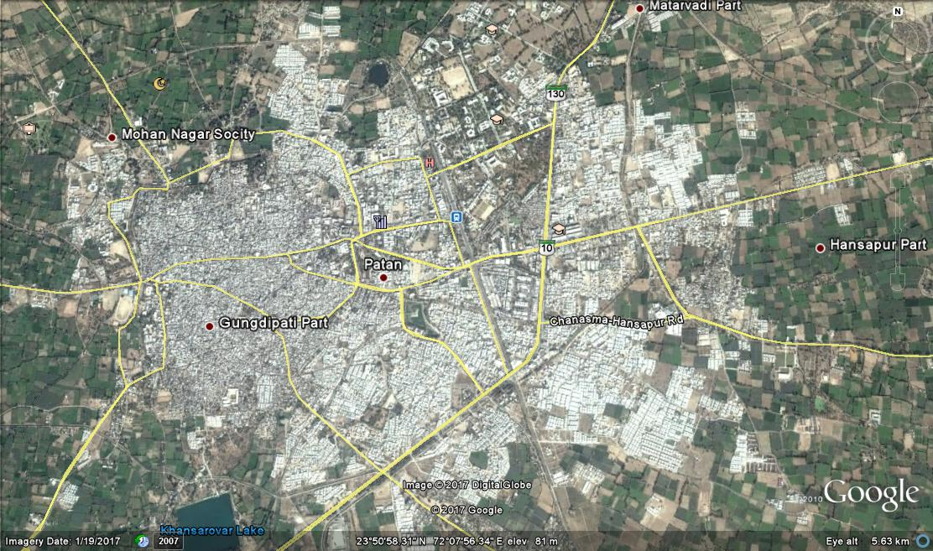

Map Of City

2.7 LOCATION MAP IN PATAN CITY CITY:

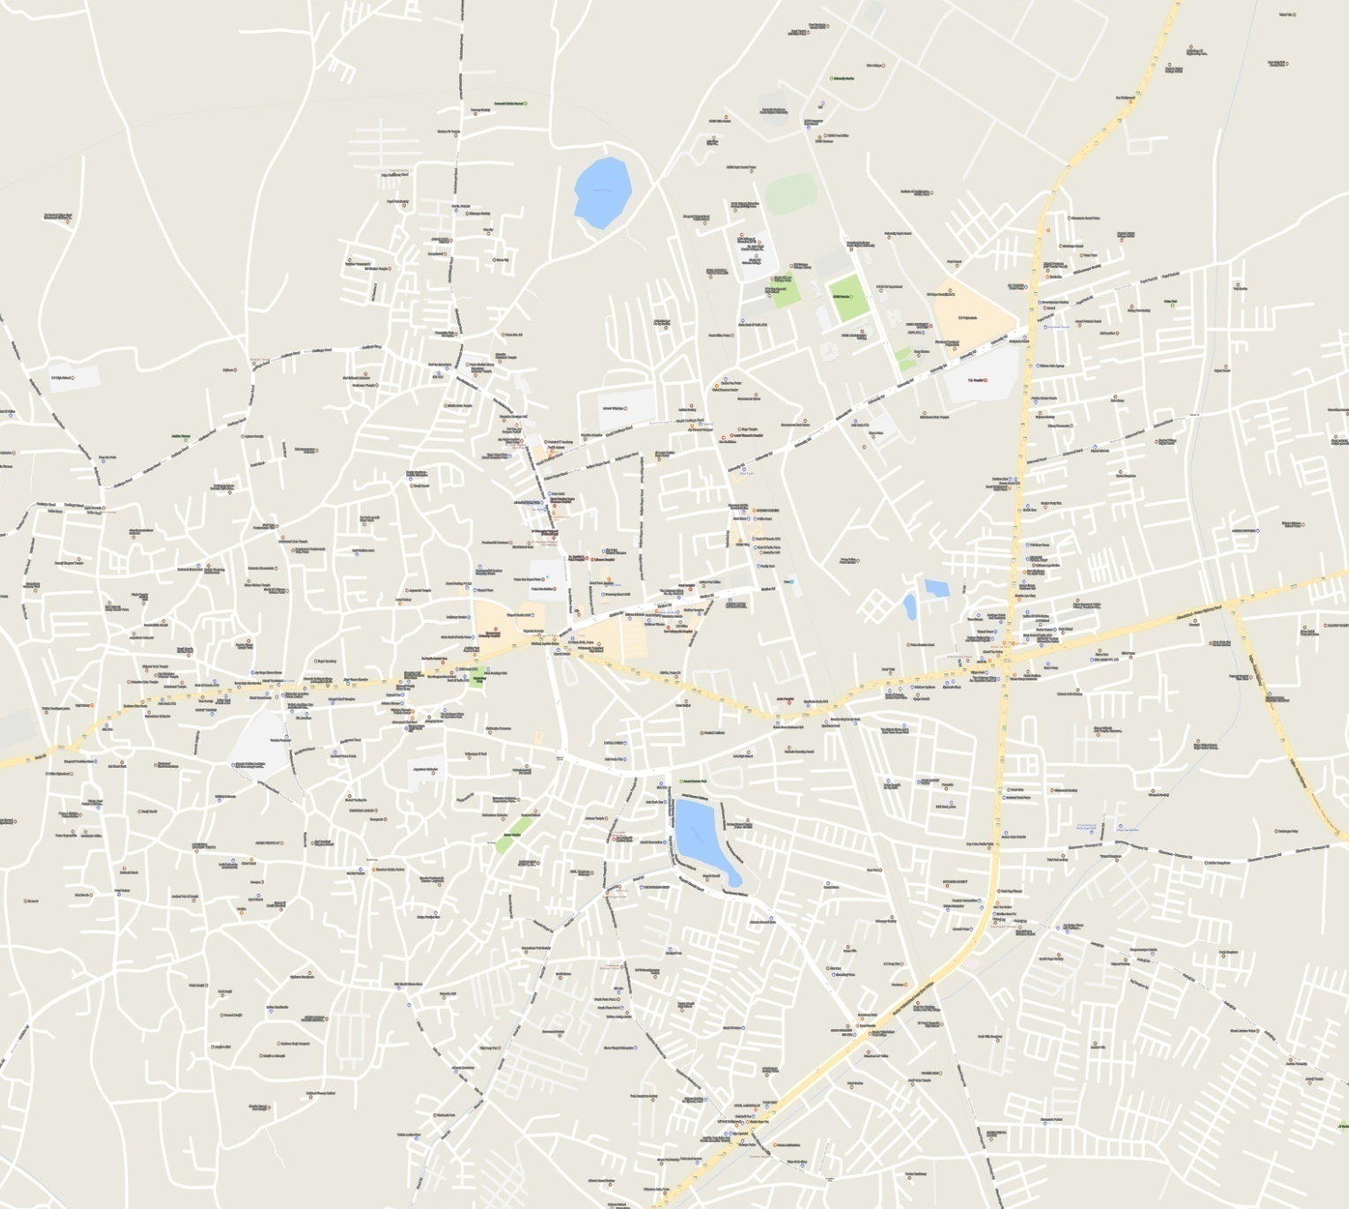

- LITTERATEUR REVIEW:

  - SMART CITY DEFINITION:
A developedurban area that creates sustainable economic development and highquality of life by excelling in multiple key areas; economy, mobility, environment, people, living, and government. Excelling in these key areas can be done so through strong human capital, social capital, and/or ICT infrastructure.

  - FEATURE OF SMART CITY:

- Health and education
- Ensuring safety of citizens, official women and elderly.
- Sustainable environmental
- Goods governance, especially e-governance and citizen participation.
- Affordable housing, especially for poor
- Efficient urban mobility and public infrastructure.
- Sanitation including solid management.
- Assured electricity supply- least 10% of the energy requirement coming from solar power.
- Ad equalities water supply including waste water recycling and storm water reuse.
- New building makes energy efficient.
- 15% of the building will be in the affordable housing category.

  - URBANIZATION:

The major case for increase in urban population is the rural urban migration of people in search of better employment opportunity. Further the larger cities also attract in migration of population from smaller cities. The migrate settle in available open land close to their job sites, despite often unsatisfactory living conditions.
Urbanization is a result of continues economic development accompanied by emphasis on the development of human resources and urban infrastructure. Tread, commerce and other economic activities thrive in areas where accessibility is high. Urban development takes place around such activities generators.

- Problem of urbanization:
- The housing shortage becomes more acute.
- The cost of living for the inhabitants rises.
- The road becomes congested.
- Level of air pollution increases.
- The urban sprawl increase.
- As a result of urban sprawl, the average tripe length increases.
- The number of trips in urban area increase.
- The number of vehicles and traffic accident increases.

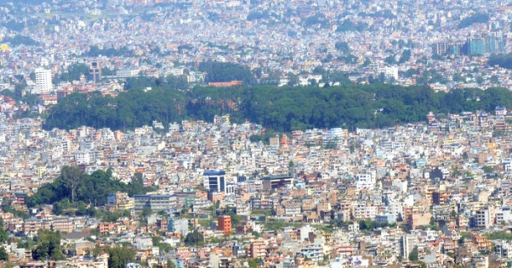
`

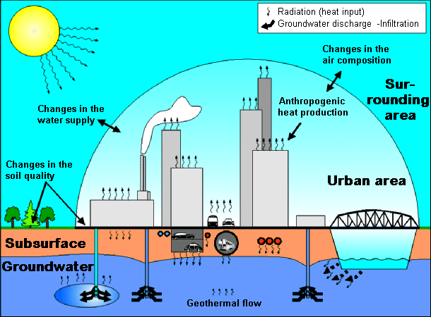
FIG: shows the urbanization cycle

  - BUILDING BYE LAWS

In order to have planned development there must be some uniform rules pertaining to various types of development such as residential, commercial, and industrial.
The by-law of regulate the development in terms of utility of services. buildings and other specific requirement for planned development various region, cities, towns and villages are framing their regulations in terms of building regulations and by - laws in construction of local climate condition, environment, tradition and life style.
There are various central and local authorities framing building by - laws for residential, commercial and industrial development. The government of India I has published nation building code - 1980 for enforcement f rules for building in 10 parts.
This building code serves as a central guideline to frame various building by - laws. The local authorities principally adopts these by - laws and makes some changes in consideration of local climate and living conditions.
In own city to maintain local authorities like Ahmadabad Municipal Corporation has framed building by - laws to be enforced in their jurisdiction by Ahmadabad Municipal Corporation.

The building by - laws are divided into five parts. They are;
1. General Definitions
2. General Building Requirements
3. Additional Byelaws for Special Structures
4. Administration
5. Maintenance of Building

  - LIST OF SMART CITY IN INDIA
List of smart city in India:

Sr. No | Name of state | Name of cities
1 | Maharashtra | Greater Mumbai, Thane, Kalyan-Dombivali, Navi Mumbai, Nashik, Amravati, Solapur, Nagpur, Pune, Aurangabad
2 | West Bengal | New Town Kolkata, Bidhannagar, Durgapur, Haldia
3 | Gujarat | Gandhinagar, Ahmedabad, Surat, Vadodara, Rajkot, Dahod
4 | Madhya Pradesh | Bhopal, Indore, Gwalior, Jabalpur, Satna, Ujjain, Sagar
5 | Tamil Nadu | Coimbatore, Chennai, Madurai, Tiruchirapalli, Vellore, Salem, Erode, Tiruppur, Thanjavur, Tirunelveli, Dindigul, Thoothukudi,
6 | Karnataka | Bangalore, Mangaluru, Belagavi, Shivamogga, Hubbali-Dharwad, Tumakuru, Davanagere
7 | Kerala | Kochi, Trivandrum
8 | Telangana | Warangal, Karimnagar
9 | Andhra Pradesh | Vishakhapatnam, Tirupati, Kakinada
10 | Uttar Pradesh | Meerut, Moradabad, Aligarh, Saharanpur, Bareilly, Jhansi, Kanpur, Allahabad, Lucknow, Varanasi, Ghaziabad, Agra, Rampur
11 | Rajasthan | Jaipur, Udaipur, Ajmer, Kota
12 | Panjab
  Ludhiana, Jalandhar, Amritsar
13 | Bihar
  Muzaffarpur, Bhagalpur, Biharsharif
14 | Haryana | Karnal, Faridabad
15 | Assam
  Guwahati
16 | Odisha | Bhubaneshwar, Rourkela
17 | Himachal Pradesh
  Dharamshala
18 | Uttarakhand
  Dehradun
19 | Jharkhand
  Ranchi
20 | Sikkim
  Namchi
21 | Manipur | Imphal
22 | Andaman and Niko bar | Port Blair
23 | Arunachal Pradesh
  Pasighat
24 | Chhattisgarh | Chandigarh
25 | Chandigarh | Raipur, Bilaspur
26 | Dadra and Nagar Haveli
  Silvassa
27 | Daman and div
  Diu
28 | Delhi
  New Delhi
29 | Goa | Panaji
30 | Lakshadweep
  Kavaratti
31 | Meghalaya
  Shillong
32 | Mizoram
  Aizawl
33 | Nagaland | Kohima
34 | Pondicherry | Oulgaret

  - CASE STUDY:

- New York Case Study In Smart Solution:
- The Problem:
Between 2001 and 2009, motorists killed 3,774 people on New York City Streets. In addition to the deaths, roughly 4,000 New Yorkers suffered serious injuries in road accidents each year.

The Solution:

Using smart data modeling techniques to analyze traffic and pedestrian patterns, New York City’s Department of Transportation (NYCDOT) proposed removing motor vehicles from some New York City’s busiest roads so the space could be converted into public spaces for pedestrians and cyclists. NYCDOT also oversaw the creation of miles of segregated bicycle lanes and created a bicycle sharing program, which made cycling a viable transportation option for citizens.

The Results:

Almost instantaneously, average travel times improved and injuries to pedestrians fell by as much as 35%. Cycling became an easier transport option, and 74% of New Yorkers surveyed by the Times Square Alliance — one of the neighborhoods affected by the transformations — said that Times Square had dramatically improved.

- Barcelona: Promoting solar energy to increase sustainability

The problem
Barcelona, which has the second largest metropolitan population in Spain, was heavily dependent on costly and environmentally damaging fossil fuels. The city was pushed to identify a different solution to take the city's energy policy in a new direction.

The solution
The city government of Barcelona issued a Solar Thermal Ordinance in 1999. The ordinance set targets for public and private buildings, making it compulsory to use solar energy to supply 60% of running hot water in all new or renovated buildings. It also put solar powered bus stops on Barcelona’s streets.

The results
Barcelona has reduced its energy consumption by 25,000 MWh annually compared to 2000 usage levels. It has achieved this by creating a more environmentally friendly energy supply, including more solar and more photovoltaic energy. More than 70 other Spanish cities have followed Barcelona’s example.

4.DATA COLLECTION
  - GENERAL
Preparation of database is a prerequisite step, it is carried out through inventory data studies from various cases and articles, field studies from municipality and field survey and personal interview of various government and private authorities, employee of the beneficiaries etc. Without secondary data is difficult to judge the present condition of the field. The next step in planning after the study area imagination involves collection of data for studying different construction terminology. This is the major activity in the study process, which required so much time, efforts, also correct and large number of databases is required. Therefore proper data collection is a very important part.

  - INVENTARY DATA
Patan City city is governed my municipal corporation which comes under Patan City metropolitan region. The Patan City city is located in Gujarat state of India.

As per provisional reports of census India population of the Patan City in 2011 is 1,25,497; of which male and female are 65,535 and 59,962 respectively all through Patan City has population of 1,33,737; its urban/ metropolitan population is 1,33,737 of which 69,898 are male and 63,839 are females.

Patan City city | Total | Male | Female
City-out growth | 1,33,737 | 69,898 | 63,839
Population | 1,25,497 | 65,535 | 59,962
Literature | 96,835
  53,862
  42,973
Children(0-6) | 12,887 | 6,919 | 5,968
Average literacy |  | 91.89 % | 79.59 %
  85.99 %
Sex ratio | 915
Child sex ratio | 863

- PROPOSAL
  - PROPOSAL OF PARKING FACILITIES

Parking is the act of stopping and disengaging a vehicle and leaving it unoccupied. Parking on one or both sides of a road is often permitted, though sometimes with restrictions. Some buildings have parking facilities for use of the buildings' users. Countries and local governments have rules for design and use of parking spaces.

Type of Parking Space | Length  (m) | Width  (m)
Private Cars and Taxis | 5 | 2.5
Light Goods Vehicles (LGV) | 7 | 3.5
Medium / Heavy Goods Vehicles (MGV/HGV) | 11 | 3.5
Container Vehicles | 16 | 3.5
Coaches and buses | 12 | 3.5
Light buses | 8 | 3.0
Notes:
i) | Buses mean a motor vehicle constructed or adapted for the carriage of more than 16 passengers and their personal effects.
ii) | Light buses mean a motor vehicle having permitted gross vehicle weight not exceeding 4 tones which is constructed or adapted for use solely for the carriage of not more than 16 passengers and their personal effects, but does not include an invalid carriage, motorcycle, motor tricycle, private car and taxi.

    - PARKING PROBLEM:
The Patan City city is facing a new problem now a day lack of sufficient parking space. With families getting smaller and the total number of motor vehicles exceeding the total number of heads per family, the parking scenario is woefully falling short of the current requirements in the city. The situation is such that on any given working day approximately 40% of the roads in city are taken up for just parking the cars. The problem has been further exacerbated by the fact that nowadays even people from low income group are able to own cars. The number of families with cars has become much more than what the city is able to manage.
The Patan City city is highly congested and on top of that the parked cars claim a lot of space that could otherwise be used in a better way. Thanks to poor, and at times zero, navigability, Patan City city is regarded as some of the worst options for living. One can also add the issue of pollution to this mix and understand the enormity of the crisis. In this context it needs to be understood that the Patan City city.

    - PARKING SOLUTION:
      - Increase parking supply:
This is the first thing that comes to mind when pondering parking problems and solutions. Essentially, its gets property managers/developers, businesses and central/local governments to build more parking facilities. It has the advantage of economies of scale. The top disadvantage is that it increases overheads and encourages driving as opposed to public transport.
- Establish minimum parking requirements:
By raising the requirements for parking spaces the demand for parking can be reduced. The use of zoning is usual in this context. This method is easy to implement but can add to the costs of providing parking to developers and public authorities.
- Increase on-street/curbside parking provision:
This has the advantage of being relatively cheap and convenient with parking problems and solutions. It has the disadvantage of having provision ceilings and parallel parking makes for hazards for cyclists and increases the chances of motor crashes.
- Increasing on-street parking:
Town planners can design more on-street parking while local governments can have fewer parking restrictions and encourage parallel parking. This is easy and cost-effective but there are limits on how many extra parking spaces can be created.

- Subsidizing off-street parking:
This has the advantage of making parking cheaper and bringing it into policy but it amounts to a public subsidy for driving instead of encouraging utilization of public transport.

- Adding overflow facilities:
This amounts to having in reserve extra parking facilities when the usual nearby parking spaces have been all taken up. This can happen during popular events. It has the advantage of flexibility and one disadvantage is how remote the secondary parking area is.

- Maximizing parking spaces in existing facilities:
This can involve utilising unused spaces such as in corners and on the edges of the parking areas and having specially sized spaces for smaller vehicles. This is relatively inexpensive but there is a ceiling on how much can be added.
Parking problems and solutions vary from country to country and from district to district within a country.

5.1.3Parking Facility:
Parking facilities can be both indoor and outdoor, public or private. It can be a parking garage, or a parking space that belongs to the property of a person’s house.
These are the different types of parking facilities:

- Parking lot
A parking lot is an area that is assigned for parking. Normally, the parking spaces are marked on the ground with white or yellow lines that form squares that each fit one car. Parking lots are common near shops, bars, restaurants and other facilities that require parking. There are parking lots that are open throughout the year, but there are also improvised parking lots that are specially assigned for an event. For example, when there is a music festival that only happens once a year people can decide to open a nearby meadow to provide parking spaces for the visitors of that particular music festival.
- Parking garages
A parking garages is also called car park, parking structure, parking building, parking ramp, parkade or parking deck.
There are several types of parking garages:
- Single level parking garage
- Multi-storey parking garage
- Underground parking garage
- Automated parking garage
- Carports
Carports are usually located on people’s driveways next to their house. These carports are covered places where one or more cars can be stalled. They are private property that comes with the house. Car ports do not have four walls: Normally they only have one or two walls and sometimes they are attached to a wall of the house it belongs to. Car ports offer protection from bad weather conditions like rain and snow.

- Parking spaces on the side of the street
Also parking spaces on the side of the road where metered or spaces that are laid out for the use of parking, are considered parking facilities. Commonly you can identify such spaces because there are one or more squares lined out with yellow or white paint that fit one car. You as a driver are supposed to park your car in between the squares. In other areas there aren’t any parking spaces drawn on the streets. This usually only happens in residential areas where it isn’t crowded.
- Automated Parking System (APS)
An Automated Parking System or APS is a mechanical system that moves cars from the entry to an available parking space. It uses multiple levels and stacks cars vertically to use as less land as possible to park as many cars as possible. It’s entirely automatic and doesn’t require any staff. Automated Parking Systems are sometimes also called:
- Mechanical Parking System
- Robotic Parking System
- Rotary Parking System
- Automatic Parking
- Stacker Parking
- Etc.
Automatic parking systems are very space efficient. You can simply stack all the cars plus the parking space doesn’t have to be as wide as in a conventional parking lot. You can stack more cars in a compact space, because cars are moved by platforms and lifts. The system doesn't need as much space to park as a human does. There’s no need for ramps, pedestrian areas etc.
- Semi-Automated Parking System
A Semi-Automated Parking System uses a mechanical system to move cars to their parking space, only it needs a human action to work, either by the driver or an attendant. This action can be as simple as pushing a button.

5.1.4 Parking design:
We provide mechanical type parking facilities in PATAN city. It is more suitable for aroma circle area which haveto much traffic problem due to parking problem. A mechanical system designed to minimize the area and volume required for parking cars. Like a multi-story parking garage, mechanical car parking provides parking for cars on multiple levels stacked vertically to maximize the number of parking spaces while minimizing land usage. Mechanical parking utilizes a mechanical system to transport cars to and from parking spaces (rather than the driver) in order to eliminate much of the space wasted in a multi-story parking garage. While a multi-story parking garage is similar to multiple parking lots stacked vertically, mechanical parking system is more similar to an automated storage and retrieval system for cars. The paternoster (shown animated at the right) is an example of one of the earliest and most common types of mechanical parking system. Mechanical parking system is generically known by a variety of names are as follows.
- Automatic parking system
- Automated parking facility
- Automated vehicle storage & retrieval system
- Car parking system
- Mechanical parking
- Robotic parking garag

5.2 PROPOSAL OF GREEN BUILDING:

“It is the practice of increasing efficiency with which buildings use resources- energy, water and materials-while reducing building impacts on human health and the environment.”

Green building (also known as green construction or sustainable building) expands and complements the building design concerns of economy, utility, durability, comfort and good ventilation. A Green Building is one which uses less water, optimizes energy efficiency, conserves natural resources, generates less waste and provides healthier space for occupants as compared to conventional buildings.

5.2.1 Concept:

The “Green Building” concept is gaining importance in various countries. These are buildings that ensure that waste is minimized at every stage during the construction and operation of the building, resulting in low costs, according to experts in the technology.

The techniques associated with the `Green Building' include measures to prevent erosion of soil, rainwater harvesting, use of solar energy, preparation of landscapes to reduce heat, reduction in usage of water, recycling of waste water and use of energy efficient.

A similar concept is natural building, which is usually on a smaller scale and tends to focus on the use of natural materials that are available locally.

5.2.2. Importance Of Green Buildings:

We should make a way to maximize our natural resources and also help our earth to get some relief since pollution is everywhere plus the global warming that we are all experiencing. Non-renewable energy is expensive and unsafe but did you know that through green building we can save a lot of energy.
Before that, let's define first the meaning of green building (know also as green construction is the practice of creating structures and using processes that are environmentally responsible and resource-efficient throughout a building's life-cycle from siting to design, construction, operation, maintenance, renovation, and deconstruction.
The importance of this is it lessen consumes of energy and the pollution as well because the more we use nonrenewable energy the higher the risk of pollution.

5.3.3Principle Of Green Building:

- Design: Solar orientation is the most important design element. Heating and cooling loads in a home could be cut significantly by orienting the long walls of houses east-west, exposing south facing windows in winter, and shading them in summer, and avoiding expanses of glass on west-facing walls that get the full brunt of the flat afternoon sun.

- Durability:Controlling air and moisture leakage from inside to out not only saves energy, but also can prevent damaging condensation from forming in framing cavities. The use of vapor barriers in cold climates is an important moisture control element.

- Energy efficient:Insulation is a job that needs careful detailing. From a green perspective, this is very important. And air sealing feel the holes where inside air can leak out or outside air can leak is at least as important as insulation, because no insulation can achieve its potential if air can leak through it. Air infiltration must be kept as low as possible.

- Indoor air quality:There are two approaches to improving indoor air quality. The first is reducing the use of products that off-gas. Use plywood floor sheathing. Detached garages separate exhausts, fuel, and pesticide storage from living spaces. Providing dedicated combustion air for furnaces, boilers, and water heaters can prevent back-drafting stack gasses into the house.
The approach is as important as reducing sources. Using heat recovery ventilators in northern climates, brings fresh outside air in, while exhausting stale inside air. The two air streams pass each other in the ventilator's heat exchanger, with the outgoing indoor air tempering the incoming outdoor air. It exhausts air from bathrooms, and laundry and kitchen areas, and directs the tempered incoming fresh air into the living areas and bedrooms.
- Water conservation: Water issues also include managing stormwater runoff to maintain natural ground percolation that recharges aquifers, as well as preventing siltation of waterways. It's often possible to reduce the storm sewer infrastructure by increasing the ability of individual home sites to absorb storm flows.

- Green products:Simply choosing one product over another is the easiest, yet the least important path to going green. Look for swaps that take something not as green and replace it with something greener that requires no changes in worker skills. Examples include specifying concrete that incorporates fly ash (a waste product from coal-burning power plants) as a partial substitute for Portland cement. Another example is using bamboo flooring, which regenerates quickly, instead of wood species that are not as sustainable.

